**Purification of recombinant Tau Repeat Domain (TauRD) from *Escherichia coli***

**Authors:** Patricia Yuste-Checa1, F Ulrich Hartl1

1Department of Cellular Biochemistry, Max Planck Institute of Biochemistry

**Abstract**

This protocol details how to efficiently purify the recombinant Tau repeat domain from *Escherichia coli*.

**NOTE:** This protocol was optimized for purification of the cysteine-free TauRD (Tau residues 244-371, C291A/P301L/C322A/V337M), but in principle any Tau isoform or mutant could be purified following this method if it is tagged with a His6-ubiquitin tag. If cysteines are present, reducing agent should be added to buffers to avoid the formation of disulphide bonds.

Buffers and Media

Terrific Broth (TB) media: 24 g L-1 yeast extract, 20 g L-1 tryptone, 4 mL l-1 glycerol, 0.017 M KH2PO4, 0.072 M K2HPO4.

Lysis buffer: 50 mM PIPES-NaOH pH 6.5, 250 mM NaCl, 10 mM imidazole, 2 mM β-mercaptoethanol (β-ME).

Ni-NTA high salt buffer: 50 mM PIPES-NaOH pH 6.5, 500 mM NaCl, 10 mM imidazole, 2 mM β-ME.

Ni-NTA wash buffer: 50 mM PIPES-NaOH pH 6.5, 250 mM NaCl, 50 mM imidazole, 2 mM β-ME.

Ni-NTA elution buffer: 50 mM PIPES-NaOH pH 6.5, 50mM NaCl, 250 mM imidazole, 2 mM β-ME.

PIPES buffer or Cation exchange Buffer A: 50 mM PIPES-NaOH pH 6.5, 2 mM β-ME.

Cation exchange Buffer B: 50 mM PIPES-NaOH pH 6.5, 1 M NaCl, 2 mM β-ME.

TauRD expression

1. Thaw RbCl-competent *Escherichia coli* Bl21 cells (DE3) on ice.

2. Add 1 µL of pHUE-TauRD plasmid (His6-ubiquitin-TauRD) and incubate 30 min on ice.

3. Heat shock 45 sec at 42 °C.

4. Incubate on ice 2 min, then add 850 µL Lysogeny broth (LB) or

Super Optimal broth with Catabolite repression (SOC) medium.

5. Shake for 1 h at 37 °C.

6. Centrifuge for 5 min at 3,000x g and remove most of the supernatant.

7. Resuspend the pellet with the remaining supernatant and plate the bacteria on LB /Ampicillin agar plates and incubate overnight at 37 °C.

8. Prepare preculture: Scrap all colonies with the scraper and inoculate 25-50 mL LB/Ampicillin. Shake at 37°C for 4-6 h.

9. Measure OD600 of the preculture and inoculate two flasks with 1 L of TB media each to an OD600 = 0.05.

10. Shake flasks at 37°C until approx. OD600 = 0.5-0.8. (2-4 h)

11. Add isopropyl β-d-1-thiogalactopyranoside (IPTG) at final concentration of 0.4 mM.

12. Shake flasks overnight at 37°C.

13. Centrifuge bacterial culture at 4,000x rpm for 1 h. Discard supernatant. Cell pellets can be stored at –80°C.

Ni-NTA chromatography

14. Resuspend the cell pellets with lysis buffer (50mL lysis buffer/2 L bacteria culture) supplemented with Complete EDTA-free protease inhibitor cocktail (Merck) and benzonase.

15. Add 1 mg mL-1 lysozyme and incubate gently shaking for 30 min at 4°C.

16. Sonicate lysate on ice, 5 cycles 30 sec ON, 90 sec OFF.

17. Centrifuge lysate at 40,000x g 1 h at 4 °C.

18. Prepare Ni-NTA column by transferring 10 mL Ni-NTA resin slurry to a column (5 ml column bed). Wash Ni-NTA column with 10 column volumes (CV, 50 mL) water and equilibrate with 10 CV (50 mL) lysis buffer.

19. Load lysate supernatant to Ni-NTA column.

20. Wash Ni-NTA column with 10 CV (50 mL) high salt buffer and 10 CV (50 mL) wash buffer.

21. Elute His6-ubiquitin-TauRD with 20 mL elution buffer and collect everything.

**NOTE:** Prepacked or any other Ni column can be used for His6-ubiquitin-TauRD purification.

His6-ubiquitin cleavage

22. Dilute eluted protein 1:5 with PIPES buffer to reduce the amount of salt (20 mL eluted protein + 80 mL PIPES buffer).

23. Incubate diluted His6-ubiquitin-TauRD protein with 0.5 mg Usp2 ubiquitin protease at 4°C overnight.

**NOTE:** Dilution of eluted protein is not needed for protease cleavage but recommended to avoid protein precipitation during incubation. Salt dilution is needed for the next purification step, cation exchange chromatography.

Cation exchange chromatography

24. Load the cleavage mixture onto a Source S cation exchange column previously equilibrated with cation exchange buffer A.

25. Wash the column with 5 CV of cation exchange Buffer A

26. Elute TauRD with a 0-500 mM linear NaCl gradient in 50 mM PIPES-NaOH pH 6.5, 2 mM β-ME (0-50% gradient from cation exchange buffer A to cation exchange buffer B over 10 CV).

27. Analyze eluted fraction by SDS-PAGE and Coomassie blue staining.

Size exclusion chromatography

28. Load TauRD-containing fractions onto a Superdex-75 column previously equilibrated with PBS.

29. Analyze eluted fraction by SDS-PAGE and Coomassie blue staining.

30. Pool fractions containing TauRD, aliquot and flash-freeze in liquid nitrogen for storage at −80 °C.

**NOTE:** Due to the intrinsic disordered nature of Tau protein, the apparent size observed by size exclusion chromatography is larger than expected.

**NOTE:** TauRD protein contains few Tyr and Trp residues, and therefore the determination of pure protein concentration by OD280nm is not reliable. We recommend to determine protein concentration of purified TauRD by BCA assay or Coomassie blue staining including a BSA standard curve. Rapid commercial Coomassie protein stain buffers are not recommended since sensitivity for the TauRD is very low. Standard Coomassie blue staining buffer should be used.

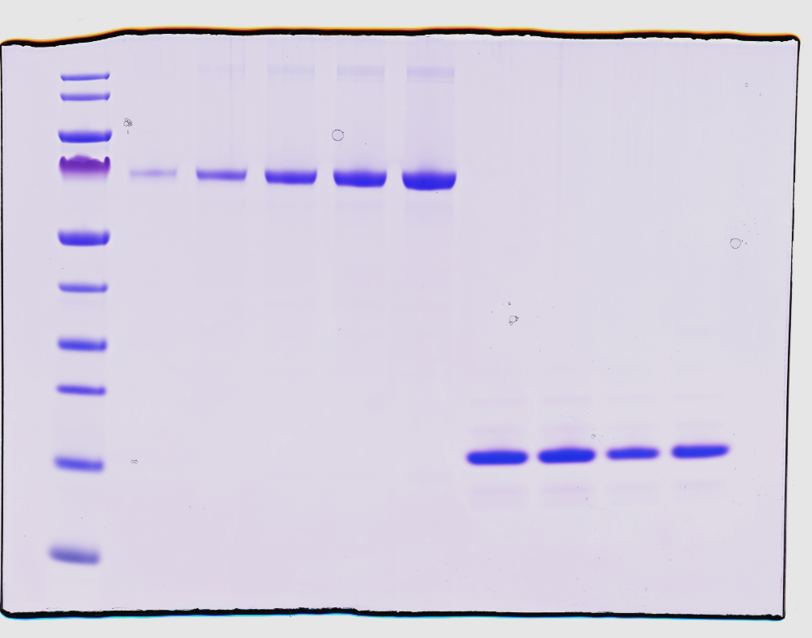

Pure

TauRD

BSA (µg)

0.2

0.5

1

1.5

2

180

130

100

70

55

40

35

25

15

10

MW

(KDa)

**NOTE:** For TauRD thiol labelling, the mutation I260C could be introduced in the cysteine-free TauRD. The same purification protocol can be followed but 1 mM tris(2-carboxyethyl)phosphine (TCEP) should be added to the size exclusion chromatography buffer in order to prevent the formation of disulfide bonds.

**NOTE:** Approximate yield: from 2 L of bacterial culture around 8 mg of pure TauRD are obtained.