Semi-Automated Dual Fluorescence In-Situ Hybridization (d-FISH) Procedure

- Scope: This semi-automated protocol will provide step by step instructions for performing Dual-Fluorescence In Situ Hybridization on tissue.

- Materials:
  - 10% Tween.
  - Methanol.
  - H₂O₂
  - 0.2M HCL.
  - PBS.
  - PK Buffer.
  - Roche Proteinase K.
  - 4% PFA.
  - Ambion In Situ Hybridization Buffer.
  - cRNA – Riboprobes in 96 deep-well plate.
  - 5x SSC.
  - Formamide I.
  - Formamide II.
  - 0.1x SSC.
  - NTE.
  - Iodoacetamide.
  - TNT.
  - 4% Lamb Serum.
  - TNB Blocking Buffer.
  - anti-DIG–POD.
  - anti-DNP HRP
  - Tyramide Biotin (TSA).
  - Tyramide DNP (TSA Plus DNP).
  - 1% Blocking Reagent without Neutravidin.
  - Maleate Wash Buffer.
  - Streptavidin Alexa-Fluor 488 conjugate.
  - Streptavidin Blocking Reagent.
  - Biotin Blocking Reagent.
  - Anti-DNP-KLH Alexa-Fluor 555 conjugate.
  - 0.025 M Sodium Bicarbonate.
  - 70% Ethanol.
  - 100% Ethanol.
  - RNase-free MilliQ water.
  - Millipore 0.45um filter.
  - 500 mL RNase-free bottles.
  - 1L RNase-free bottles.
  - 2L RNase-free bottles.
  - 15 mL conical tubes.
  - 50 mL conical tubes.
  - 96 deep-well plates.
  - RNase-ZAP (or equivalent).
  - MSDS.
  - D-FISH Run Instructions.
  - D-FISH Runplan
  - Check List.

- Equipment
  - TECAN Freedom Evo or Tecan RSP 200.
  - 4ºC Refrigerator.
  - -20ºC Freezer.
  - -80°C Freezer.
  - Pipetteman (P200, P1000).
  - Rainin EDP3-Plus 1200 µL multi-tip pipette.
  - Water Bath.
  - Stir Plate.
  - Eppendorf Centrifuge (5415 D, 5810 R).
  - IEC Centra GP8 Centrifuge.
  - Lauda T2200.
  - Pt100 Temperature Probe.
  - Lauda Ecoline 03.
  - Vacuubrand diaphragm pump, model MD4C.
  - Labconco vacuum desiccators cabinet (Cat #5530000).

- Safety:
  - Do not have any body part over the work table while the machine is running.
  - Always wear proper PPE when operating a Tecan Robot
    - Nitrile gloves
    - Eye protection
    - Lab coat

- Output: Digoxigenin and Dinitrophenyl labeled tissue sections ready for microscopic analysis.

- Reference Documents:
  - PF0004: 1x3 Slide Acetylation Using the Leica XL Autostainer.
    - To be Published
  - PF0016: FISH DAPI Staining and Coverslipping.
    - To be Published
  - RP0008: 3% H₂O₂ in Methanol.
    - To be Published
  - RP0042: SOP Anti-DNP-HRP.
    - To be Published
  - RP0019: Proteinase K working solution.
    - To be Published
  - RP0017: Degassing Reagents.
    - dx.doi.org/10.17504/protocols.io.bg4wjyxe
  - RP0041: Streptavidin Alexa-Fluor 488.
    - To be Published
  - RP0046: Anti-DNP Alexa-Fluor 555.
    - To be Published
  - RP0033: TSA.
    - To be Published
  - RP0044: TSA-DNP.
    - To be Published

Warning: This process is extremely sensitive to RNase contamination; ensure that you have been properly trained using sterile techniques before starting this protocol. Personal Protective Equipment (PPE) should be used at all times while operating this protocol. If you are unsure what PPE you should be using, see your immediate supervisor.

- Set-up for in situ hybridization:
  - Obtain reagent volumes used for all freshly made reagents for the current run.
  - Remove one bottle of hyb mix per full run from the -20°C freezer. This should be done at least five hours before the run start time.
    - Leave the bottle(s) at room temperature for an hour to allow them to thaw.
    - Invert the bottle(s) of Hyb mix 5 times and swirl to thoroughly mix the solution.
    - Place hyb mix (in sealed bottles) in a designated waterbath set to 65°C for 10 minutes to allow for any particulates to go into solution.
    - Remove bottles from the waterbath and invert an additional 5 times to assure they are well mixed.
      - After the hyb mix has been heated for 10 minutes and the bottle(s) have been inverted/swirled to mix, check for particulates:
        - If still present, heat again at 65°C for 10 additional minutes.
        - If no particulates are seen, proceed to step 7.2.5.
    - Remove sealed bottles of Hyb mix from waterbath and allow to cool for 1 hour at room temp (still in sealed bottles).
    - After 1 hour cooling at room temperature, pour hyb mix into glass containers to be used on that day’s ISH runs and degas (See RP0017). This task should take place three hours before the run start time. The hyb mix needs to degas approximately five hours and be placed onto the tecan deck at three hours after the run start time.
  - Record all reagent lot numbers in the space provided on the dFISH run checklist. (This can be done on the day prior to the run). (See appendix A)
  - Obtain dFISH run instructions for sectioned slides to be hybridized.
  - Remove the appropriate slides for the dFISH run(s) from the room temperature slide storage location.
  - Organize the slide boxes by the tissue specimen number and series number.
  - Wipe down the slide assembly area with RNase-Zap.
  - Obtain the appropriate number of glass back-plates, metal chamber clamps, mounting racks, and metal support frames.
  - Unwrap and assemble the sectioned slides into the flow-through chambers. (See PF0004 for detailed instructions on flow-through chamber assembly).
  - Below is a checklist for the daily Tecan Set-Up activities that must be completed prior to the initiation of a new dFISH run.

Must be completed prior to the initiation of a new dFISH run.
Fisher H₂O bath on and set to 65°C (add 25mM sodium bicarbonate if necessary).
Add 25 mM sodium bicarbonate in table top Lauda if below 1 inch from top of bath.
Check Antifreeze levels of Lauda H₂O baths. Replenish if levels under the half-way point.
Must be completed before start of next dFISH run.
Make sure Tecan is turned on.
Make sure Lauda H₂O baths turned on, and that each Pt100 temperature probe is securely fastened to both the Te-Flow.and the Lauda.
Make sure TeFlows are drained and the drainage lines are tied to the Tecan deck.

Warning: Before running any Tecan program, make sure that you have double checked that the deck layout provided by the software matches exactly the current deck configuration. Failure to do so may result in a tip collision.

Warning: All chemicals (waste) should be handled with care. Please familiarize yourself with the chemicals being handled. Detailed descriptions of each chemical used in this protocol can be found in the MSDS. If you come in contact with any one of the chemicals used in this protocol, immediately seek help and flush the area with water for 10 – 15 minutes. Next, notify a responsible party for further instructions. In case of an emergency dial 9-911.

- Methodology for in situ hybridization:
  - Referencing the provided d-FISH runplan load each Te-Flow rack with the assembled slides. See Picture below.

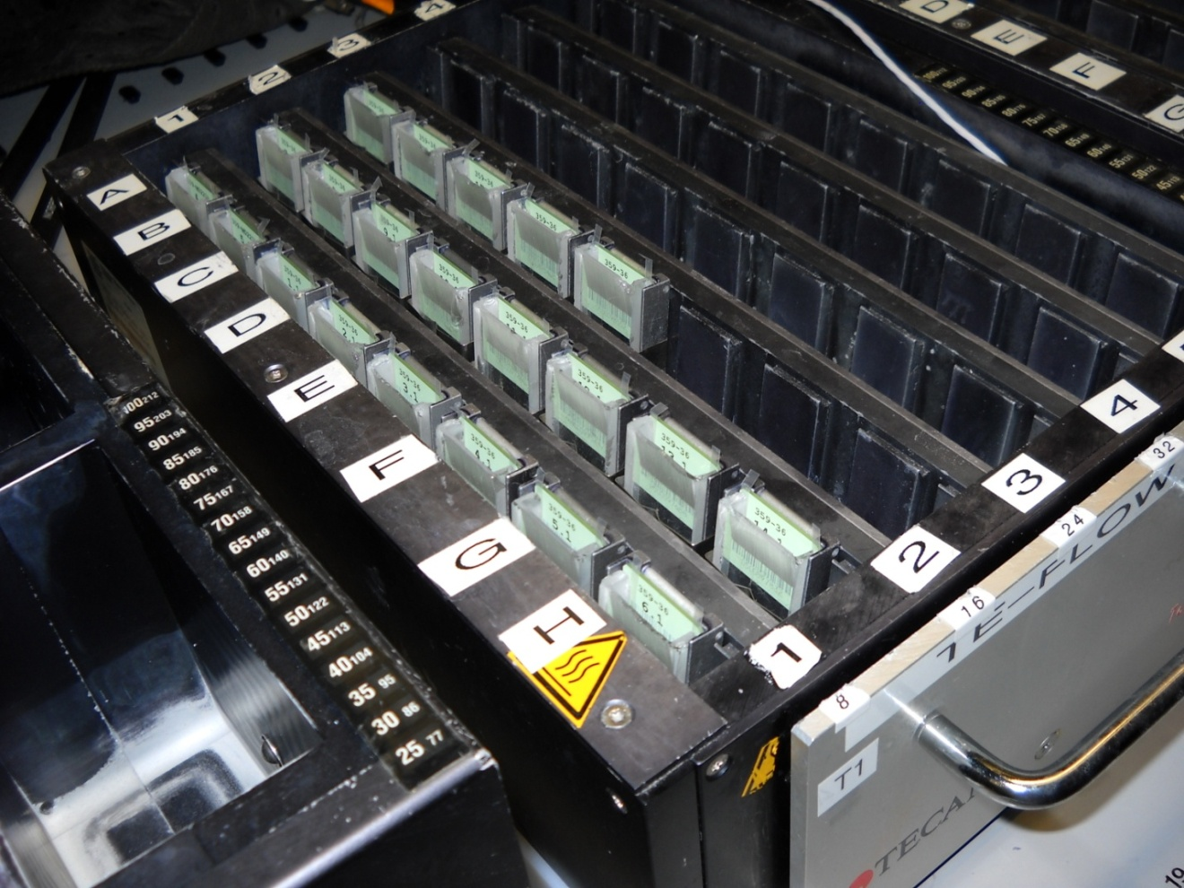
  - Using the dFISH runplan verify that the correct slides have been inserted into the appropriate slot in the Te-Flow chamber. Do this by confirming the first and last slide in each column.
  - Double click on the Gemini icon, located on the desktop.
  - Log-in using the Production group ‘user name’ and password.

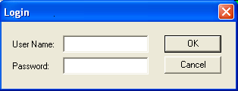

  - From the toolbar, click on the ‘open file button’ and double click on the “AI_FISH_Protocol_Version_X_Y.gem” program. (Double check that the deck layout on the screen matches the hardware layout on the Tecan).

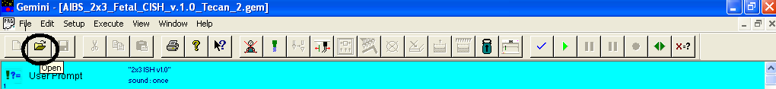
  - Use the reagent map to add the appropriate reagents to their proper locations on the deck of the Tecan. As the reagents are added, check them off as complete on the d-FISH Production Run Checklist. Document time completed when indicated on the sheet. MeOH and Proteinase K should be made immediately prior to the start of the run. (See SOP’s RP0008, RP0019) (See Table 1 for reagent volumes and Table 6 for reagent map.)

Table 1 – Reagent Volumes (see appendix A)

 | Volume (mL)
Reagent | 1TeFlow (48slides) | 2 TeFlow (96slides) | 3 TeFlow (144slides) | 4 TeFlow (192 slides)
3% H202 in MeOH (1st day) | 150 | 250 | 350 | 500
3% H202 in MeOH (2nd day) | 150 | 250 | 350 | 500
PBS | 600-Lg 250-Sm | 1000-Lg 500-Sm | 1400-Lg 650-Sm | 1600-Lg 850-Sm
HCl | 100 | 150 | 165 | 185
PK Buffer | 75 | 125 | 135 | 150
Proteinase K Solution | 100 | 200 | 200 | 200
4% PFA (1st day) | 90 | 150 | 155 | 185
4% PFA (2nd day) | 130 | 200 | 250 | 320
Hyb Buffer | 110 | 150 | 180 | 200

  - Important! Check that all deck components have been properly seated and have been pushed back as far as the placement holders will allow. Ensure that each Pt100 probe is securely fastened to its respective Te-Flow, and that each Lauda thermostat is properly displaying the external probe temperature.
  - Prepare the Proteinase K solution per SOP RP0019. Add the reagent to the appropriate deck location. (See Table 6 for reagent map.) Document on the dFISH Production Run Tracking sheet that this reagent has been added to the Tecan deck.
  - Prepare the 3% H2O2 in MeOH as per SOP RP0008 and add to the deck (See Table 6 or reagent map). Document on the dFISH Production Run Tracking sheet that this reagent has been added to the Tecan deck.
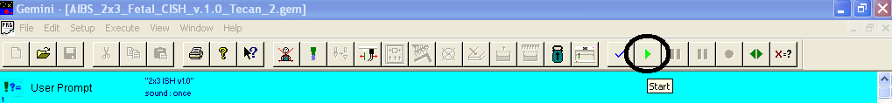
  - Once all of the reagents have been added, and the correct deck configuration has been confirmed, run the “AI_FISH_Protocol_Version_X_Y.gem” program by clicking on the green ‘play’ symbol icon located in the toolbar.

  - There will be a prompt in the script for the number of slides. The number entered should reflect the last slide position to receive dispensed reagents regardless of any empty locations up until that point. As a result, the number entered in the prompt window may differ from the actual slide number. The “AI_FISH_Protocol_Version_X_Y.gem” program will perform the liquid handling processes. (See Table 2 on following page for pre-hybridization robotic processes).

Table 2 – Pre-Hybridization- (see Appendix A)
Cycles | Cycle time | Vol. (µL) | Reagent | Function | Temp | Time (min) | Est. Run Time | Action
5 | 5 min | 250 | 3% H2O2 in MeOH | Blocks peroxidase activity. | 24ºC | 25
5 | 5 min | 300 | PBS (1) | Washes, and restores pH. | 24ºC | 25 | 50 min
2 | 5 min | 300 | 0.2M HCl | Permeates cell membrane. | 24ºC | 10
4 | 5 min | 300 | PBS (2) | Washes, and restores pH. | 24ºC | 20
1 | 5 min | 400 | PK(+) buffer | Equilibrates samples for Proteinase K addition. | 24ºC | 5 | Hour 1:15
2 | 10min | 300 | Proteinase K | Degrades proteins, allowing riboprobes to penetrate the tissue. | 24ºC | 20
5 | 5 min | 300 | PBS (3) | Washes, and restores pH. | 24ºC | 25 | Hour 2:10
2 | 10 min | 300 | 4% PFA (1) | Fixes tissue | 24ºC | 20 | Hour 2:30
7 | 5 min | 300 | PBS (4) | Washes, and restores pH. | 24ºC | 35 | Hour 3:05
2 | 15 min | 300 | hyb-mix (1) | Stabilizes riboprobe. | 64ºC | 30
 | 15 min |  | heat up to 64ºC | Incubation temperature. | 64ºC | 15 | Hour 3:50
 |  | 320 | riboprobe addition | Targets nuclear mRNA. | 64ºC |  |  | Add O/N reagents
 |  |  |  | **5.5-hour hybridization** | 64ºC | 330

  - 2.5 hours into the run place the hyb mix on the deck (See Table 6 for reagent map).
  - All of the post-hybridization reagents should be completed by the time the probe plate is added to the deck, which is 3.5 hours after the run start time. Note: Some of these reagents may have been started earlier in the day in order to be completed by this time. During the dispense of the hyb mix there will be two 15 minute timers at which time the Te-Flow units will heat up to 64ºC. 10 minutes into the first timer obtain the riboprobe plates to be used for the dFISH run from the Production -20°C.01 freezer. Double check the runplan and Tecan numbers on the probe plates against the weekly run schedule.
  - Place the probe plates in a 65°C water bath for 30 minutes. This should be completed 10 minutes into the first hybridization buffer incubation. The purpose of this incubation is to denature any secondary structure that might have formed in the riboprobes. Remove the plates from the water bath, dry off and bump down in the centrifuge (1800 rpm).
  - Following the incubation, there will be a prompt to add the riboprobes. Slowly remove the seal on the plate and place the probes in their appropriate deck location (see Table 6 for probe plate position) and click ‘OK’ to resume program. Document the completion of this task on the dFISH Production Run Tracking sheet.
  - Remove dishes labeled #1 and #4 along with the hyb glassware. Place #1B, 4B and the four overnight glass containers in the proper positions. Dispose of any excess reagents in their appropriate location.
  - Rinse all of the reagent containers once with MilliQ water. Then spray each container with RNase Away and triple rinse with MilliQ water.
  - Dry the reagent containers with a Kimwipe. Remember to form a “Kimwipe mitten” around your hand to insure that your gloves don’t touch the inside of the container while drying. Important: DO NOT use a Kimwipe that has touched the outside of a container for drying the inside of it.
  - Store the clean reagent containers in their appropriate location.
  - Add all of the overnight reagents to the proper containers except for the SSC’s and Formamides. Once the riboprobes have been dispensed, verify that they were properly dispensed by holding the plate up to a light and looking through the bottom of the plate.
  - Add the SSC’s and the Formamides. Document the completion of this task on the tracking sheet. In addition, sign off or witness the final overnight (O/N) quality control (QC) step for reagent location, deck configuration and the proper seating of all reagent containers and Te-Flow units (See Table 4 for post-hybridization reagent volumes and Table 6 for reagent map).

Table 4 – Post-Hybridization Reagent Volumes (see Appendix A)

ISH Reagent Volumes/Run
Volume (mL)
Reagent | 1 TeFlow (48 slides) | 2 TeFlow (96 slides) |  | 3 TeFlow (144 slides) | 4 TeFlow (192 slides)
5 x SSC | 400 | 400 |  | 500 | 500
Formamide I | 400 | 400 |  | 500 | 500
Formamide II | 400 | 400 |  | 500 | 500
0.1 x SSC | 400 | 400 |  | 500 | 500
NTE | 300 | 500 |  | 650 | 800
20mM Iodoacetamide | 200 | 300 |  | 400 | 500
TNT | 650 | 1200 |  | 1600 | 2000
4% Lamb Serum | 200 | 300 |  | 400 | 500
TNB Blocking Buffer | 200 | 400 |  | 500 | 575
Maleate Wash Buffer | 350 | 500 |  | 700 | 800
Blocking Reagent | 100 | 150 |  | 200 | 250
Anti-DIG-POD | 100 | 150 |  | 200 | 250
Tyramide-Biotin | 13 | 25 |  | 37 | 50
Streptavidin Fluor | 38 | 76 |  | 114 | 152
Streptavidin Blocking | 13 | 25 |  | 37 | 49
Biotin Blocking | 13 | 25 |  | 37 | 49
Anti DNP-HRP | 100 | 150 |  | 200 | 250
Tyramide-DNP | 13 | 25 |  | 37 | 50
Anti-DNP Fluor | 38 | 76 |  | 114 | 152

  - The “AI_FISH_Protocol_Version_X_Y.gem” program will perform the overnight processes. (See Table 5 for post-hybridization robotic processes).

Table 5 – Post-Hybridization (see Appendix A)
Cycles | Time (min) | Volume (µL) | Reagent | Function | Temp | Time (min) | ~ Run Time | Action
5 | 5 min | 300 | 5 x SSC | Washes slides post hybridization. | 62ºC | 25 | Hour 10
5 | 10 min | 350 | Formamide I | Reduces the amount of non-specific binding. | 62ºC | 50
5 | 12 min | 350 | Formamide II | Reduces the amount of non-specific binding. | 62ºC | 60 | Hour 12:15
5 | 8 min | 300 | 0.1 x SSC | Washes slides post hybridization. | 62ºC | 40
4 | 5 min | 300 | NTE | Washes and restores pH. | 24ºC | 20
6 | 5min | 300 | 20 mM iodoacetamide | Blocking reagent. | 24ºC | 30 | Hour13:45
4 | 5 min | 300 | NTE | Washes and restores pH. | 24ºC | 20
2 | 5 min | 300 | TNT | Washes and restores pH. | 24ºC | 10
6 | 5 min | 300 | 4% lamb serum | Blocking reagent. | 24ºC | 30
3 | 5 min | 300 | TNT | Washes and restores pH. | 24ºC | 15
2 | 10 min | 300 | TNB blocking buffer | Equilibrates Samples. | 24ºC | 20
2 | 5 min | 250 | TNT | Washes and restores pH. | 24ºC | 10 | Hour 15:30
2 | 5 min | 300 | maleate wash buffer | Washes and restores pH. | 24ºC | 10
2 | 10 min | 350 | blocking reagent | Blocking reagent. | 24ºC | 20
2 | 5 min | 300 | maleate wash buffer | Washes and restores pH. | 24ºC | 10
3 | 5 min | 300 | TNT | Washes and restores pH. | 24ºC | 15
4 | 10 min | 300 | TNB | Equilibrates tissue. | 24ºC | 40
2 | 30 min | 350 | anti-DIG-POD | 1st Antibody | 24ºC | 60
6 | 5 min | 300 | TNT | Washes and restores pH | 24ºC | 30 | Hour 18:35
1 | 45 min | 250 | tyramide-biotin-manual | Signal amplification reagent. | 24ºC | 45 | Hour 19:20 | Add 4% PFA back to deck
6 | 5 min | 300 | maleate wash buffer | Washes and restores pH. | 24ºC | 30 |  | Add 4% PFA back to deck
2 | 20 min | 350 | Streptavidin Fluor | Conjugates to Biotin/first fluorescent color | 24ºC | 40 |  | Add 4% PFA back to deck
3 | 5 min | 300 | TNT | Washes and restores pH. | 24ºC | 15 | Hour 20:55
4 | 5 min | 300 | 4% PFA | Fixation step | 24ºC | 20 | Hour 21:15
3 | 5 min | 300 | PBS | Washes and restores pH. | 24ºC | 15
1 | 15 min | 250 | Streptavidin Blocking | Blocks endogenous Biotin | 24ºC | 10
3 | 5 min | 300 | PBS | Washes and restores pH. | 24ºC | 15 | Hour 21:55
1 | 15 min | 250 | Biotin Blocking | Blocks endogenous Biotin | 24ºC | 10
3 | 5 min | 300 | PBS | Washes and restores pH. | 24ºC | 15 |  | Add 3% H2O2 in MeOH back to deck
5 | 5 min | 250 | 3% H2O2 in MeOH | Blocks peroxidase activity. | 24ºC | 25
3 | 5 min | 300 | PBS | Washes and restores pH. | 24ºC | 15
2 | 10 min | 300 | TNB blocking buffer | Equilibrates Samples. | 24ºC | 20 | Hour 23:20
2 | 30 min | 350 | anti-DNP-HRP | 2nd Antibody | 24ºC | 60
3 | 5 min | 300 | TNT | Washes and restores pH. | 24ºC | 15
1 | 45 min | 250 | tyramide-DNP-manual | Signal amplification reagent. | 24ºC | 45
3 | 5 min | 300 | TNT | Washes and restores pH. | 24ºC | 15
2 | 20 min | 350 | Anti-DNP Fluor | Conjugates to DNP/second fluorescent color | 24ºC | 40
3 | 5 min | 300 | TNT | Washes and restores pH. | 24ºC | 15 | Hour 26:35

  - 19 hours and 20 minutes into the run, the Tecan will pause and a prompt window will indicate it is time for the addition of TSA-Biotin (tyramide-biotin reagent).
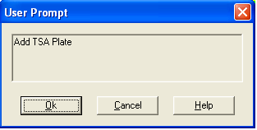

  - Obtain the TSA reagent components from the Production 4ºC.01 refrigerator. Below is a brief description of how it is prepared. (See SOP RP0033 for further details regarding the preparation of the TSA reagent). Note: Also add 4% PFA into container 4B FISH on the TECAN deck.
  - Prepare the TSA-Biotin in a 50mL conical tube. Dispense the completed TSA into a 96 deep well plate using the Rainin EDP3-Plus 1200 µL multi-tip pipette. After dispensing the TSA into the appropriate wells, seal plate and bump it down in the IEC Centra GP8 Centrifuge.
  - Add the plate to their appropriate position on the tecan deck and click “OK” in the user prompt to continue with the process. Document the completion of this task on the dFISH Production Run tracking sheet (see Table 6 for the proper deck layout of the Tecan containers).
  - After the TSA has been added, place the appropriate amount of 4% PFA on the deck. The 4% PFA will be available from Reagent Prep. Volumes may be confirmed using Table 1.
  - 20 hours and 35 minutes into the run the Tecan will once again pause and the prompt window will indicate it is time for the first Fluorescent addition, Streptavidin Fluor.
  - Prepare the Streptavidin Fluor plate before the prompt appears, degas, and bump down in the centrifuge. (See SOP RP0041Streptavidin Fluor for details on preparation).
  - Place the plate in its proper location on the Tecan Deck and press OK. Document the completion of this task as well as the time on the d-FISH Production Tracking sheet. (See Table 6 for the proper deck layout of the Tecan containers).
Add Strep. Fluor Plate(s)

  - Approximately 21 hours and 28 minutes into the d-FISH run, retrieve the Streptavidin/Biotin blocking solutions from the Production 4ºC.01 refrigerator. Pipette Streptavidin blocking solution into each well of a 96 deep-well plate as necessary. Pipette Biotin blocking solution into a second 96 deep-well plate. Degas and seal both plates. (See 8.30.1 below for details on preparation and de-gassing).
  - Bump down the plates in the centrifuge and place them into their proper location on the tecan deck. Remove the seal from the Streptavidin plate and press OK.
Add Avidin Plate

  - After the Tecan has dispensed Streptavidin blocking and the subsequent 1xPBS wash (approximately 30 minutes), it will pause and prompt the user to add the Biotin blocking solution.
  - Remove the seal from the Biotin blocking solution plate and re-place it into its correct location. Press OK. Also refill the small container of PBS.
Add Biotin Plate and Refill PBS

  - Once the Biotin begins dispensing, set a personal timer for 15 minutes.
  - At the end of the 15 minutes, add the Day 2 3%H2O2 in MeOH onto the deck. The Tecan does not pause for this addition. Wait until the tecan is on a wait timer for PBS (+) before pouring the 3%H2O2 in MeOH into its container.
  - 23 hours and 40 minutes into run the Tecan will pause and a window prompt for the addition of the second antibody, Anti-DNP HRP, will appear.
Add Anti-DNP HRP Plate(s)

  - Prepare the Anti-DNP HRP plate, degas, and bump down in the centrifuge. (See SOP RP0042 Anti-DNP HRP for details on preparation).
  - Place the plate onto the deck and press OK. Document the time of completion of this task on the dFISH Production Run Tracking sheet.
  - Following the completion of Anti-DNP HRP and its subsequent 1xTNT dispense, the Tecan will pause once again, and prompt window for TSA-DNP will appear (approx. 1 hour and 15 minutes after the addition of Anti-DNP HRP).
Add TSA-DNP Plate

  - Obtain the TSA reagent components from the Production 4ºC.01 refrigerator. Below is a brief description of how it is prepared. (See SOP RP0044 TSA-DNP for further details regarding the preparation of this TSA reagent).
  - Dispense the completed TSA-DNP into a 96 deep well plate using the Rainin EDP3-Plus 1200 µL multi-tip pipette. After dispensing the TSA into the appropriate wells, seal plate and bump it down in the IEC Centra GP8 Centrifuge.
  - Place the TSA-DNP plate onto the deck and click OK. Document the time of completion of this task on the dFISH Production Run Tracking sheet (see Table 6 for the proper deck layout of the Tecan containers).
  - An hour after the TSA-DNP is added to the slides the Tecan will pause for the final time and prompt the user for the addition of the second fluorescent, Anti-DNP Fluor. (See SOP RP0046 Anti-DNP Fluor for further details on its preparation).
Add Anti-DNP Fluor Plate(s)

  - Prepare the Anti-DNP Fluor plate, degas, and bump down in the centrifuge. Place plate in proper location, press ‘OK’ on prompt window and document on the dFISH Production Run Tracking sheet (See SOP RP0046 Anti-DNP Fluor for details on preparation).
  - While the Tecan is completing the remaining day 2 processes prepare the appropriate work area for slide disassembly.
  - Once the run has completed, document the run completion time, and remove all of the slides from the Te-Flow chambers, and pass the slides on for the disassembly process. (See SOP PF0004 for detailed instructions on flow-through chamber disassembly).

- Completion of the in situ hybridization Production Run:
  - After all the slides have been disassembled and prepared for cover slipping, remove all of the used reagent containers from the Tecan and dispose of any excess reagents in their appropriate location. Record run end time and any notes on the dFISH Production Tracking Run sheet. Note: Consult the AIBS policy on reagent disposal or storage that should be posted on the Production floor.
  - Coverslip slides according to D-FISH coverslipping SOP PF0016 FISH DAPI Staining and Coverslipping.
  - Dry the reagent containers with a Kimwipe. Remember to form a “Kimwipe mitten” around your hand to insure that your gloves don’t touch the inside of the container while drying. Important: Do NOT use a Kimwipe that has touched the outside of a container for drying the inside of it.
  - Store the empty reagent containers in their appropriate location or place back on the deck if it is necessary to start a new d-FISH run.
  - File the d-FISH run paperwork in its appropriate location.

- Reference Diagram for Reagent Placement on Tecan Deck:

Table 6 – Tecan Deck Layout dFISH VX.Y (see Appendix A)

1 | TSA Biotin / Biotin Plate/ TSA DNP |  | Probe Plate 2/ Strep-Fluor Plate 2/ Avidin Plate/ Anti-DNP Pod Plate 2/ Anti-DNP Fluor Plate 2 |  | Probe Plate 1/ Strep-Fluor Plate 1/ Anti-DNP Pod Plate 1/ Anti-DNP Fluor Plate 1 |  |  | FISH Version 1.8 Deck Configuration
7 |  |  |  |  |  |  |  | FISH Version 1.8 Deck Configuration
 |  | 5x SSC |  | Formamide I |  |  |  | FISH Version 1.8 Deck Configuration
 |  | Hyb Mix/0.1x SSC |  | Formamide II |  |  |  | FISH Version 1.8 Deck Configuration
13 |  |  |  |  |  |  |  | FISH Version 1.8 Deck Configuration
14 | Chamber Rack I |  |  |  |  |  |  | FISH Version 1.8 Deck Configuration
23 |  |  |  |  |  |  |  | FISH Version 1.8 Deck Configuration
24 | Chamber Rack II |  |  |  |  |  |  | FISH Version 1.8 Deck Configuration
33 |  |  |  |  |  |  |  | FISH Version 1.8 Deck Configuration
34 | Wash Station |  |  |  |  |  |  | FISH Version 1.8 Deck Configuration
35 | Chamber Rack III |  |  |  |  |  |  | FISH Version 1.8 Deck Configuration
44 |  |  |  |  |  |  |  | FISH Version 1.8 Deck Configuration
45 | Chamber Rack IV |  |  |  |  |  |  | FISH Version 1.8 Deck Configuration
54 |  |  |  |  |  |  |  | FISH Version 1.8 Deck Configuration
56 | PBS/TNT |  |  |  |  |  | 1/1B | FISH Version 1.8 Deck Configuration
 | maleate wash buffer |  |  |  |  |  | 2 | FISH Version 1.8 Deck Configuration
 | NTE |  |  |  |  |  | 3 | FISH Version 1.8 Deck Configuration
 | PK Buffer + Proteinase K |  | MeOH+H2O2#1/ MeOH+H₂O₂ #2 |  | 4%PFA#1/4% PFA#2 |  | 4/4B | FISH Version 1.8 Deck Configuration
 | TMN |  | HCl |  | Proteinase K Buffer |  | 5 | FISH Version 1.8 Deck Configuration
 | TNB |  | Sheep Serum |  | Iodoacetamide |  | 6 | FISH Version 1.8 Deck Configuration
 | PBS |  | anti-DIG-POD |  | Blocking Reagent (no Neutravidin) |  | 7
69

- Technical Information:
  - Avoid using corrosive reagents to clean the Tecan or any of its metal accessories.

