**Protocol for use of Vertical Modified Moore Swab (VMMS) to Isolate *Salmonella* from Surface Water**

**Supplies Needed – General**

* Geotech pump (Geotech #91352123) with EZ-Load II pump head
* Assorted lengths of Masterflex Silicone tubing, size 36
* Carboy for liquid waste collection
* Ringstand with adjustable clamps to hold cartridge
* Hose clamps, appropriate size for 36 tubing
* Sterilized graduated cylinders (500, 250 mL)
* Large Whirl-Pak® bags (Nasco #B01195)
* Sterile forceps
* 1x Universal Pre-Enrichment Broth (UPB, Acumedia #7510)
* Control strain, *Salmonella* *typhimurium* BIOBALL® Luminate (BioMerieux, #422190)

**Supplies Needed – Cartridge Assembly**

* Cheesecloth (grade #90, Lions Services, Fisher #5039511))
* 3/8” x ½” diameter Barbed Adapter Fitting (x2, Lowes #877100/NHB-300B)
* 1 ½” x ½” PVC S40 SPxFIP Bush (x2, Fergusons #P40SFBID)
* 1 ½ PVC DWV Male Adapter (x2, Fergusons #PDWVMAJ)
* 1 ½ PVC S50 SxF Adapter (x2, Fergusons #P40SFAJ)
* 2-inch piece of 1 ½” PVC 330 PSI Schedule 40 (Lowes #256098)
* Oatey for CPVC Purple Primer (Lowes/Fergusons #30756)
* Oatey Heavy Duty Clear PVC Cement (Lowes/Fergusons #30863)

**VMMS Cartridge Assembly**

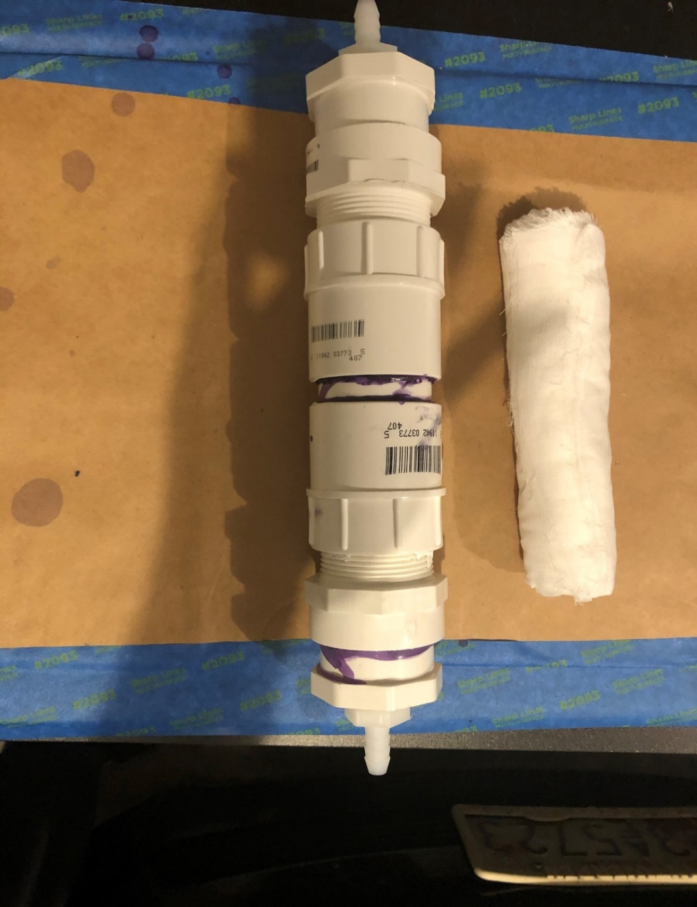

**a**

**a**

**b**

**b**

**c**

**c**

**d**

**d**

**e**

**f**

**Figure 1.** VMMS cartridge with (a) barbed adapter, (b) SPxFIP bushing, (c) male adapter, (d) SxF adapter, (e) 2” piece of PVC, and (f) rolled Modified Moore Swab.

*End piece Assembly*

**NOTE:** all work with PVC primer and cement must be done in a fume-hood or other well-ventilated area.

1. Apply Purple Primer (Oatey 30756) to ½ to ¾ in length of the bottom part of the cylindrical section of **part b (bushing,** 1 ½” x ½” PVC S40 SPxFIP Bush**).**
2. Apply purple primer to the inside, non-threaded end of **part c (male adapter,** 1 ½ PVC DWV Male Adapter**).**
3. Reapply purple primer to the bottom part of the cylindrical section of **part b (bushing)** so that it receives two coats of purple primer.
4. Apply PVC Cement to the non-threaded end of **part** **c (male adapter)** over the purple primer.
5. Apply PVC Cement to the cylindrical section of **part** **b (bushing).**
6. Reapply PVC Cement to the non-threaded end of **part** **c (male adapter)**.
7. Insert **part b (bushing)** into **part c (made adapter)** with force as far as bushing will insert. After inserting bushing, turn bushing ¼ turn to “lock” (solder) the bushing into the adapter, and leave upright to dry.
8. Repeat steps 1-7 for 2nd *End piece Assembly*.
9. Allow cement to dry overnight.

*Central Connector*

1. Apply purple primer (Oatey 30756) to up to ½ to ¾ in end of the 2-in PVC piece (**part e**)**.**
2. Apply purple primer to the non-threaded end of the SxF adapter (**part d,** 1 ½ PVC S50 SxF).
3. Apply PVC cement to non-threaded end of SxF adapter **(part d)**.
4. Apply PVC cement to 2-in PVC (**part e).**
5. Reapply a second coat of PVC cement to non-threaded end of S x F adapter **(part d).**
6. Push adapter (**part d**) on to 2-in PVC piece **(part e)** as far as it will go.
7. Using the other end of the 2-in PVC piece (**part e**), repeat steps 1-5.
8. While pushing/placing the second adapter (**part d)** on to 2-in piece **(part e),** the assembly should be vertically rested on the first SxF adapter **(part d)**.Then place the second adapter should be pushed from the top down on to 2-in piece **(part e)** (with force) until the entire *Central Connector* assemble measures 5.25 in. Adjustments to length can be made to in the first 1-2 minutes after the cement is applied.
9. Allow the whole assembly to dry in a well-ventilated space overnight.

*Barb to End piece*

1. Wrap the threads of the barbed barb **(part a)** with Teflon tape.

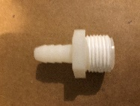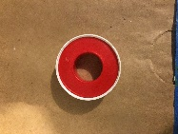

**Figure 2**. Teflon tape applied to barb.

1. Insert the barbed bard **(part a)** into the threads of the bushing **(part b)** of the entire *end piece* assembly and turn by hand (screw) until no more turns can be made.
2. Repeat for 2nd end piece.

*End piece to Central Connector*

1. Wrap threads of the male adapter (**part c)** of the *end piece assembly* with Teflon tape.

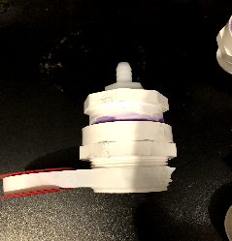

**Figure 3**. Teflon tape applied to **part c**.

1. Screw the male adapter (**part c)** into SxF adapter (**part d)** of the *central connector* assembly.
2. Repeat for second end piece.

**Prepare the VMMS Cheesecloth Filters**

1. On a large flat clean surface cut a piece of grade #90 cheesecloth to **74 cm x 92 cm**
2. Fold the cheesecloth in half by 92 cm (now 74 cm x 46 cm)
3. Fold again into thirds, so the **finished product** will be **74 cm x 16 cm**
4. **Tightly roll** the cheesecloth, along the 16-cm side.
5. Tightly roll each filter in aluminum foil and fold the ends over so that the cheesecloth doesn’t lose its shape.
6. Autoclave the foil-wrapped filters on a dry cycle.

**Disinfect the cartridges**

1. Remove (unscrew) end pieces from central connector piece.
2. Remove barbed nozzles from end pieces.
3. Unroll all Teflon tape from the threads of barbed nozzles (**part a**) and the male adapter (**part c**)
4. In a large, clean bin soak the cartridge pieces in 10% bleach overnight, making sure the bleach solution covers all parts
5. Autoclave a foil-wrapped bin that is large enough to hold all the cartridges on a dry cycle.
6. Autoclave several liters of Deionized in a carboy with a spigot attachment (you may want to wrap the spigot in foil, sterilize it separately and then screw it onto the carboy on the day of use)
7. The next day, remove the VMMS cartridge pieces **one at a time** **with gloved hands** and thoroughly rinse each piece with sterile deionized water. *Turn the carboy spigot so that the water flows slowly.*
8. **With fresh gloves**, carefully shake each piece to remove excess water and then place them in the large, sterilized bin – replacing the foil after each transfer. *The cartridges will still be slightly wet, so place the bin in a BSC to dry.*
9. Rethread Teflon tape around the threads of the barbed nozzles (**part a**) and the male adapter (**part c**).
10. Screw the bottom end piece into the central connector.
11. **With fresh gloves**, insert one of the sterile MMS into a disinfected cartridge.
12. Screw top end piece tightly.
13. Place the assembled MMS cartridge back into the sterile bin and re-cover with foil.

**Filtration Protocol**

1. Secure one of the VMMS cartridges to a support stand and adjust the height. The Cartridge will be oriented vertically with tubing attached to the barbs at the top and bottom of the cartridge (Figure 1, a).

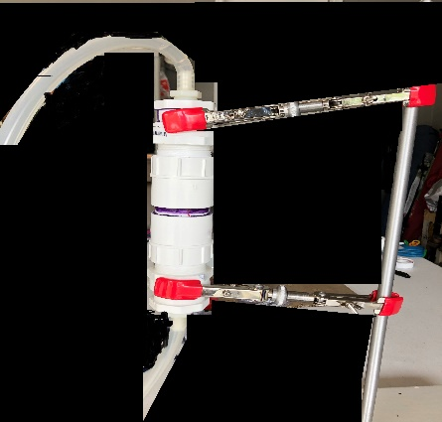

**Intake tubing attached to bottom of VMMS cartridge**

**Collection tubing attached to top of VMMS cartridge**

Figure 4. Connection of intake tubing (bottom, connected to **part a**)and collection tubing (top, **part a**) to a vertical Modified Moore Swab (VMMS) cartridge.

1. Using the Geotech pump and its accessories, place the sterilized intake tubing in the EZ Load pump head on the Geotech Pump. Then connect the outlet end of the intake sterilized hose to the bottom of the MMS cartridge over the barbed end.
2. If needed, add Control strain to 1L surface water sample by gently tipping vial over the opening. Close sample bottle tightly and thoroughly mix sample before proceeding.
3. Place the inlet end of the intake tubing into the 1 L bottle containing surface water.
4. Connect collection tubing to the top of the MMS cartridge and place the outlet end in a collection container. Use a collection container sufficient to hold up to 1 L of filtrate.
5. Turn the pump on and set the pump rate to 3/4 of maximum flow rate (use the dial). Once water is flowing into tube, then you can slow the pump speed by 5 “clicks” (turn to the left) to maintain a constant flow.
6. After 1 L has been pumped through the tubing, turn the pump off.
7. Position the waste container (containing a 10% bleach solution) underneath the MMS cartridge on the support stand and carefully disconnect the collection tubing from the top of MMS cartridge to retrieve the MMS. Allow water in collection tubing to drain to collection vessel.
8. Place the collection tubing into the waste container and let sit for at least 30 mins.
9. Remove (Unscrew) the top piece (male adapter with barb) of the MMS cartridge from the central connector and carefully place it in the waste container as well.
10. Using sterile forceps aseptically transfer the MMS filter into its pre-labelled 55 oz Whirl-Pak® bag and place the forceps in the waste container.
11. Carefully disconnect the intake tubing and place both the intake tubing and the cartridge in the waste container
12. Using a sterile graduated cylinder, add 100 mL 1 X UPB into each Whirl-Pak® sample bag containing a MMS.
13. Massage entire length of MMS in UPB for 1 min and incubate at 37°C for 18-24 h.

For next steps, refer to “Selective Enrichment Protocol for *Salmonella* Isolation from Surface Water”.