A protocol for computerized quantitative analysis of nerve fibers, mast cells, enteric glial cells and the proximity of mast cells to the nerve fibers in 3D Images of human sigmoid mucosal biopsies
Abstract
This protocol describes a step-by-step computational workflow that we developed by adapting Imaris 9.7-9.9 Surfaces Rendering Technology (https://imaris.oxinst.com/products/imaris-for-neuroscientists) to perform the quantitative analysis of nerve fibers, enteric glial and immune cells in 3D images of human sigmoid mucosal biopsies, as well as to assess the proximity of mast cells to the nerve fibers which cannot be easily portrayed and precisely measured with 2D images. The volumes of surface-masked nerve fibers and enteric glial cells, the numbers of spotted mast cells and the shortest distances of the centers of each individual spot to the surfaces of nerve fibers in 3D images were automatically computed and plotted correspondently with Imaris 9.7-9.9. This computerized protocol not only reduces the biases due to observer/examiner judgment and overcomes limitations of 2D images, but also is much faster than measuring manually and allows us to quantitate a larger number of samples, increasing statistical accuracy. The parameters created in this protocol also provide efficient reference for us to apply the New AI Machine Learning Segmentation implemented into Imaris 10.1 recently for our quantitative analysis of large datasets. The study using this protocol is relevant to the underlying peripheral mechanisms of visceral pain in irritable bowel syndrome.
Protocol
- Open Imaris 9.7, click ‘Arena’ < ‘Observe Folder’ to find the location of the image files.
- In ‘Observe Folder’, double click the images that need to be analyzed. Imaris software automatically reconstructs z-stack images into 3D images and transfers the original format of .lsm to .ims format. Open the images with .ims format.
- Add a new surface (Surfaces 1) by clicking the ‘Surfaces’ icon.
- Select “Reset all Channels” through the Display Adjustment function. Then go to the next step.
- Choose the channels corresponding to the fluorescence (Red for nerve fibers and enteric glial cells, and Green for mast cells) from a drop-down menu in ‘Source Channel’.
- Set up the threshold by selecting ‘Background Subtraction (Local Contrast)’ and then set the ‘diameter of largest sphere which fits into the object’, whose value is the diameter of the finest fiber.
- Measure the diameter of finest fibers in ‘Slice’ view. Find the finest fiber and zoom in by scrolling up. Click two edges of the fiber and the diameter of the fiber is shown on upper right of the screen. Enter the diameter and turn off the button “slicer rendering” for selected object. The button is located on the upper right of ‘Source Channel’ panel.
- Adjust ‘Threshold (Absolute Intensity)’ to highlight the fibers of interest. Carefully choose the threshold and make sure the thickness of the highlighted fibers is similar to the original.
- Skip the next step “Classification” and click the button “Finish: Execute all creation steps and terminate the wizard”.
- Click the button “color” and un-select ‘Class A’ and ‘Class B’ under “Set 1”. Rotate the 3D View to find the layers where there are weak fluorescent signals (fewer highlighted fibers). Choose “Edit” menu and input numbers of these layers. Select “Delete Slices” to delete them.
- Click the button “Creation” and then click “Surfaces” to recompute the surfaces by following the procedures as mentioned above. No need to adjust ‘Threshold (Absolute Intensity)’ (Step 8) because the software already remembers the settings.
- Delete undesired areas that are highlighted (such as fluorescent residues and tissue debris) using the pointer selection mode or circle selection mode. These modes can be found on the upper right of the screen. If some undesired areas are connected with the area of interest, click ‘Cut Surface’ to delete the undesired highlighted surfaces.
- When finished, click ‘Statistics’ icon and choose ‘Detailed’ < ‘Average Values’ to find the sum of fiber volume.
- Add a new surface (Surfaces 2) and choose the ‘Skip automatic creation, edit manually’ algorithm to manually construct contours representative of the areas of mucosa.
- Choose the red channel by controlling the channel visibility and adjust minimum and maximum Intensity Range through the Display Adjustment function. Ideally, maximized the Intensity Range until epithelium layers show up.
- Choose “Contour” button under “Draw” category and press the “Draw” button. Adjust slice position to draw the representative contours. Be sure not to include the submucosal areas. Usually three slice positions are selected (beginning, middle and ending). In each position, draw the area of mucosa (closed regions). After drawing the three contours, click ‘Create Surface’.
- Click ‘Statistics’ icon and choose ‘Detailed’ < ‘Average Values’ to get the sum of the volume of the mucosa.
- Add a new spot (Spots 1) by clicking the ‘Spots’ icon and use the ‘Skip automatic creation, edit manually’ algorithm to manually pick up the mast cells.
- Choose “Auto-depth placement based on” “specific Channel” and select the Green channel for mast cells from a drop-down menu. Do left click + Shift to add the spots in the center of mast cells. Scroll up or down to change the size of spots (the size of spots does not affect the statistics).
- When finished, click ‘Statistics’ icon and choose ‘Overall’ to find the number of spots (number of mast cells).
- The densities of nerve fibers and enteric glial cells were calculated and expressed as percentage of their volumes in the contoured mucosa volumes (v/v, %). The density of mast cells was expressed as the numbers of mast cells per unit of the contoured mucosa volume (No. of mast cells/mm³)
- Measure the shortest distance from mast cells to fibers by selecting “Spots 1” and click ‘Filter’ icon. Click ‘Add’ under ‘Filters’ and choose ‘Shortest Distance to Surfaces Surfaces = Surfaces 1’ under ‘Filter Type’.
- Adjust the ‘lower threshold’ to make sure all the spots (100%) are selected. Then click ‘Duplicate Selection to new Spots’ to generate Spots 1 Selection [“Shortest Distance to Surfaces Surfaces = Surfaces 1”].
- When finished, click ‘Statistics’ icon and choose ‘Detailed’ < ‘Specific Values’ and select Shortest Distance to Surfaces Surfaces = Surfaces 1” from a drop-down menu.
- Click “Export Statistics on Tab Display to File” on the right of the bottom of the Statistics panel to export the measures to excel worksheet.
- A shortest distance with values equal or less than 5.2 µm was defined as the contact to nerve fibers. This is on the basis of the sizes of human colonic mucosal MCs measured in this study with an average diameter 10.4 µm.
- Sum up the total number of spots and the spots with Shortest Distance to Surfaces 1 <= 5.2 μm.
- The proximity of mast cells to the nerve fibers was expressed as percentage of mast cells with contact to nerve fibers in the total mast cells (%)
- The 5-6 3D images generated from each biopsy and immunostained with each marker antibody were used for the quantitative analysis.

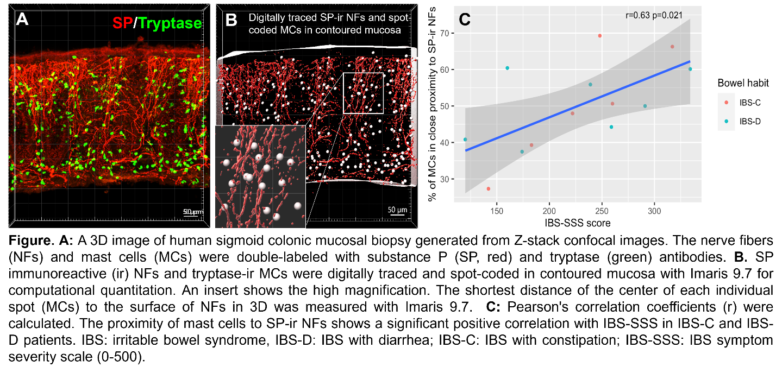
Figure

