**Protoplast luminescence deconvolution and plotting via Python script**

**Input:** Excel (.xlsx) spreadsheet of results, saved in a folder called ‘ResultsSheets’ with the following column headings. Enter one sample for each row.

1. transfection_date
2. cultivar
3. tube_no
4. Reporter
5. Normalisation
6. Avr_R
7. hrs_incubation
8. raw_RLU_nofilter
9. raw_RLU_GREEN
10. raw_RLU_RED

Copy ADA_plotting_script.py to a folder, then open command-line terminal

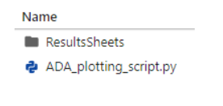

To see all options:

python ADA_plotting_script.py -h  
  
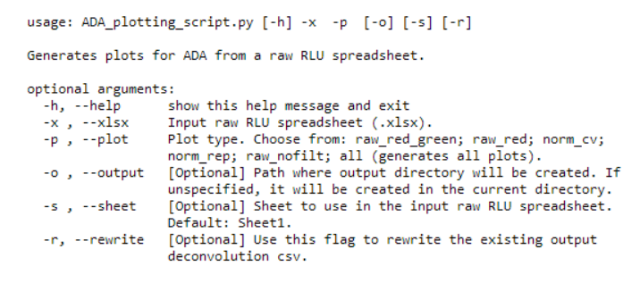

**Basic usage:**

python ADA_plotting_script.py**-x** ResultsSheets/20220629_Results_pD15,pD16_AvrSr27_BD.xlsx**-p**raw_red

Output dir (named 20220629_Results_pD15,pD16_AvrSr27_BD) will be created in the current directory, and contains

* Deconvolution CSV
* Raw red plot

**-p all** can be used to generate all five types of plots in one go.

**-o** **<path>** is optional, for directing output directory to another path.  
If **-o foo/bar** is used then foo/bar/20220629_Results_pD15,pD16_AvrSr27_BD/... will be created.

**-s** is optional just in case a different sheet name is used in the supplied raw input xlsx.

Once the deconvolution CSV is created it will be reused for other plot types, so it doesn't generate a new one every time we run the script.  
If we want to rewrite the existing csv use**-r** to enable.

**Notes:**

Constants R, G, Rrf, Grf, Rgf, Ggf may vary according to the plate reader used. Callibrate for each machine using directions in Promega Chroma-Glo™ Luciferase Assay System Technical Manual (Product numbers E4910, E4920, E4950).