Spinal manipulations for migraine: a protocol for an updated systematic review of randomized clinical trials

Background
Migraine affects more than one billion individuals worldwide ¹ and the global prevalence rate of the condition is estimated at 14% ². The prevalence of migraineurs in general populations ranges in different countries e.g., from 6% in South Korea to 22.4% in Belgium . The Global Burden of Disease (GBD) Study 2019, estimated migraine to be the second most common cause of disability, and the leading cause of disability-adjusted life years (DALYs) in young women ⁴. Migraine is associated with a significant suffering such as severe headache and autonomic nervous system dysfunction, medical and psychiatric comorbidities, increased health care resource use, and poor health-related quality of life ⁵. Several risk factors of this complex neurobiological disorder have been identified including hormonal imbalances (estrogen or cortisol dysregulation), female gender, obesity, head trauma, genetic factors, anxiety disorders, chronic stress, environmental and dietary factors . The pathophysiology of migraine is multidimensional and may involve the trigeminovascular system and brainstem nuclei, the hypothalamus, the thalamus, and the cortex . Adenosine signaling, high-conductance calcium-activated potassium channels, ¹¹⁻¹³ calcitonin gene-related peptide (CGRP), pituitary adenylate cyclase activating polypeptide (PACAP)¹⁶ or endothelin have all been implicated in the pathogenesis .

Spinal manipulative therapy (SMT) is a manual treatment often practiced by allied health professions including physiotherapists, chiropractors, and osteopaths. It is based on the assumption that, by correcting misalignments of the spinal joints, many conditions, including migraine, can be treated effectively. However, biological plausibility, effectiveness, and cost-effectiveness of SMT are doubtful . In addition, several hundred severe complications after upper SMT have been reported including carotid or vertebral artery dissections, strokes and deaths ²¹⁻²⁴.

Several new trials have been published ²⁵⁻²⁷ since our previous systematic review (SR) was published²⁸. Therefore, this article is aimed at updating the evidence base for the effectiveness of SMT for migraine.

Methods
Search Strategy and Data Sources
An update searche will be performed in the following electronic databases: Amed, Embase, Medline, CINAHL, Mantis, Index to Chiropractic Literature, and Central (from their respective inceptions) using the exact same search terms that had previously been constructed over two concepts: SMT and migraine headache (without any methodological filters). In addition, bibliographies of all thus identified studies and relevant SRs will be scanned for any relevant papers. We will search for English language papers but considered studies published in any language.
Data Selection, Extraction, and Management
The search results from those databases will be combined in a single EndNote (20.1) library, and duplicate records of the same reports will be removed. Titles and abstracts identified through the electronic database searching will be screened by one reviewer (PP) and validated by another (EE). During that initial stage, any references which obviously did not meet the inclusion criteria of the review will be excluded. Full papers will be obtained for all the potentially relevant references; and will be examined in detail to determine whether they meet the criteria for inclusion. Again, this will be done by one reviewer (PP) and validated by another (EE). With respect to both screening stages, any discrepancies between reviewers will be resolved through a consensus. The selection of studies will be reported in accordance with the Preferred Reporting Items for Systematic Reviews and Meta-Analyses (PRISMA) guidelines ²⁹.
The types of data that will be extracted included details of the study design, populations, treatments, comparators, outcome measures and results. Data extraction will be performed by one reviewer (PP) and validated by another (EE). Wherever feasible, we will attempt to obtain missing data from the original authors; when SDs of continuous outcome data are missing, we will calculate them from other statistics, such as 95% CIs, standard errors, or P values.
Eligibility criteria
In this update, we will apply the same inclusion and exclusion criteria i.e., randomized or quasi-randomized trials, testing the effectiveness of SMT in migraine in human subjects. Any type of controls and outcome measures will be permissible. We will exclude participants suffering from cervicogenic or tension type headaches, as well as observational studies or trials of e.g., gentle soft tissue mobilizations. Primary outcomes will consist of pain intensity/severity, migraine duration, number of migraine days, disability, quality of life and adverse effects at follow-ups of up to 12 months. The original data extraction form will be used to collect the data. One reviewer will perform data extractions (PP), and another (EE) will validate the entries. Any disagreements will be resolved through a consensus.
Risk of bias assessment
As the Jadad scale is now considered obsolete, we will use the Cochrane Risk of Bias tool to assess the methodological risk of bias of all reviewed studies. The Cochrane Handbook for Systematic Reviews of Interventions recommends explicitly reporting the following individual elements for RCTs: random sequence generation; allocation concealment; blinding (participants, personnel); blinding (outcome assessment); completeness of outcome data (attrition bias), selective outcome reporting (relevant outcomes reported); other sources of bias (baseline imbalances) ³⁰.
Data Synthesis
Where studies are homogeneous enough in terms of populations, interventions, comparators, outcomes, and study designs, we will pool them quantitatively in a meta-analysis. For studies that assessed the same continuous outcomes, we will estimate standardized mean differences (for different scales) between groups, along with 95% CIs. For dichotomous outcomes, risk ratios will be estimated along with 95% CIs. The results of meta-analyses will be displayed in forest plots which provide effect estimates and 95% CIs for each individual study as well as a pooled effect estimates and 95% CI. We will combine results of studies that reported uniform and comparable timing of outcome assessment. All meta-analyses will be performed using RevMan 5.4 (desktop version); and adhering to the statistical guidelines described in the Cochrane Handbook, 2022³¹. We will use Generic Inverse Variance method where applicable. A random-effects model will be chosen as it provides a more conservative estimate of effect. We will assess heterogeneity through a visual inspection of the overlap of forest plots and by calculating the Chi-squared, Tau-squared tests and I² inconsistency statistics. For pooling, if more than one intervention arm was relevant for a single comparison, we will compare the relevant SMT arm with the least active control arm to avoid double‐counting of data. We will perform subgroup analyses by the types of intervention i.e., osteopathic versus chiropractic SMT.
References:

1. Amiri P, Kazeminasab S, Nejadghaderi SA, et al. Migraine: A Review on Its History, Global Epidemiology, Risk Factors, and Comorbidities. Front Neurol. 2021;12:800605.
2. Safiri S, Pourfathi H, Eagan A, et al. Global, regional, and national burden of migraine in 204 countries and territories, 1990 to 2019. Pain. Feb 1 2022;163(2):e293-e309.
3. Kim KM, Cho SJ, Shin HJ, et al. Prevalence, Disability, and Management Patterns of Migraine in Korea: Nationwide Survey Data from 2009 and 2018. J Clin Neurol. Jan 2021;17(1):77-85.
4. Steiner TJ, Stovner LJ, Jensen R, Uluduz D, Katsarava Z, on behalf of Lifting The Burden: the Global Campaign against H. Migraine remains second among the world’s causes of disability, and first among young women: findings from GBD2019. The Journal of Headache and Pain. 2020/12/02 2020;21(1):137.
5. Burch RC, Buse DC, Lipton RB. Migraine: Epidemiology, Burden, and Comorbidity. Neurol Clin. Nov 2019;37(4):631-649.
6. Bigal ME, Lipton RB. Modifiable risk factors for migraine progression. Headache. Oct 2006;46(9):1334-43.
7. Charles A, Brennan KC. The neurobiology of migraine. Handb Clin Neurol. 2010;97:99-108.
8. Goadsby PJ, Charbit AR, Andreou AP, Akerman S, Holland PR. Neurobiology of migraine. Neuroscience. Jun 30 2009;161(2):327-41.
9. Puledda F, Silva EM, Suwanlaong K, Goadsby PJ. Migraine: from pathophysiology to treatment. J Neurol. Jul 2023;270(7):3654-3666.
10. Gross EC, Lisicki M, Fischer D, Sandor PS, Schoenen J. The metabolic face of migraine - from pathophysiology to treatment. Nat Rev Neurol. Nov 2019;15(11):627-643.
11. Al-Karagholi MA, Hakbilen CC, Ashina M. The role of high-conductance calcium-activated potassium channel in headache and migraine pathophysiology. Basic Clin Pharmacol Toxicol. Nov 2022;131(5):347-354.
12. Kokoti L, Al-Karagholi MA, Ashina M. Latest Insights into the Pathophysiology of Migraine: the ATP-Sensitive Potassium Channels. Curr Pain Headache Rep. Dec 3 2020;24(12):77.
13. Lengyel M, Hajdu D, Dobolyi A, et al. TRESK background potassium channel modifies the TRPV1-mediated nociceptor excitability in sensory neurons. Cephalalgia. Jun 2021;41(7):827-838.
14. Summ O, Charbit AR, Andreou AP, Goadsby PJ. Modulation of nocioceptive transmission with calcitonin gene-related peptide receptor antagonists in the thalamus. Brain. Sep 2010;133(9):2540-8.
15. Santos-Lasaosa S, Belvis R, Cuadrado ML, et al. Calcitonin gene-related peptide in migraine: from pathophysiology to treatment. Neurologia (Engl Ed). Jun 2022;37(5):390-402.
16. Zagami AS, Edvinsson L, Goadsby PJ. Pituitary adenylate cyclase activating polypeptide and migraine. Ann Clin Transl Neurol. Dec 2014;1(12):1036-40.
17. Thuraiaiyah J, Kokoti L, Al-Karagholi MA, Ashina M. Involvement of adenosine signaling pathway in migraine pathophysiology: A systematic review of clinical studies. Cephalalgia. Jul 2022;42(8):781-792.
18. Forland-Schill A, Berring-Uldum A, Debes NM. Migraine Pathophysiology in Children and Adolescents: A Review of the Literature. J Child Neurol. Jun 2022;37(7):642-651.
19. Mirtz TA, Morgan L, Wyatt LH, Greene L. An epidemiological examination of the subluxation construct using Hill's criteria of causation. Chiropr Osteopat. Dec 2 2009;17:13.
20. Vautravers P, Maigne JY. [Cervical spine manipulation: risks--benefit--assessment]. Rev Neurol (Paris). Nov 2003;159(11):1064-6.
21. Smith WS, Johnston SC, Skalabrin EJ, et al. Spinal manipulative therapy is an independent risk factor for vertebral artery dissection. Neurology. May 13 2003;60(9):1424-8.
22. Ernst E. Deaths after chiropractic: a review of published cases. Int J Clin Pract. Jul 2010;64(8):1162-5.
23. John S, Tavee J. Bilateral diaphragmatic paralysis due to cervical chiropractic manipulation. Neurologist. Feb 2015;19(3):65-7.
24. Rothwell DM, Bondy SJ, Williams JI. Chiropractic manipulation and stroke: a population-based case-control study. Stroke. May 2001;32(5):1054-60.
25. Rist PM, Bernstein C, Kowalski M, et al. Multimodal chiropractic care for migraine: A pilot randomized controlled trial. Cephalalgia. Mar 2021;41(3):318-328.
26. Munoz-Gomez E, Ingles M, Serra-Ano P, Espi-Lopez GV. Effectiveness of a manual therapy protocol based on articulatory techniques in migraine patients. A randomized controlled trial. Musculoskelet Sci Pract. Aug 2021;54:102386.
27. Chaibi A, Benth JS, Tuchin PJ, Russell MB. Chiropractic spinal manipulative therapy for migraine: a three-armed, single-blinded, placebo, randomized controlled trial. Eur J Neurol. Jan 2017;24(1):143-153.
28. Posadzki P, Ernst E. Spinal manipulations for the treatment of migraine: a systematic review of randomized clinical trials. Cephalalgia. Jun 2011;31(8):964-70.
29. Page MJ, McKenzie JE, Bossuyt PM, et al. The PRISMA 2020 statement: an updated guideline for reporting systematic reviews. BMJ. Mar 29 2021;372:n71.
30. Higgins J, Thomas J, Chandler J, et al. Cochrane handbook for systematic reviews of interventions version 6.2 (updated February 2021) [Internet]. 2021 [accessed 6.8.21]. https://training.cochrane.org/handbook
31. Higgins JPT TJ, Chandler J, Cumpston M, Li T, Page MJ, Welch VA (editors). . Cochrane Handbook for Systematic Reviews of Interventions version 6.3 (updated February 2022). Cochrane, 2022. Available from www.training.cochrane.org/handbook.
32. Nelson CF, Bronfort G, Evans R, Boline P, Goldsmith C, Anderson AV. The efficacy of spinal manipulation, amitriptyline and the combination of both therapies for the prophylaxis of migraine headache. J Manipulative Physiol Ther. Oct 1998;21(8):511-9.
33. Tuchin PJ. The efficacy of chiropractic spinal manipulative therapy (SMT) in the treatment of migraine. A pilot study. Australas Chiropr Osteopathy. Jul 1997;6(2):41-7.
34. Parker GB, Tupling H, Pryor DS. A controlled trial of cervical manipulation of migraine. Aust N Z J Med. Dec 1978;8(6):589-93.
35. Rist PM, Hernandez A, Bernstein C, et al. The Impact of Spinal Manipulation on Migraine Pain and Disability: A Systematic Review and Meta-Analysis. Headache. Apr 2019;59(4):532-542.
36. Cerritelli F, Ginevri L, Messi G, et al. Clinical effectiveness of osteopathic treatment in chronic migraine: 3-Armed randomized controlled trial. Complement Ther Med. Apr 2015;23(2):149-56.
37. Voigt K, Liebnitzky J, Burmeister U, et al. Efficacy of osteopathic manipulative treatment of female patients with migraine: results of a randomized controlled trial. J Altern Complement Med. Mar 2011;17(3):225-30.
38. Garner P, Hopewell S, Chandler J, et al. When and how to update systematic reviews: consensus and checklist. Bmj. Jul 20 2016;354:i3507.
Table 1. Randomized controlled studies of spinal manipulations for the treatment of migraines
First author  (Year) [reference] | Study design | Participants (n) | Experimental intervention (details see Tab 3) | Control intervention | Primary outcome measure | Main result | Comment
Chaibi (2017) ²⁷ | Single blind, sham- controlled RCT with 3 parallel groups | 104 migraineurs | SMT | (i) sham  (ii) pharmacotherapy | (i) migraine days per month  (ii) duration  (iii) intensity  (iv) Headache Index | (i) a. mean (SD) 3.9 (3.1) vs 4.1 (5.7) (p=0.20) at post-intervention  b. 4.5 (3.6) vs 4.6 (5.7) (p=0.39) at 3 months follow-up  c. 4.1 (3.9) vs 5.1 (6.4) (p=0.65) at 6 months follow-up  d. 4.4 (4.2) vs 4.1 (6.0) (p=0.85) at 12 months follow-up  (ii) a. 9.2 (5.8) vs 10.4 (7.0) (p=0.04) at post-intervention  b. 9.5 (6.9) vs 10.6 (7.2) (p=0.06) at 3 months follow-up  c. 7.3 (7.1) vs 11.6 (7.4) (p=0.12) at 6 months follow-up  d. 8.1 (7.3) vs 8.9 (7.7) (p=0.34) at 12 months follow-up  (iii) a. 4.7 (2.8) vs 5.0 (3.0) (p=0.27) at post-intervention  b. 5.0 (3.0) vs 4.9 (2.8) (p=0.46) at 3 months follow-up  c. 4.4 (3.6) vs 5.2 (2.9) (p=0.69) at 6 months follow-up  d. 5.1 (3.5) vs 4.4 (3.2) (p=0.97) at 12 months follow-up  (iv) a. 295.5 (348.1) vs 330.1 (602.3) (p=0.16) at post-intervention  b. 338.0 (350.8) vs 399.6 (582.0) (p=0.32) at 3 months follow-up  c. 313.0 (395.6) vs 402.8 (595.1) (p=0.56) at 6 months follow-up  d. 350.8 (451.6) vs 322.9 (668.8) (p=0.92) at 12 months follow-up | Blinding successfully achieved in >80% of patients
Munoz-Gomez (2021) ²⁶ | Single blind, sham- controlled RCT with 2 parallel groups | 50 migraineurs | OMT | (i) sham | (i) intensity  (ii) frequency  (iii) disability  (iv) QoL | (i) a. mean (SD) 6.4 (1.0) vs 7.9 (1.1) at 1 month (p<0.001)  b. 6.5 (1.0) vs 7.6 (0.9) at 2 months (p<0.001)  (ii) a. 22.0 (10.9) vs 23.2 (8.9) at 1 month (MD= 1.2; 95% CI - 4.5 to 6.8)  b. 20.6 (10.3) vs 23.4 (8.6) at 2 months (MD= 2.8; 95% CI – 2.6 to 8.2)  (iii) a. 30.2 (18.1) vs 33.9 (13.9) at 1 month (MD= 3.7; 95% CI –5.5 to 12.9)  b. 24.3 (14.2) vs 34.3 (14.6) at 2 months (MD= 10.0; 95% CI 1.8 to 18.2; p<0.05)  (iv) a. 66.9 (15.0) vs 57.7 (15.8) at 1 month (MD =-9.3; 95% CI -18.0 to -0.5; p<0.05)  b. 66.3 (21.1) vs 58.3 (14.9) at 2 months (MD =-8.0; 95% CI -18.4 to 2.4; n.s.) | Relatively well designed and reported study
Nelson (1998) ³² | Quasi RCT with 3 parallel groups | 218 patients with migraine | SMT | (i) drug therapy (amitriptyline)  (ii) SMT + amitriptyline | (i) Headache index  (ii) severity  (iii) frequency  (iv) medication use | (i) a. mean (SD) 11.1 (5.6) vs 8.4 (9.0) at post-treatment  b. 10.8 (9.6) vs 12.5 (8.3) at 1month  (ii) a. 4.3 (1.5) vs 4.3 (1.6) at post-treatment  b. 4.4 (1.7) vs 4.5 (1.3) at 1month  (iii) a. 37.5 (25.9) vs 26.8 (22.6) at post-treatment  b. 36.9 (29.3) vs 40.5 (23.3) at 1month  (iv) a. 1.2 (1.2) vs 0.7 (0.9) at post-treatment  b. 1.2 (1.2) vs 1.3 (1.3) at 1month | Manipulation group received more attention (14 visits) compared to max. of 3 visits for drug therapy group
Parker (1978) ³⁴ | Quasi RCT with 3 parallel groups | 85 migraine patients | (i) SMT by chiropractor  (ii) SMT by medical practitioner or physiotherapist | Mobilization | (i) frequency of attacks  (ii) duration of headaches (hours)  (iii) disability  (iv) VAS for pain intensity | (i) mean=5.1 vs 5.7 .  (ii) 19.4 vs 11.9  (iii) 1.8 vs 2.2  (iv) 2.8 vs 4.5 | (i) lack of randomization,  (ii) lack of control for placebo effects
Rist (2021) ²⁵ | RCT with 2 groups | 61 females with episodic migraines | SMT + UC | UC alone | (i) migraine days  (ii) severity  (iii) duration  (iv) disability (MIDAS)  (v) (acute) medication use  (vi) QoL (emotional) | (i) a. mean change = -1.92; 95% CIs -3.46 to -0.37) at weeks 11-14  b. -1.71; 95% CI -3.26 to -0.16 at weeks 15-18  (ii) a. -0.85 (-1.77 to 0.06) at weeks 11-14  b. -0.64 (-1.65 to 0.38) at weeks 15-18  (iii) a. -1.48 (-3.44 to 0.48) at weeks 11-14  b. 0.31 (-1.96 to 2.57) at weeks 15-18  (iv) a. -5.58 (-10.44 to -0.72) at weeks 11-14  b. -9.45 (-17.47 to -1.43) at weeks 15-18  (v) a. -1.36 (-3.48 to 0.76) at weeks 11-14  b. -0.83 (-3.20 to 1.53) at weeks 15-18  (vi) a. 3.60 (-1.10 to 8.30) at weeks 11-14  b. 6.57 (2.78 to 10.36) at weeks 15-18
Tuchin (2000) ³³ | Quasi RCT with 2 groups | 127 volunteers | SMT | Placebo (detuned interferential therapy) | (i) frequency  (ii) intensity  (iii) duration  (iv) disability  (v) medication use | (i) mean (SD)= 4.1 (6.55) vs 6.9 (6.6) (p<0.005)  (ii) 6.9 (1.8) vs 6.2 (1.7) n.s.  (iii) 14.8 (19.8) vs 19.8 (17.7) (p<0.01)  (iv) 13.0 (18.2) vs 15.6 (18.2) (p<0.05)  (v) 9.8 (12.4) vs 16.2 (12.4) (p<0.001) | (i) unequal distribution of patients into groups,  (ii) unjustified blinding  (iii) the use of placebo not credible

Table 1 Legend: CI = confidence interval; MD = mean difference; MIDAS= Migraine Disability Assessment; n.s. = No significant between-group differences at post intervention (unless otherwise specified); OMT= osteopathic manipulative therapy; QoL=quality of life; SD = standard deviation; SMT=spinal manipulative therapy; VAS= visual analogue scale.

Table 2. Adverse effects (AEs) reported in RCTs
Study (year) | Details of adverse effects reported
Chaibi (2017) ²⁷ | Adverse effects were significantly more frequent in the SMT than the placebo intervention sessions (83/355 vs. 32/348; P < 0.001
Munoz-Gomez (2021) ²⁶ | No serious reported
Nelson (1998) ³² | No info provided
Parker (1978) ³⁴ | Chiropractic group were more likely to complain of side effects such as neck pain and soreness (P<0.005).
Rist (2021) ²⁵ | Almost twice the amount of overall AEs in the SMT+UC versus UC alone 52% versus 34%
Tuchin (2000) ³³ | None reported
Table 2 Legend: SMT = spinal manipulative therapy; UC = usual care
Table 3 Details of the spinal manipulation intervention
Study (year) | Details of the chiropractic intervention (direct quote where applicable)
Chaibi (2017) ²⁷ | “SMT group received spinal manipulative therapy using the Gonstead method, a specific contact, high-velocity, low-amplitude, short-lever spinal with no post-adjustment recoil that was directed to spinal biomechanical dysfunction (full spine approach) as diagnosed by standard chiropractic tests at each individual treatment session”
Munoz-Gomez (2021) ²⁶ | “low velocity and moderate to high amplitude movements were conducted on the neck and upper-trunk joints and sacroiliac joints to force their full range of motion. Specifically, the following techniques were applied bilaterally in all treatment sessions (Dunning et al., 2016): occiput-atlas-axis articulatory manipulation, upper cervical spine (C0–C1) mobilization, middle cervical spine (C2–C7) mobilization in supine, middle cervical spine (C2–C7) mobilization in prone, cervicothoracic junction articulatory manipulation, upper thoracic spine (T2-T6) articulatory manipulation and global sacroiliac joint articulatory manipulation.”
Nelson (1998) ³² | Spinal manipulation 14 times over 8 weeks (no more than 2 times per week)— preceded by 5–10 min of massage and/or trigger point therapy
Parker (1978) ³⁴ | “ (…) the chiropractors were required to manipulate the cervical spine. […] “The chiropractors were free to manipulate other parts of the spine on members of this group”. Frequency: no more than twice weekly for 2 months.
Rist (2021) ²⁵ | “All treatments applied in this study were within the scope of chiropractic practice in the Commonwealth of Massachusetts and included: posture correction and spinal stabilization exercises, soft tissue relaxation/release techniques, spinal manipulation and joint mobilization, relaxation techniques, education, stretches, and ergonomic modifications”
Tuchin (2000) ³³ | “Two months of chiropractic SMT (diversified technique) at vertebral fixations determined by the practitioner (maximum of 16 treatments).”
Table 4 Summary of findings for the review’s main comparison

SMT with or without usual care compared to (least active) control for the treatment of migraines
Patient or population: Migraineurs (all types)
Setting: Secondary care
Intervention: SMT (with or without usual care)
Comparison: (least active) control
Outcomes | № of participants  (studies)  Follow-up | Certainty of the evidence  (GRADE) | Relative effect  (95% CI) | Anticipated absolute effects
 |  |  |  | Risk with (least active) control | Risk difference with SMT
Migraine days post-treatment | 472  (4 RCTs) | ⨁◯◯◯  Very low^{a,b,c} | - | - | SMD 0.24 lower  (0.47 lower to 0.02 lower)
Migraine duration post-treatment | 312  (4 RCTs) | ⨁◯◯◯  Very low^{a,b,c} | - | - | SMD 0.11 lower  (0.33 lower to 0.12 higher)
Intensity/severity post-treatment: measured with VAS scales | 509  (6 RCTs) | ⨁◯◯◯  Very low^{a,b,c,d} | - | - | SMD 0.22 SD lower  (0.65 lower to 0.21 higher)
Disability: measured with MIDAS | 234  (3 RCTs) | ⨁◯◯◯  Very low^{a,b,c} | - | - | SMD 0.27 lower  (0.54 lower to 0.01 lower)
Emotional QOL: measured with SF-36 | 111  (2 RCTs) | ⨁◯◯◯  Very low^{a,b,e} | - | - | SMD 14.47 lower  (31.61 lower to 2.68 higher)
Adverse effects | 764  (2 RCTs) | ⨁◯◯◯  Very low^{a,b,c,d} | RR 2.06  (1.24 to 3.41) | 113 per 1,000 | 208 more per 1,000  (102 more to 368 more)
CI: confidence interval; MIDAS: Migraine Disability Assessment; QOL: quality of life; RCT: randomized controlled trial; RR: risk ratio; SF-36: short form 36 questionnaire; SMD: standardized mean difference; SMT: spinal manipulative therapy; VAS: visual analogue scale
GRADE Working Group grades of evidence
Very low certainty: we have very little confidence in the effect estimate: the true effect is likely to be substantially different from the estimate of effect.
a. Unclear or high risk of bias of the included studies.
b. Clinical and methodological heterogeneity in terms of population, intervention, comparator.
c. Wide confidence intervals around the effect estimate.
d. Significant statistical heterogeneity detected.
e. Very small sample size; wide confidence intervals around the effect estimate.

List of figures

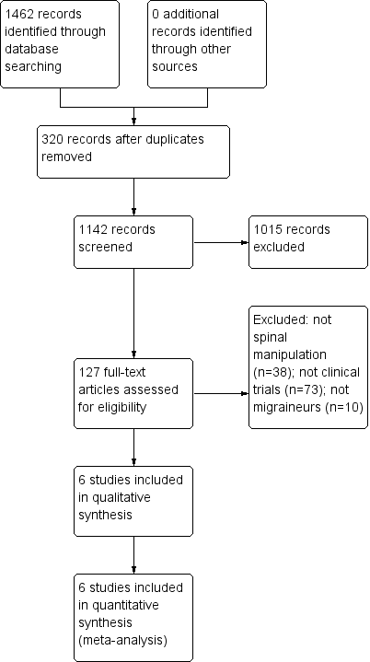
Figure 1: PRISMA flowchart of eligibility assessment and inclusion

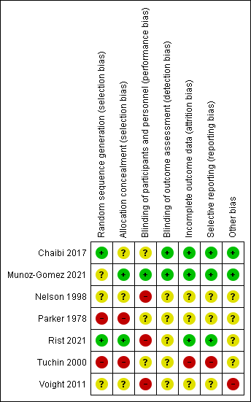
Figure 2: Risk of bias summary: review authors' judgements about each risk of bias item for each included study.
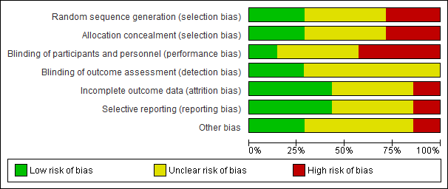
Figure 3: Risk of bias graph: review authors' judgements about each risk of bias item presented as percentages across all included studies.

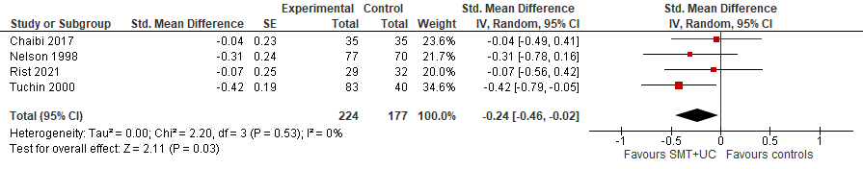

Figure 4: SMT versus controls: Outcome: Number of migraine days (post-treatment)

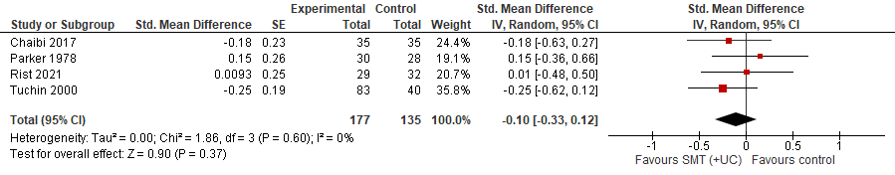

Figure 5: SMT versus controls: Outcome: migraine duration (post-treatment)

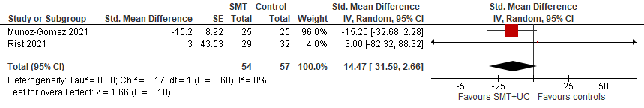

Figure 6: SMT versus controls: Outcome: emotional QoL (post-treatment)

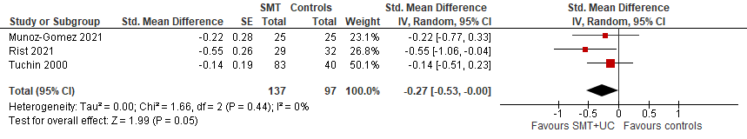

Figure 7: SMT versus controls: Outcome: disability (post-treatment)

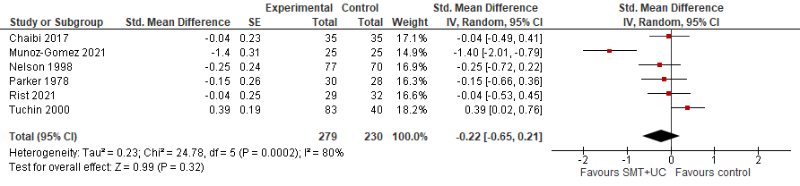

Figure 8: SMT versus controls: Outcome: intensity/severity (post-treatment)

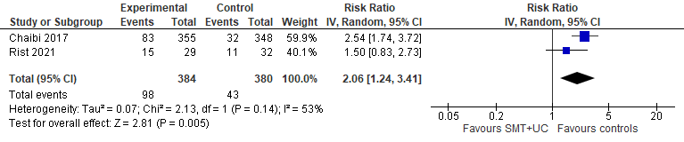

Figure 9: SMT versus controls: Outcome: adverse-effects

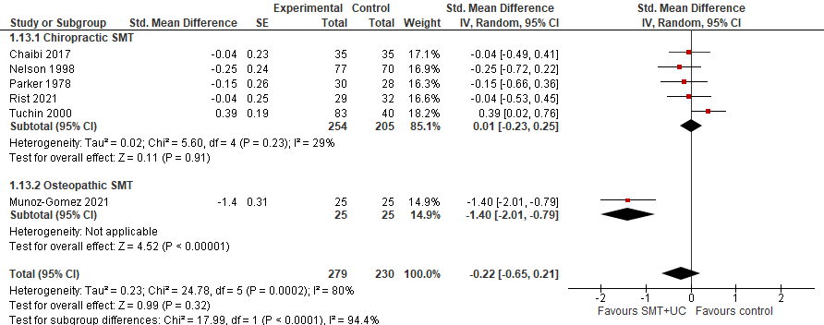

Figure 10: Subgroup analysis (chiropractic vs osteopathic SMT) versus controls: Outcome: intensity/severity (post-treatment)

