# **Verifying the localisation of TMEM192 using immunofluorescent microscopy**

**Authors: Rotimi Y. Fasimoye and Dario R. Alessi**

**Medical Research Council Protein Phosphorylation and Ubiquitylation Unit, School of Life Sciences, University of Dundee, Dow Street, Dundee DD1 5EH, UK**

**Summary**

Immunofluorescent (IF) microscopy is a powerful tool used in cellular and molecular biology to monitor the subcellular localisation of proteins. By combining the advantages of immunostaining and confocal light microscope, IF microscopy can be used to assess the colocalization of two or more proteins within the cell. Here, we describe a method that can be used to verify the correct localisation of endogenously expressed TMEM192, by assessing their colocalization with LAMP1 (a lysosomal marker) and ATPB1 (a mitochondrial marker). Furthermore, our data showed that the anti-TMEM192 antibody is compatible for immunofluorescence assay.

1. **Materials**
   1. **Cell lines**
      * HEK293 (ATCC Catalog number CRL-1573, RRID:CVCL_0045)
   2. **Antibodies**
      * See Tables 1 and 2
   3. **Media and Reagents**
      * Growth Media: Dulbecco’s Modified Eagle’s Medium (DMEM) (GIBCO 11960-085); 10% (v/v) Foetal Bovine Serum (FBS) (Sigma F7524 Batch# BCBW6817); 1% L-Glutamine (GIBCO 25030024); 1% Penicillin-Streptomycin (GIBCO 15140122).
      * Dulbecco's phosphate-buffered saline (PBS) (GIBCO 14190169)
      * Bovine Serum Albumin, BSA (Roche, 10735094001)
      * Sodium Azide (Sigma, S2002)
      * Poly-L-lysine (Sigma, P4832) Hoechst 33342 solution (Thermo, 62249)
      * VECTASHIELD antifading Mounting media (|Vector Laboratories, H1000)
   4. **Equipment**
      * Incubator with FPI-sensor system and display controller MB1 (BINDER GmbH. Model: CB150. Power Output: 1.40kW, 230V, 6.1 Amp)
      * Leica TCS SP8 MP Multiphoton Microscope.
      * See-saw rocker (VWR SSL4, or equivalent).
   5. **Consumables**
      * 6-well tissue culture Petri Dishes (ThermoFisher. Catalog# 140675).
      * Borosilicate Glass square coverslips (VWR, 631-0125)
      * Super Premium microscope slides (Frosted on one side) (VWR, 631-0114)
      * Standard 1ml and 200µl Pipette tips (Greiner bio-one. Catalog# 686271 and 685261 respectively).
2. **Seeding cells for immunofluorescence microscopy**
   1. Coat coverslips (sterilised in 100% ethanol prior to use) with poly-L-lysine by immersing the coverslips in poly-L-lysine solution for 1 hour.
   2. Rinse the coated coverslips in media and place in a 6-well plate (one coverslip in each well).
   3. Seed cells to 50-60% confluency in Growth media on coated coverslips from step 2.2.
   4. Incubate overnight.
3. **Preparing cells for Immunofluorescence imaging**
   1. Remove media completely using an aspirator and wash cells 3 times with 3ml PBS added with 0.2% (w/v) BSA and 0.02% (w/v) sodium azide (5 minutes per wash on a see-saw rocker).
   2. Fix cells by adding 4% (w/v) PFA in PBS and Incubate at room temperature for 10 mins.
   3. Permeabilise cells with 1% (v/v) NP-40 in PBS + 0.2% (w/v) BSA + 0.02% (w/v) sodium azide.
   4. Block with 3% (w/v) BSA in PBS at room temperature for 30 minutes.
   5. Prepare the primary antibody dilutions in 0.2% BSA (w/v) in PBS + 0.02% (w/v) sodium azide (See Table 2 for a list of antibodies and their working dilution).

Note: Primary antibodies raised in different species are combined for co-staining, as follows:

* + - Mouse anti-LAMP1 and Rabbit anti-TMEM192
    - Mouse anti-ATPB and Rabbit anti-TMEM192
  1. Incubate cells at room temperature with diluted primary antibodies for 60 mins. Note: This should be done in a humid chamber to avoid samples drying out. Cover a glass plate with parafilm and add 20 µl of primary antibody dilution to the relevant labelled area on the parafilm. Using tweezers, place each coverslip on the primary antibody solution (facing downward, so the cells are in contact with the antibody).
  2. Wash the coverslips 3 times with 0.2% (w/v) BSA in PBS + 0.02% sodium azide. (5 minutes per wash).
  3. Prepare a combination of Secondary antibodies as described below (see Table 2 for more information about the secondary antibodies). Antibodies are diluted in PBS +0.2%BSA+0.02% sodium azide.
     + anti-Mouse Alexa 488 (1:500) and anti-Rabbit Alexa 594 (1:500).
  4. Add 0.5 µl Hoechst 33342 solution for nuclear staining.
  5. Incubate cells at room temperature with diluted secondary antibodies for 60 mins. Do this in a humid chamber on a piece of Parafilm. Put a 60 µl drop of diluted antibodies on the parafilm. Carefully place coverslip on the droplet, with the side containing attached cells, facing inward, making contact with the droplet.
  6. Wash cells, 3 times, with 3ml PBS +0.2%BSA+0.02% sodium azide.
  7. Rinse cells by dipping briefly in MilliQ water and gently dry on Kleenex wipes.
  8. Label microscope glass slides (preferably the one with frosted side) according to the primary antibody used. Take note of the emission wavelength of the probe on the secondary antibodies.
  9. Add a drop of VECTASHIELD antifading Mounting media.
  10. Mount cover slip (containing cells) on the glass slide, ensuring that the side containing the cells is facing inward, making contact with the oil. Allow to dry for 30 mins, ensuring slides are prevented from direct light.
  11. Slides can be stored at 4oC or viewed immediately on a confocal microscope.

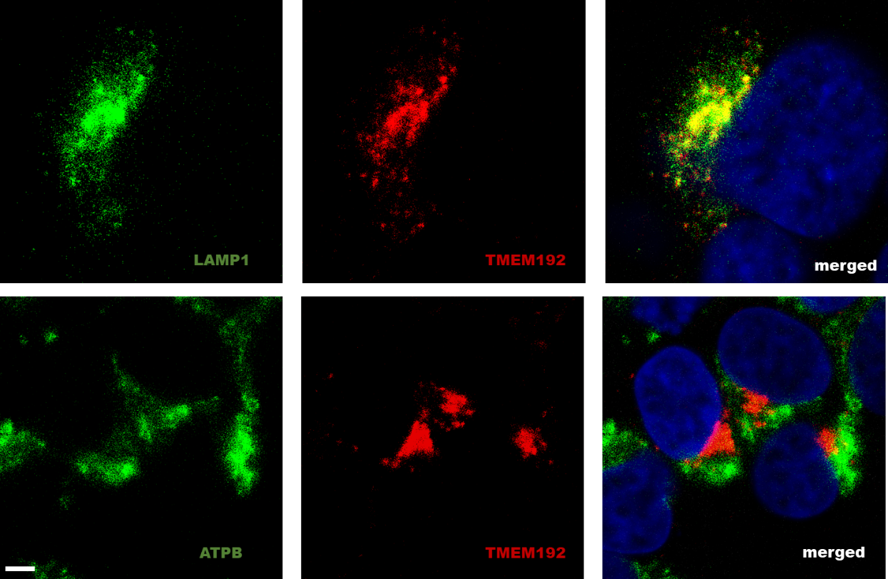

Figure 1: Immunofluorescence images of HEK293 cells showing localisation of endogenous TMEM192 with LAMP1 (a lysosomal marker) and ATPB1 (a mitochondrial marker). Scale bar is 2 µm.

Table 1: List of primary antibodies

|  |  |  |  |
| --- | --- | --- | --- |
| **Antibody** | **Company** | **Cat. number** | **Host species** |
| TMEM192 | Abcam | Ab232600 | Rabbit |
| LAMP1 | Santa Cruz | Sc-20011 | Mouse |
| ATPB | Abcam | Ab14730 | Mouse |

Table 2: List of fluorophore-conjugated secondary antibodies

|  |  |  |  |  |
| --- | --- | --- | --- | --- |
| **Antibody** | **Conjugated Fluorophore** | **Company** | **Cat. number** | **Host Species** |
| anti-Mouse | Alexa 488 | Invitrogen | A21206 | Donkey |
| anti-Rabbit | Alexa 594 | Invitrogen | A11012 | Goat |