# **Transfection by electroporation of GFP-LRRK2 and Immunofluorescent imaging of MEFs VPS35 (D620N) mutants stably expressing LysoTag.**

**Authors: Rotimi Y. Fasimoye and Dario R. Alessi**

**Medical Research Council Protein Phosphorylation and Ubiquitylation Unit, School of Life Sciences, University of Dundee, Dow Street, Dundee DD1 5EH, UK**

**Summary**

Transfection of foreign DNA and Immunofluorescent (IF) microscopy are powerful tools used in cellular and molecular biology to monitor subcellular localisation of proteins. Mouse embryonic fibroblasts (MEFs) are primary cells notorious for their low transfection efficiency by mostly available chemical methods. This efficiency become even lower if the aim is to express a large sized protein, such as LRRK2, a 250kD protein. Here, we described a method where we used electroporation to transiently transfect GFP-tagged LRRK2 into MEFs. We also used IF microscopy to visualise the subcellular localisation of the transiently expressed GFP-LRRK2. Furthermore, we investigated the colocalization of GFP-LRRK2 with a lysosomal localised TMEM192-3xHA.

1. **Materials**
   1. **Cell lines**
      * Mouse Embryonic Fibroblast VPS35 WT (stably expressing TMEM192-3xHA)
      * Mouse Embryonic Fibroblast VPS35 D620N (stably expressing TMEM192-3xHA)
   2. **Plasmids**
      * GFP-LRRK2 (DU13363). Plasmid available at MRCPPU depository at MRCPPUreagents@dundee.ac.uk
   3. **Antibodies**
      * See Tables 1 and 2
   4. **Media and Reagents**
      * Growth Media: Dulbecco’s Modified Eagle’s Medium (DMEM) (GIBCO 11960-085); 10% Foetal Bovine Serum (FBS) (Sigma F7524 Batch# BCBW6817); 1% L-Glutamine (GIBCO 25030024); 1% Penicillin-Streptomycin (GIBCO 15140122). 1X NEAA (GIBCO 11140-035) and 1mM Sodium Pyruvate (GIBCO 11360-039).
      * Transfection media: Growth media without Penicillin-Streptomycin (Pen-Step)
      * Dulbecco's phosphate-buffered saline (PBS) (GIBCO 14190169)
      * Bovine Serum Albumin, BSA (Roche, 10735094001)
      * Sodium Azide (Sigma, S2002).
      * Hoechst 33342 solution (Thermo, 62249)
      * VECTASHIELD antifading Mounting media (|Vector Laboratories, H1000)
   5. **Equipment**
      * NEPA21 Super Electroporator with electroporator chamber (SONIDEL)
      * 2mm gap Cuvette with individual pipette (SONIDEL, EC-002S)
      * Incubator with FPI-sensor system and display controller MB1 (BINDER GmbH. Model: CB150. Power Output: 1.40kW, 230V, 6.1 Amp). This incubator has CO2 and O2 control.
      * Leica TCS SP8 MP Multiphoton Microscope.
      * Super Premium microscope slides (Frosted on one side) (VWR, 631-0114)
      * Borosilicate Glass square coverslips (VWR, 631-0125)
      * DeNovix® CellDrop Brightfield cell counter
   6. **Consumables**
      * 6-well tissue culture Petri Dishes (ThermoFisher. Catalog# 140675).
      * Standard 1ml and 200 µl Pipette tips (Greiner bio-one. Catalog# 686271 and 685261 respectively).
2. **Transfection of cells with GFP-LRRK2 plasmid by electroporation**

*Note: Only use media without Pen-Strep at this stage*

* 1. Place coverslips in 6 well plate (one coverslip per well) and add 2 ml of media. Place the plate in an incubator.
  2. Pellet cells from 100% confluent 10cm plate and resuspend in 1ml media.
  3. Count cells and resuspend in media a way that there are 30000-40000 cells per 10ul.
  4. Power on Electroporator and plug in the electroporator chamber to the output socket.
  5. Set the following Poring Pulse parameters:
     + - Voltage: 200V
       - Length: 5ms
       - Interval: 50ms
       - Number of cycles: 2
       - Decay rate: 10%
       - Polarity: +
  6. Set Transfer Pulse parameters:
     + - Voltage: 20V
       - Length: 50ms
       - Interval: 50ms
       - Number of cycles: 5
       - Decay rate: 40%
       - Polarity: +/-
  7. Add 3-4 µg of plasmid into a 1.5ml Eppendorf tube (Ensure this is not more than 10 µl. if plasmid is too concentrated, add required amount and top-up to 10 µl with media)
  8. Add 90 µl of resuspended cells into the tube. In total, cell number should be approximately 300000-400000. Pipette gently up and down 3 times to mix cell and plasmid.
  9. Transfer cell-plasmid mixture into 2mm gap Cuvette and close the cap. Add gently to the side to ensure there are no bubbles. If there are bubbles, tap the cuvette gently on the side until the bubbles move to the top.
  10. Insert the cuvette into the electroporator chamber and close the lid.
  11. Briefly measure electrical impedance by pressing the “Ω" button and check reading. This should be between 0.03 and 0.055. If reading is too low, add 1-2ul of cells. if too high, add 1-2 µl of media.
  12. Press start button to begin electroporation process.
  13. On completion, use Pasteur pipette (provided with the cuvette) to transfer cells into the wells containing a coverslip (from step 2.1)
  14. Rotate plate gently to spread the cells within the well.
  15. Return plate into the incubator and incubate for at least 18 hours at 37oC.
  16. Replace media with full Growth media (i.e., media with Pen-Strip) and incubate for another 12-18 hours.

1. **Preparing cells for Immunofluorescence imaging**
   1. Remove media and wash cells, 3 times, with 3ml PBS +0.2%BSA+0.02% sodium azide.

*(Note that each wash session is 5 mins)*

* 1. Fixed cells in 4% w/v PFA. Add 3 ml of dissolved PFA and incubate at room for 10 mins.
  2. Permeabilise cells with 1% NP-40 (v/v in PBS +0.2%BSA+0.02% sodium azide)
  3. Block with 3% BSA (w/v in PBS) for 30 mins
  4. Prepare a combination of primary antibodies (Table 1) as shown below. Antibodies are diluted in PBS +0.2%BSA+0.02%sodium azide
     + Rat anti-HA (1:1000) and Chicken anti-GFP (1:1000)
  5. Incubate cells at room temperature with diluted primary antibodies for 60 mins. Do this in a humid chamber on a piece of Parafilm. Put a 60 µl drop of diluted antibodies on the parafilm. Carefully place coverslip on the droplet, with the side containing attached cells, facing inward, making contact with the droplet
  6. Wash cells, 3 times, with 3ml PBS +0.2%BSA+0.02% sodium azide.
  7. Prepare a combination of Secondary antibodies as described below (see Table 2 for more information about the secondary antibodies). Antibodies are diluted in PBS +0.2%BSA+0.02% sodium azide.
     + anti-Rat Alexa 594 (1:500) and anti-Chicken Alexa 488 (1:500).
  8. Add 0.5 µl Hoechst 33342 solution for nuclear staining.
  9. Incubate cells at room temperature with diluted secondary antibodies for 60 mins. Do this in a humid chamber on a piece of Parafilm. Put a 60 µl drop of diluted antibodies on the parafilm. Carefully place coverslip on the droplet, with the side containing attached cells, facing inward, making contact with the droplet.
  10. Wash cells, 3 times, with 3ml PBS +0.2%BSA+0.02% sodium azide.
  11. Rinse cells by dipping briefly in MilliQ water and gently dry on Kleenex wipes.
  12. Label microscope glass slides (preferably the one with frosted side) according to the primary antibody used. Take note of the emission wavelength of the probe on the secondary antibodies.
  13. Add a drop of VECTASHIELD antifading Mounting media.
  14. Mount cover slip (containing cells) on the glass slide, ensuring that the side containing the cells is facing inward, making contact with the oil. Allow to dry for 30 mins, ensuring slides are prevented from direct light.
  15. Slides can be stored at 4oC or viewed immediately on a confocal microscope.

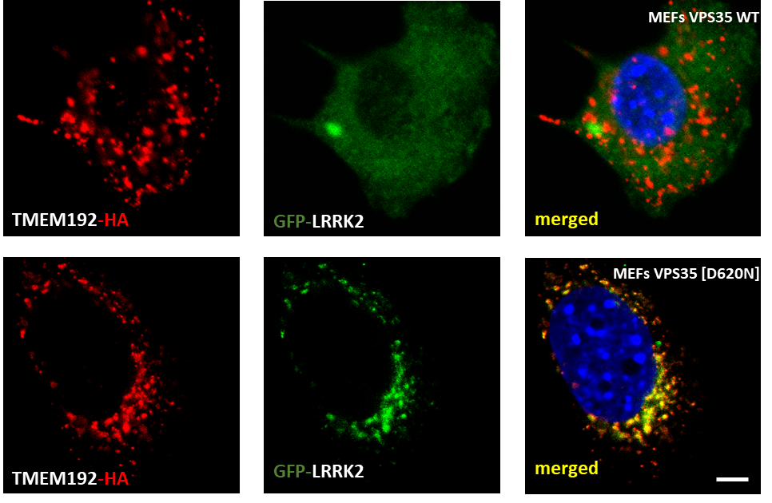

Figure 1: Immunofluorescence images of mouse embryonic fibroblasts (MEFs) expressing GFP-LRRK2 and TMEM192-3xHA. MEFs VPS35 wildtype and D620N mutants stably expressing TMEM192-3xHA and transiently expressing GFP-LRRK2 were co-immunostained with anti-HA and anti-GFP antibodies. Scale bar is 2 µm.

Table 1: List of primary antibodies

|  |  |  |  |
| --- | --- | --- | --- |
| **Antibody** | **Company** | **Cat. number** | **Host species** |
| GFP | Abcam | AB13970 | Chicken |
| HA | Roche | 47877600 | Rat |

Table 2: List of fluorophore-conjugated secondary antibodies

|  |  |  |  |  |
| --- | --- | --- | --- | --- |
| **Antibody** | **Conjugated Fluorophore** | **Company** | **Cat. number** | **Host Species** |
| anti-Chicken | Alexa 488 | Invitrogen | A11039 | Goat |
| anti-Rat | Alexa 594 | Invitrogen | 21209 | Donkey |