**Prepare:**

Perfused brains, stored in PBS + 0.02% azide at 4C.

4% ultrapure agarose in PBS + 0.02% azide at 55C for embedding.

24 well plates, with PBS + 0.02% azide for slice storage.

**Embedding the brain:**

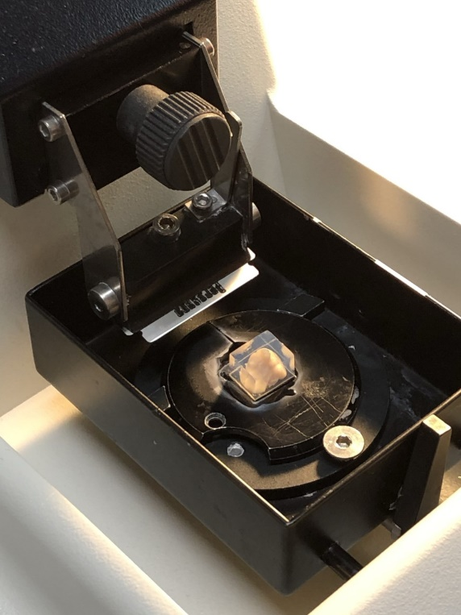1 mm brain matrix

Plastic dropper

Square plastic molds

Super glue

Razor blade

Compressed air

Perform a gross coronal cut using the 1 mm matrix at a site either anterior or posterior of the region of interest, ~2mm distal from the region of interest. Dry the flat part of the brain repeatedly on a kimwipe. Place in the plastic square mold, with the now flat portion of the brain lying face-down, and press against the mold to eliminate any bubbles.

Using the plastic dropper, put the agarose/azide solution around the brain until completely submerged. Once submerged, place on ice or place in the fridge until completely solid. 5 min in the fridge is a good in-between to prevent the agarose from being too gooey and too solid.

Once solid, pop out of the molds and dry off.

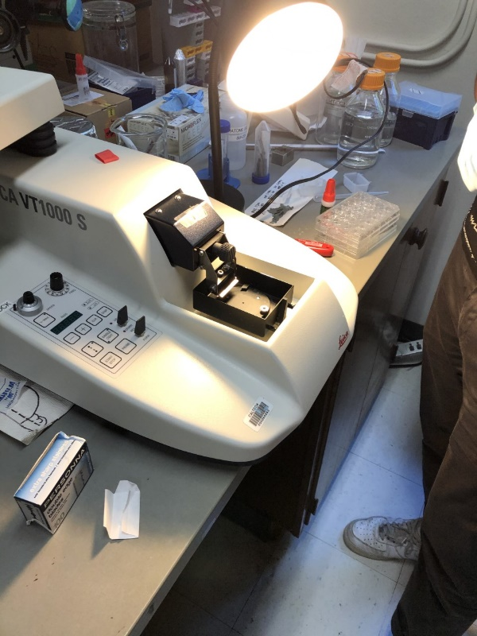Take a sharp razor and slice the excess agar off to make a small cube. There should be enough agarose on the edges to grip with the paintbrush but not too much that it is strongly adhered to the brain.

On the circular stage, paint a generous layer of superglue generously in the middle. Place the brain in the pool of superglue, face down, and swirl around to eliminate any bubbles and make full contact. Let dry. The compressed air can be used to accelerate this process. It is completely dry when it is all white around the edges.

**Mounting the Stage**

Lock the rectangular stage pool in the place by moving the clamp straight up from its left-pointing position. Screw the razor blade into the clamp. Load the blade in first and then screw it tightly in. Use the screw to attach the blade holder into the vibratome.

Screw the circular stage on and orient it such that the cube of agarose is parallel to the razor blade. Ensure it’s dry before adding PBS. Submerge everything in PBS (no azide) to cover the brain cube.

The knob to the top left increases the speed of slicing. The vibration frequency should be between 8 and 10.

-/+ control the thickness (z) direction of slices.

∑ is the cumulative microns since the start of the slicing

Single – one slice

Continuous – continuous slicing

**Slicing**

Orient the stage using the upper switch such that the razor blade’s path just barely grazes the top of the agarose cube. Use the extreme posterior end or the extreme anterior end (facing upwards on the stage) to orient yourself with how many mm relative to bregma you can safely cut off without keeping for staining. Definitely aim start cutting >1mm anterior/posterior of your region of interest (depending on the direction your slices are starting from), and aim to finish >1 mm beyond your region of interest. If 10 50 um slices are put into 1 well, then your region of interest should appear after the second well, but it’s not perfect.

Use the button containing an up arrow and a down arrow to set the upper and lower limits of the razor path. The first press of the button sets the upper limit (above the agarose) and the second press of the button sets the lower limit (below the agarose). Using the individual arrow keys, set the thickness of the slice (in microns) and hit start. The vibratome will slice once (if single is lit) or will keep slicing and moving automatically (if cont. is selected).

Pause can be used, provided a slice is not in progress.

To change the slice thickness, hit stop, then change the thickness, then hit start. Pause should be used in preference of stop if all the slices are the same thickness.

**Cleanup**

Hit stop.

Manually change the stage height and push the razor back.

Unscrew the blade holder and remove the blade (these are disposable).

Remove the circular stage, and use a razor blade to shave off residual agarose and glue.

Unlock the rectangular stage and pour out the PBS into the catch container.

If not slicing another brain, place the circular stage, screw for the blade holder, and the blade holder in the rectangular pool and fill with MQ H2O. While the parts are soaking, spray a paper towel with ethanol and wipe down the vibratome. Pour out the water from the bath.

Cleanup all mess, turn off the vibratome, and replace the cover.

**Sectioning Notes from Meeting with Mark 02/05/20**

* Going to section the following brain regions
  + CB – no activation
  + SN- activation; focus on the SnPr
  + STR – activation
  + Frontal cortex- no activation
* Want to have 5-8 brains per experimental group
* Antibodies to use:
  + TH
  + IBA1
  + A-synuclein (Ps129)
  + DAPI
* **1) making gross cut of brain**
  + Plan is to cut at the anterior portion of the hypothalamus; one half will contain the striatum and frontal cortex and the other will contain the SN and the cerebellum
  + From there we will do coronal slicing at 50uM slices
  + Mount both halfs of the brain and then slice them together
* **2) splitting brain**
  + A good approach would be to split the brain into 4 wells
  + First slice in well 1, second slice in well 2, etc.
  + This way each well will represent a whole brain (more or less) with the space between slices being 200uM.
  + For an experiment you pick one well and do the staining on all the slices of that one well; that way you can go back and re-stain the other 3 wells at a future time point if necessarily.
  + Next you need to mount the slices and they must be mounted in the correct order that they appear in the brain.
* **3) # of slices to look at per region**
  + Its really important to be consistent with the regions you are looking at and taking data from; need to be consistent among images and between brains
  + The best thing to do is find 2-4 areas for each region of the brain that are in sequential order and take several pictures of each area.
  + For taking pictures, you should first take a low mag pic of the area to look for any obvious global changes between different experimental groups
  + Next, take a high mag pic and then quantify microglial activation, a-syn aggregation, etc. from that high mag picture.
* **4) data collection**
  + Take a zoomed in picture of the 2-4 different slices per brain area and you can then combine data from those 2—4 different sections
  + Can combine data from several sections that are several bregma points apart
  + BE CONSISTENT BETWEEN MICE AND BETWEEN EXPERIMENTAL GROUPS THOUGH

Vibratome Protocol Notes

Sectioning notes from the literature

* <https://www.ncbi.nlm.nih.gov/geo/query/acc.cgi?acc=GSE35723>
* <https://www.cell.com/molecular-therapy-family/nucleic-acids/pdfExtended/S2162-2531(17)30241-X>
  + Look striatum bregma 0.35mM