Generation of stable cell lines via retroviral or lentiviral transduction
Authors: Rotimi Y. Fasimoye and Dario R. Alessi

Medical Research Council Protein Phosphorylation and Ubiquitylation Unit, School of Life Sciences, University of Dundee, Dow Street, Dundee DD1 5EH, UK
Summary
The ability to stably express a protein of interest in cells is critical to study its function. Here, we describe a protocol to generate stable cell lines using a retrovirus system that can be used for a variety of mouse and human cell lines. Our protocol includes the production of retroviruses encoding the transgene of interest in HEK293FT and the subsequent transduction of the cell line that is intended to stably express the protein of interest. The same protocol can also be used to generate stable cell lines using a lentivirus system. It should be noted that when using this method, the transgene of interest will be randomly integrated into the cell genome.
- Materials
  - Cell lines
    - HEK293FT for virus packaging and propagation (Invitrogen™. Catalog# R70007)
    - HEK293 cells
Note: This protocol can be used to stably express a protein of interest in a variety of mouse and human cell lines.
  - Plasmids
    - Retrovirus plasmid construct (pBABED vector) or Lentivirus plasmid construct (pLVX or pLJC5 vector) with the gene encoding the protein of interest inserted. As an example for this protocol, we used pBABED-SLC35A2-2xFLAG (DU72094 available at MRCPPU Reagents and Services https://mrcppureagents.dundee.ac.uk). The plasmid should contain an antibiotic selection cassette for the selection of successfully transduced cells (hygromycin, in this case).
    - pCMV VSV-G. Retrovirus envelope plasmid. (Cell Biolabs. Catlaog# RV-110).
      - Note: Use Lenti-X HTX Packaging system (Clontech. Catalog# 631247) for Lentivirus based construct.
    - pCMV Gag/Pol. Retrovirus Gag/Pol plasmid. (Cell Biolabs. Catalog# RV-111).
      - Note: Use Lenti-X HTX Packaging system (Clontech. Catalog# 631247) for Lentivirus based construct

(Note: We purify plasmids using a QIAGEN HiSpeed® Plasmid Maxi kit following the manufacturer’s protocols and ensure sterile reagents are used and mixtures prepared in tissue culture hood to avoid contamination)
  - Media and Reagents
    - Growth Media (for HEK293FT and HEK293 cells): Dulbecco’s Modified Eagle’s Medium (DMEM) (GIBCO. Catalog# 11960-085); 10% (v/v) Foetal Bovine Serum (FBS) (Sigma F7524 Batch# BCBW6817); 1% (v/v) L-Glutamine (GIBCO. Catalog# 25030024); 1% (v/v) Penicillin-Streptomycin (GIBCO. Catalog# 15140122).
    - Selection Media (for HEK293 cells after retroviral/lentiviral transduction): Growth Media with 500 ug/ml Hygromycin (InvivoGen. Catalog# ant-hg-5).
    - Transfection media (for HEK293FT cells): OptiMem (GIBCO. Catalog# 31985-062)
    - Dulbecco's phosphate-buffered saline (PBS) (GIBCO. Catalog# 14190169)
    - Linear polyethylenimine (PEI Max 40K. Polyscience. Catalog# #24765)
    - Polybrene Infection/Transfection reagent (Millipore. Catalog# TR1003G)
  - Equipment
    - Incubator with FPI-sensor system and display controller MB1 (BINDER GmbH. Model: CB150. Power Output: 1.40kW, 230V, 6.1 Amp). This incubator has CO₂ and O₂ control.
  - Consumables
    - 10cm tissue culture Petri Dishes (ThermoFisher. Catalog# 172931).
    - 15ml CELLSTAR® tubes (Greiner bio-one. Catalog# 188271).
    - Standard 1ml and 200µl Pipette tips (Greiner bio-one. Catalog# 686271 and 685261 respectively).
    - Syringe filter (0.45µm. Sartorius, Item # ST16537-Q)
    - Syringes (10ml) (Medicina. REF# IVS10. LOT# 19111004).
- Methods:
  - Packaging SLC35A2-2xFLAG plasmid into a Retrovirus system
      - Note: The same protocol can be used to package the gene of interest into a Lentivirus system.
      - Note: All the following steps should be performed under sterile conditions in a CATEGORY 2 biological safety cabinet.
    - Grow HEK293FT cells to 50-60% confluency in Growth media in a 10cm Petri Dish.
    - Prepare a transfection mix in a sterile 1.5ml Eppendorf tube, containing:
      - 3.8µg pGag/Pol plasmid
      - 2.2µg pVSVG plasmid
      - 6µg pBABE-SLC35A2-2xFLAG plasmid
      - 300µl OptiMem
    - Prepare PEI mixture in a sterile 1.5ml Eppendorf tube, containing:
      - 20µl 1mg/ml PEI Max 40K dissolved in distilled water
      - 300µl OptiMem
    - Incubate each mixture (from step 2.1.2 and 2.1.3) separately for ~5 mins at room temperature, then combine.
    - Mix by vortexing and incubate at room temperature for 30 mins.
    - Add the mixture dropwise to the cells from step 2.1.1 using a P1000 sterile pipette.
    - Incubate cells at 37°C for 24 h.
    - Replace media with 10 mL of fresh Growth Media and incubate cells for a further 24 h at 37°C.
    - Collect the culture media from step 2.1.8 (that now contains the retroviruses) and pass through a 0.45µm syringe filter.
Note: The retrovirus infection media from step 2.1.9 can be used immediately (as described below) or can be stored at -80°C for subsequent use.

  - Retrovirus infection (Transduction) and Selection of cells stably expressing SLC35A2-2xFLAG
    - Mix 5ml of retrovirus infection media from step 2.1.9 with 5ml of fresh Growth Media in a sterile 15ml Eppendorf tube.
    - Add Polybrene (10mg/ml stock dissolved in MilliQ water, sterile filtered) to a final concentration of 10µg/ml.
    - Gently add to a 10cm plate of HEK293 cells (or any cell line of interest) at ~60% confluency.
    - Incubate at 37°C for 24 h.
    - Change media to Growth Media and incubate for another 24 h at 37°C.
    - To select cells stably expressing SLC35A2-2xFLAG, replace media with 10 ml of freshly prepared Selection Media.
Note:
- Cells that have not been infected should be included as a control for the efficiency of the selection agent.
- Cells that have not been successfully transduced should start dying 24 h after the addition of selection media.
    - Change Selection Media every 24h for 3-5 days to remove dead cells. After 5 days, cells stably expressing SLC35A2-2xFLAG should have reached 100% confluency.
    - Cells can now be passaged and plated for experiments, or frozen down for long term storage in liquid nitrogen (Freezing media: growth media added with 10% v/v DMSO).
Note: Cells should be grown in Selection Media only.

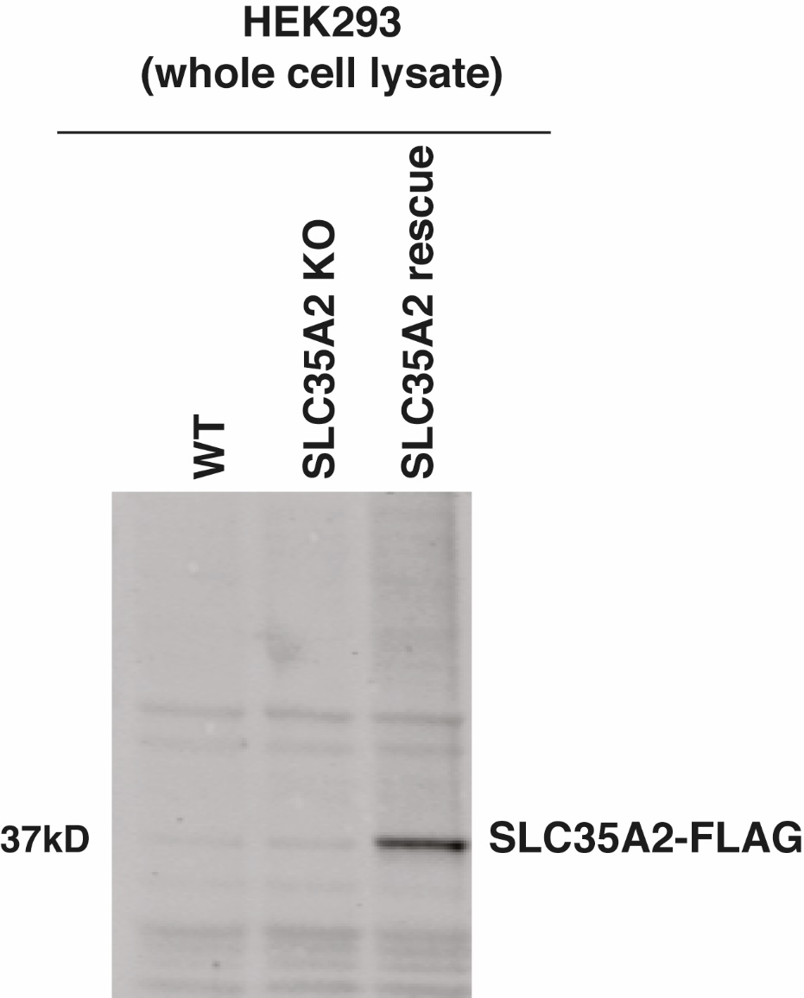
Figure 1: Verification by immunoblotting analysis of the expression of SLC35A2-FLAG that was re-expressed in SLC35A2 knock-out (KO) HEK293 cells using the method described here. Whole cell lysate was prepared from HEK293 cells that are SLC35A2 wildtype (WT), SLC35A2 knock-out (SLC35A2 KO) and SLC35A2 rescue. The lysate was immunoblotted with anti-FLAG antibody (Sigma. Catalog# F1804. RRID:AB262044) to detect the stable expression of SLC35A2-FLAG reintroduced by retrovirus transduction.

References:
Bozena Szulc, Paulina Sosicka, Dorota Maszczak-Seneczko, Edyta Skurska, Auhen Shauchuk, Teresa Olczak, Hudson H. Freeze and Mariusz Olczak (2020). Biosynthesis of GlcNAc-rich N- and O-glycans in the Golgi apparatus does not require the nucleotide sugar transporter SLC35A3. Journal of Biological Chemistry 295 (48), 16445-63. ISSN 0021-9258. https://doi.org/10.1074/jbc.RA119.012362.

