**LRRK1 Immunoprecipitation kinase assay**

**Authors: Asad Malik, Athanasios Karapetsas, Dario R. Alessi**

Medical Research Council Protein Phosphorylation and Ubiquitylation Unit, School of Life Sciences, University of Dundee, Dow Street, Dundee DD1 5EH, UK

**Summary**

We describe a non-radioactive assay that we deploy for analysing LRRK1 protein kinase activity *in vitro* using Rab7A as a substrate. This assay can be used to measure the intrinsic activity of LRRK1 immunoprecipitated from cells as well as to assess the impact of mutations on LRRK1 activity.

*Note:* Once the in vitro kinase assay has been performed, we recommend analysing the reaction products by quantitative immunoblotting (as described in [**XXXXX**](https://dx.doi.org/10.17504/protocols.io.bsgrnbv6)).

*Note:* This protocol was adapted from dx.doi.org/10.17504/protocols.io.bw4bpgsn

**1) MATERIALS**

**1.1) Reagents:**

1.1.1) For transfection of GFP-tagged LRRK1 in HEK293 cells: cDNA for expression of human GFP-tagged LRRK1 in mammalian cells; Polyethylenimine “Max” (MW 4,000) (Polysciences, Inc., cat no 24885): 1 mg/ml stock in de-ionised H2O, filtered.

1.1.2) Lysis buffer: 50 mM HEPES pH 7.51, 0.3% (v/v) CHAPS hydrate1, 1 mM Na3VO42, 50 mM NaF, 10 mM β-glycerophosphate, 5 mM sodium pyrophosphate, 0.27 M sucrose, cOmpleteTM, EDTA-free Protease Inhibitor Cocktail (Roche, 11836170001)2, 1mM GTP-γ-S2, 1 μg/ml Microcystin-LR (Enzo Life Sciences, ALX-350-012)2.

1: Prior optimisation has shown that LRRK1 best retains its kinase activity when cells are harvested in a lysis buffer containing 0.3% CHAPS with 50mM HEPES pH 7.5 (Figure 1)

2: To be added fresh before use.

1.1.3) Bradford assay kit (Pierce™ Coomassie Plus (Bradford) Assay Kit, ThermoFisher Scientific 23236, or equivalent).

1.1.4) Resin for LRRK1 immunoprecipitation: aGFP16-aGFP2-His6 NHS-activated Sepharose beads (available from MRC Reagents and Services: <https://mrcppureagents.dundee.ac.uk/>) for GFP-tagged LRRK1

1.1.6) IP wash buffers: Lysis buffer supplemented with 300 mM NaCl; 50 mM HEPES pH 7.5;

1.1.7) Kinase assay buffer: 50 mM HEPES pH 7.5; 10 mM MgCl2; 1 mM ATP;

1.1.8) Recombinant Rab7A protein (available from MRC Reagents and Services: <https://mrcppureagents.dundee.ac.uk/>)

1.1.9) 4X Loading buffer: Invitrogen™ NuPAGE™ LDS Sample Buffer, cat no NP0007, or 4X SDS loading buffer: 250mM Tris-HCl, pH6.8, 8% (w/v) SDS, 40% (v/v) glycerol, 0.02% (w/v) bromophenol blue.

**1.2) Equipment:**

1.2.1) Refrigerated bench-top centrifuge (Eppendorf microcentrifuge 5417R, or equivalent).

1.2.2) Plate reader for Protein quantification (BioTek Epoch, or equivalent)

1.2.3) Thermo mixer (Eppendorf ThermoMixer, or equivalent)

1.2.4) Dry bath/heat block (Thermo Scientific™ 88870005, or equivalent).

**2) METHOD:**

**2.1) Transient transfection of HEK293 cells for analysis of over-expressed LRRK1 activity *in vitro*:**

2.1.1) Transfect HEK293 cells at around 60-70% confluency. For a 10cm dish, add 10 μg DNA (GFP-tagged LRRK1 or GFP-empty vector) and 30 μl of 1 mg/ml PEI solution to 1 mL of Opti-MEMTM Reduced Serum Medium and vortex for 20/30 seconds.

*Note: We recommend including a GFP-empty vector transfection as well as a GFP-tagged LRRK1 D1409A (kinase dead) transfection to control for specificity of LRRK1 immunoprecipitation and activity.*

2.1.2) Incubate at room temperature for 20 minutes to allow the DNA/PEI complexes to form.

2.1.3) Add the transfection mix to the culture medium in each dish and incubate cells at 37oC after transfection.

2.1.4) Lyse cells 20-24 hours after transfection.

**2.2) Preparation and quantification of cell lysates:**

2.2.1) Quickly rinse cells in the tissue culture dish by carefully pouring room temperature culture media without Foetal bovine serum (FBS) into the dish.

2.2.2) Pour off media from the culture dish and completely aspirate any residual media. Immediately add freshly prepared ice-cold lysis buffer, ensuring that the entire surface is covered by lysis buffer.

Note: The amount of lysis buffer to use will depend on cell type. As a guideline, use 400 μl of lysis buffer for a 10 cm dish for HEK293 cells.

2.2.3) Immediately transfer the cell dishes to ice.

2.2.4) Scrape the cells on the dish using a cell lifter (Sigma-Aldrich CLS3008, or equivalent) to ensure all cells are detached from the dish.

2.2.5) Using a pipette, transfer cell lysate to an Eppendorf tube on ice.

2.2.6) Leave samples on ice for 20 minutes to allow for efficient lysis.

2.2.7) Clarify lysates by centrifugation at 20,800 g for 10 min at 4oC.

2.2.8) Transfer the supernatants into new Eppendorf tubes and discard the pellet. Keep the tubes on ice.

Note: Cell lysates can be snap frozen in liquid nitrogen and stored at -80oC for future use. When assessing kinase activity of LRRK1 immunoprecipitated from cells, we do not recommend more than one freeze/thaw cycle.

2.2.9) Determine the protein concentration of cell lysates by Bradford assay according to the manufacturer’s instructions, performing measurements in triplicate.

Note: Ensure the concentration of the samples is in the linear range for the Bradford assay. If it isn’t, prepare appropriate dilutions in water of each lysate. Generally, protein concentrations of near confluent cells lysed as described above should result in protein concentrations of at least 2 μg/μl.

**2.3) Immunoprecipitation of over-expressed LRRK1 from HEK293 cells:**

*Note: When comparing multiple GFP-tagged variants of LRRK1, we recommend assessing the levels of LRRK1 in the lysates prior to immunoprecipitation by subjecting ~10 ug cell extract to immunoblotting, normalizing total LRRK1/Tubulin levels and adjusting how much cell lysate is to be used to immunoprecipitate LRRK1 based on this quantification, to ensure that the amount of enzyme between reactions is as close as possible.*

2.3.1) Add 20 μl of aGFP16-aGFP2-His6 NHS-activated Sepharose beads (washed 3 times in PBS and resuspended in PBS to make a 1:1 slurry) to 1 mg of cell extract.

*Note: The immunoprecipitation conditions (amount of resin and amount of cell extract) might need optimisation.*

2.3.2) Incubate at 4oC for three hours, under mild agitation.

2.3.3) Collect the resin by centrifugation at 2,500 g for 2 minutes at 4oC. Discard supernatant.

2.3.4) Resuspend resin in 500 μl of lysis buffer supplemented with 300 mM NaCl.

2.3.5) Repeat step 2.3.3 and 2.3.4 twice.

2.3.6) Collect the resin by centrifugation at 2,500 g for 2 minutes at 4oC. Discard supernatant.

2.3.7) Resuspend resin in 500 μl of 50 mM HEPES pH 7.5.

2.3.8) Repeat step 2.3.3 and 2.3.7.

2.3.9) Collect the resin by centrifugation at 2,500 g for 2 minutes at 4oC. Discard supernatant.

2.3.10) Resuspend the resin in 50 mM HEPES pH 7.5 (1:1 ratio).

2.3.11) Aliquot the resin into Eppendorf tubes kept on ice (one Eppendorf tube per reaction, 10 μl resin each).

**2.5) In vitro kinase assay:**

The amount of kinase and that of substrate, as well as the duration of the reaction should be optimised to ensure that the measured activity of LRRK1 is in the linear range. We recommend performing a pilot study to establish the optimal parameters to use for the kinase assay under the experimental conditions of choice.

2.5.1) Prepare a “master mix” containing 50 mM HEPES pH 7.5, 50 mM KCl, 10 mM MgCl2, 1 mM ATP, and recombinant Rab protein.

2.5.3) Start the kinase reaction by adding the master mix to the immunoprecipitated kinase and transferring the Eppendorf tubes to the thermo mixer set at 30oC, 1,000 rpm.

2.5.4) Stop the kinase reaction by adding 4X LDS loading buffer to the reaction mix to a final concentration of 2X.

2.5.5) Incubate the mixture at 70°C on a heat block for 10 min to elute LRRK1 from the resin.

2.5.6) Collect the eluent by centrifugation through a 0.22‐μm‐pore‐size Spinex column.

2.5.7) Supplement the samples with 2‐Mercaptoethanol to 1% (v/v).

2.5.8) Incubate the samples for 5 min at 70°C on a heat block before proceeding to quantitative immunoblotting analysis.

**2.6) Analysis of kinase reaction products by quantitative immunoblotting analysis:**

The reaction products can be analysed by quantitative immunoblotting analysis (as described in XXXX). **Table 1** lists the primary antibodies that we recommend using, which include antibodies to detect Rab7A phosphorylation at Serine-72

|  |  |  |  |  |
| --- | --- | --- | --- | --- |
| **­Antibody Target** | **Company** | **Cat. number** | **Host species** | **Dilution** |
| pS72 Rab7A | Abcam Inc. | MJF-38, Clone 1 | Rabbit | 1 μg/ml |
| Rab7A (Total) | Sigma | R8779 | Mouse | 1 μg/ml |
| LRRK1 (total) (C-terminus) | MRC-PPU Reagents and Services, University of Dundee | S405C | Sheep | 1 μg/ml |
| alpha-tubulin | Cell Signaling Technology | 3873 | Mouse | 1:5,000 |

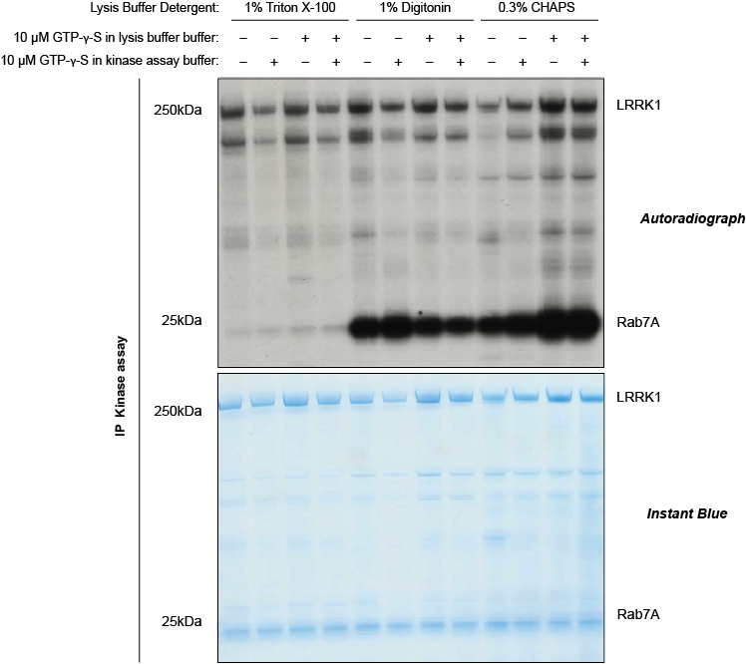

**Figure 1:Optimisation of recombinant Rab7A phosphorylation *in vitro* by immunoprecipitated GFP-LRRK1.** HEK293 cells were transfected with GFP-LRRK1 WT The cells were harvested 24 h post transfection in lysis buffer containing either 1% Triton, 1% Digitonin or 0.3% CHAPS and supplemented with 1mM GTP-γ-S as indicated. 1mg of cell extract was subjected to a GFP immunoprecipitation, followed by a 45-minute kinase reaction at 30°C in the presence of 5 mg recombinant Rab7A and excess Mg-32P-ATP. 75% of kinase reactions were separated on SDS-PAGE. Following electrophoresis, gels were fixed (50% (v/v) methanol, 10% (v/v) acetic acid), stained in Coomassie brilliant blue, dried and exposed to a phospho-imaging screen for assessing radioactive 32P incorporation.



**Figure 2: *In vitro* phosphorylation of recombinant Rab7A by immunoprecipitated GFP-LRRK1 WT.** HEK293 cells were transfected with GFP-LRRK1 WT or GFP-LRRK1[D1409A] (kinase inactive mutant). The cells were lysed 24 h post transfection and the 1mg of cell extract were subjected to a GFP immunoprecipitation, followed by a 45 minute kinase reaction at 30°C in the presence of 5 mg recombinant Rab7A and excess Mg-ATP. 25% of GFP-LRRK1 WT and GFP-LRRK1[D1409A] kinase reactions were subjected to immunoblot analysis with the indicated antibodies and the membranes were developed using the Odyssey CLx scan Western Blot imaging system.