Mouse Brain Perfusion and Flash Freezing Protocol

- Scope and Applicability: Transcardial perfusion with HEPES-Sucrose Cutting Solution (Referred as HEPES hereafter), followed by fast brain dissection and flash freezing for use by the Molecular Genetics team.

- Materials:
  - 500 mL or larger jar for HEPES solution (VWR 10862-164 or equivalent)
  - 1 L or larger container for wet ice (VWR 76266-414 or equivalent)
  - HEPES-Sucrose Cutting Solution (RP0264)
  - Vinyl Dissection Pad (Paoli Clay Company ASPAD or equivalent)
  - Plastic tray (VWR 470147-486 or equivalent)
  - Isoflurane (Patterson Veterinary 78931389 or equivalent)
  - Needles for pinning paws to perfusion board
  - Surgical scissors (Roboz RS-5914 or equivalent)
  - Nose cone (VetEquip 921614 or equivalent)
  - Forceps (Fine Science Tools 11210-10 or equivalent)
  - Blunt tip perfusion needle, 22G (VWR 89134-082 or equivalent)
  - Peristaltic pump tubing (1/16” ID, 3/16” OD, 1/16” wall thickness); (VWR 32829-026 or equivalent)
  - Male luer integral lock ring 200 series (Nordson Medical MTLL210 or equivalent)
  - 70% Ethanol (RP0032)
  - Approved disinfectant (ex. Quatricide TB or Peroxigard)
  - Deionized water
  - Kim wipes or Gauze pads (VWR 82004-740 or equivalent)
  - Absorbent pad (VWR 82004-740 or equivalent)
  - Dissection tools
    - Sharp curved mayo scissors (Roboz RS-6871SC or equivalent)
    - Angled dissecting scissors (Fine Scientific 14081-09 or equivalent)
    - Fine dissection scissors (Roboz RS-5852 or equivalent)
    - Fine tipped forceps (Fine Scientific 11210-10 or equivalent)
    - Spatula (VWR 82027-490 or equivalent)
  - Plastic bag with zip lock (carcass bag)
  - Dry ice
  - Wet Ice
  - OCT (Embedding Medium) (VWR 25608-930 or equivalent)
  - Two Insulated dry ice buckets (VWR 89233-340 or equivalent)
  - Liquid Nitrogen (LN₂)
  - Liquid Nitrogen safe container (Dewar flask VWR 71000-254 or equivalent)
  - 5 ml Diamond Midi centrifuge tubes with screw top (Globe Scientific Inc. 111580S). (If ordering via VWR, use VWR76452-266, supplier number 111580S).
  - Cardboard Storage Boxes (Globe Scientific Inc. 3097)
  - Stainless Steel Double Ended Square & Lab Spoon Sampler Lab Spatula 7″ Length (Scientific Labwares no part number)
  - Cryomarker (VWR 76276-064 or equivalent)
  - Insulated gloves (VWR 75841-232 or equivalent)
  - LabTracks task
  - Timer
- Equipment:
  - VetEquip Table-Top Laboratory Animal Anesthesia System
  - Class II Biological Safety Cabinet
  - Animal Facility VWR Brand 4°C refrigerator
  - Harvard Apparatus Peristaltic Pump 66 (MA1-55-7766)
  - -80°C Freezer
- Safety:
  - See ACWI-AH012: Vivarium Entry Procedures and Movement Between Rooms.
Warning: Personal Protective Equipment (PPE) should be used at all times while operating this protocol. If you are unsure what PPE you should be using, see your immediate supervisor.
Isoflurane Warning: Acute over-exposure to waste anesthetic gases (WAG) may cause eye irritation, headache, nausea, drowsiness or dizziness. Repeated exposure may cause damage to cardiovascular system and central nervous system. Refer to MSDS for additional information. Consult the surgical workstation guide to ensure all parts of the dispensation rig are functioning properly. Employee exposure monitoring is periodically conducted by EHS and may be requested at any time from EHS.

Only IACUC approved and appropriately trained personnel may perform this procedure.

- Output:
  - Flash frozen brain specimens that are perfused with HEPES, flash frozen in liquid nitrogen vapor, and stored in 5 ml screw top centrifuge tube containing 1 ml of OCT in -80°C freezer.
- Reference Documents:
  - Harvard Apparatus Peristaltic Pump 66 manual
  - ACWI-AH012: Vivarium Entry Procedures and Movement Between Rooms
  - LASWI-0038: Isoflurane Use for Anesthesia
  - RP0032 Ethanol Dilutions
    - To be Published
  - RP0264 HEPES-Sucrose Cutting Solution
    - To be Published
  - Cold Storage Catalogue
  - Perfusion and Dissection Notes
  - Pump Calibration Instructions

- Setup:
  - This procedure is PFA free. All surfaces should be cleaned prior to procedure to remove trace amounts of PFA.
    - Perfusion tubing should be PFA free, do not use tubing that has previously been used for PFA perfusions.
      - If switching/replacing tubing, calibrate the pump with the new tubing, Section 6.8.
    - All tools should be PFA free. If tools have been used for PFA procedures previously they need to be cleaned and autoclaved prior to use in this procedure.
  - Print out the LabTracks perfusion task. Retrieve animals from designated room by verifying that the cage card has the same cage number and LabTracks ID as listed on the task (see Figure 1).
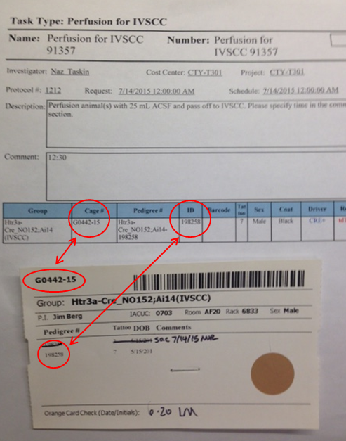
Figure 1. Verifying the cage number and specimen ID match the perfusion request

  - Perfusion Setup:
    - Obtain HEPES-Sucrose cutting solution from 4°C fridge.
      - Calculate the total volume of HEPES needed for all mouse perfusions that day by adding 30 ml HEPES for each animal being perfused. Add 20 ml to that total to account for the large surface area of the bottom of the jar holding HEPES.
    - Prepare ice bath in 1 L beaker (see Figure 2):
      - Fill beaker ~1/4 full of wet ice & ~100 ml DI water.
      - Place jar with HEPES solution into ice bath.
      - Carefully pour ice around HEPES jar until ice almost reaches top of beaker. Fill beaker with DI water until water level is at least even with HEPES solution in jar.
      - Wrap tubing once around HEPES jar and set on top of ice bath.
      - Carefully scoop ice on top of tubing so that as much tubing as possible is covered.
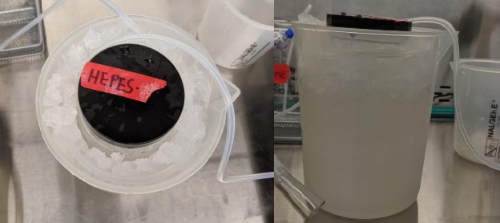
Figure 2. HEPES Ice Bath

    - Attach the 22G blunt tip perfusion needle to the luer connector by twisting it on tightly.
    - Place feeding tube into HEPES solution. Turn pump power on and press any key to initialize. Set to Pump mode (by pressing the mode key until “Pump” is highlighted), press start and pump until HEPES exits the needle, at least 6 ml. This will ensure that no bubbles are introduced into the mouse cardiovascular system.
    - Set the flow rate of the pump to 2 ml/min by pressing the Set button, followed by the Rate button, followed by 2, then Enter.
    - Press mode until Pump mode is highlighted and reads 0 ml.
    - Place perfusion board inside plastic tray.
    - Place nose cone on one end of perfusion board.

  - Dissection Setup:
    - Place absorbent pad down over dissection area.
    - Place dissection tools and carcass bag onto absorbent pad.
  - Freezing Setup:
    - Retrieve liquid nitrogen from an LN₂ storage tank by pouring directly into a liquid nitrogen Dewar flask.
      - Note: Face shield and cryogloves must be worn when obtaining LN₂ from storage tank. Any containers holding LN₂ must be transported on a cart, not hand carried.
    - Once back at procedure area, decant LN₂ into an insulated dry ice bucket until bucket is ¾ full.
      - Note: Use insulated gloves and eye protection whenever LN₂ is transferred from the Dewar flask to another container.
    - Place lid back on bucket to slow the evaporation of LN₂.
    - Fill the other dry ice bucket with dry ice.
    - Using a cryomarker label the tops of all 5 ml centrifuge tubes with the animal ID.
    - Fill all 5 ml centrifuge tubes with 1 ml of OCT.
    - Place all 5 ml centrifuge tubes into the dry ice to freeze the OCT.
      - Note: If the lids are left off the tubes, it is easier to put the specimen in the tube after flash freezing.
    - Place insulated gloves and angled spoon near the dry ice bucket containing LN₂.
- Methodology/Procedures:
  - Perfusion Procedure
    - After removing mouse from cage, double check the cage number, LabTracks ID, ear notches, sex, and tattoos all are consistent with what is requested on the perfusion task.
    - Weight the animal and record on LabTracks task.
    - Follow steps in LASWI-0038 Isoflurane Use for Anesthesia to anesthetize animal to a surgical plane.
    - Start the timer when mouse is first placed into the induction chamber.
      - Place the mouse in the induction chamber. Turn on oxygen and verify flowmeter is set to 1. Turn the vaporizer to 5%. Leave the mouse in the chamber until mouse reaches surgical plane of anesthesia, about 2-3 minutes.
      - Switch Isoflurane flow to a nose cone. Position the mouse supine, with nose inserted into the nose cone; Isoflurane flow should be at 2.5-3%.
    - Use the toe pinch reflex test to determine whether the mouse is anesthetized to a surgical plane. The absence of a response indicates the mouse is ready to be perfused.
    - Pin all four paws to the perfusion board with needles.
    - Spray mouse body with 70% Ethanol.
    - Cut the ventral surface of skin over the diaphragm using surgical scissors.
    - Grasp the xyphoid process with forceps. Carefully snip the diaphragm to open the thoracic cavity.
    - While holding the xyphoid process, snip up both sides of the rib cage. Avoid nicking the heart, lungs, or the veins going along the rib cage.
    - Bend the flap of muscle and ribs (created by the previous step) and pin the top part of the rib cage to the perfusion board with a needle.
    - Grasp the heart and then insert the blunt perfusion needle into the left ventricle directing the tip of the needle toward the aorta (see Figure 3 for anatomical reference). Note: exsanguination will not occur if needle is placed in the right ventricle or crosses the septum.
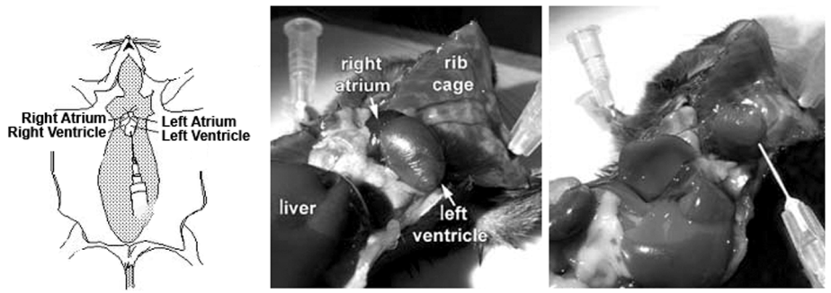
Figure 3. Anatomical reference for mouse preparation and needle placement.

    - Lay needle and tubing flat against the perfusion board. Ensure that the needle remains in place in the heart during this process.
    - Press start to run 2 ml of HEPES.
    - After 2 ml of HEPES pumps press Stop.
    - Set the flow rate of the pump to 5 ml/min by pressing the Set button, followed by the Rate button, followed by 5, then Enter.
    - Carefully snip the right atrium.
    - Press mode until Pump mode is highlighted and reads 0 ml. Press start to run 20 ml of HEPES.
    - The isoflurane should be turned off after 10 ml of HEPES is dispensed.
    - Once the pump dispenses 20 ml of HEPES press Stop.
    - Remove the needles from the animal and hand off for dissection.
    - Also hand off timer to the person dissecting and freezing.
    - Restart procedure at 8.1 if more than one animal is being perfused.
  - Dissection Procedure
    - Immediately following perfusion, remove the head of the mouse by decapitation (mayo scissors can be used here).
    - Using the fine dissection scissors, start at the neck and make an incision across the top of the head toward the nose to begin to expose the skull.
    - Make cuts through each ear to further pull back the tissue from the skull.
    - Shift loose skin tissue forward toward the nose. Note: Do not remove skin from skull as this will make the skull more difficult to handle.
    - Cut excess tissue and vertebrae off the back of the skull.
    - Using the angled scissors, start at the opening in the occipital bone at the back of the skull and working through the skull forward to the eye sockets.
      - Always brace the scissors upward, away from the brain, to avoid damaging the brain tissue.
      - Make small cuts without letting the scissors close completely, then advance the scissors forward and cut again, repeat until the cut reaches the eye sockets. Avoid bringing the scissors fully out of an incomplete cut, trying to replace the scissors into an uncompleted cut will likely cause tissue damage.
      - Put gentle pressure on both lateral sides of the skull while cutting to help make room for the scissors.
    - Make a cut perpendicular to original cut across the frontal bones (between the eye sockets).
    - Peel back the frontal, parietal, and occipital bones using fine forceps.
      - Use scissors or forceps to clear the dura.
    - Using forceps or spatula, gently scoop the brain backward out of the skull and onto the angled spoon.
      - Be sure the ventral surface of the brain is sitting on the angled spoon surface. The dorsal surface of the brain should be facing upward so the cortex is not compressed during flash freezing.
  - Flash Freezing Procedure
    - Put on the insulated gloves.
    - Remove the lid from the insulated bucket containing LN₂.
    - Lower the angled spoon with brain tissue into the LN₂ vapor.
      - Do not submerge angled spoon or brain in the LN₂.
      - Keep angled spoon as close to the LN₂ liquid as possible without touching the liquid.
    - Hold angled spoon and tissue in the LN₂ vapor for 2 minutes (until brain is frozen).
      - Use the timer to ensure a full 2 minutes in LN₂ vapor is completed.
      - Brain will appear white and dry when fully frozen.
      - As brain is freezing vapor can be observed leaving the brain. This is the moisture that is leaving the tissue.
    - When the tissue is mostly white and vapor has stopped coming off the brain (2 minutes), take the angled spoon out of LN₂ vapor.
    - Stop the timer and record total procedure time on LabTracks task.
    - Remove insulated gloves.
    - Lightly rub the angled spoon on the back of your hand to unfreeze the brain from the angled spoon.
    - Place the frozen brain into the 5 ml centrifuge tube containing 1 ml frozen OCT and cap the tube.
    - Repeat steps 8.2.1 to 8.3.9 for all specimens being collected.
    - Once all specimens have been collected, place them in the cardboard storage box. Place the box in the -80°C freezer, unless otherwise instructed.
    - Enter specimen(s) into Cold Storage Catalogue.
    - Enter any notes on the Perfusion/Dissection tracking sheet.
    - Send notes to PI. Include in notes: Pups take longer to anesthetize.
- Take Down:
  - After the last perfusion move the feeder tubing into DI water and pump the water for a minimum of 6 ml.
  - Remove the tube from DI water and Pump air through the tube until it passes the stopcock. Press Stop.
  - Using approved disinfectant, clean the peristaltic pump as well as the tubing that was contaminated by blood during the perfusion process.
  - Unused, expired, or excess HEPES can be disposed of down municipal sewer.
  - Store HEPES for up to two weeks at 4°C
  - Place plastic tray, perfusion board, dissection pad, scissors, and forceps in the sink and spray with approved disinfectant. Use water and a brush to remove debris. Rinse in 70% Ethanol and place on an absorbent pad to dry.
  - Dispose of used needles in a Sharps container.
  - Clean induction chamber with approved disinfectant.
  - Place biohazardous contaminated materials, such as used gauze and absorbent pad in biohazard trash container.
  - Dispose of animal carcass in appropriate animal waste container.
  - Dispose of blood contaminated HEPES in waste container.
  - Evaporate excess LN₂ in a biosafety cabinet.
  - 70% Ethanol can be stored in a secondary container for up to one year.

