**Lower hemoglobin levels associate with higher baroreflex sensitivity and heart rate variability**

Running head: Hemoglobin and heart rate variability

Joona Tapio1*, MD, PhD, Antti M. Kiviniemi2, PhD, Juha Perkiömäki2, MD, PhD, M. Juhani Junttila2, MD, PhD, Heikki Huikuri2, MD, PhD, Olavi Ukkola2, MD, PhD, Peppi Koivunen1, MD, PhD, Mikko P. Tulppo3,4*, PhD.

1Biocenter Oulu and Faculty of Biochemistry and Molecular Medicine, Oulu Center for Cell-Matrix Research, University of Oulu, P.O. Box 5400, FIN-90014 Oulu, Finland.

2Medical Research Center Oulu, Faculty of Medicine, Oulu University Hospital and Research Unit of Internal Medicine, University of Oulu, P.O. Box 5000, 90014, Oulu, Finland

3Research Unit of Biomedicine and Internal Medicine, University of Oulu, P.O. Box 5000, 90014 Oulu, Finland.

4Medical Research Center Oulu, Oulu University Hospital and University of Oulu, P.O. Box 5000, 90014 Oulu, Finland.

*To whom correspondence should be addressed:

Joona Tapio, email: [joona.tapio@oulu.fi](mailto:joona.tapio@oulu.fi), Mikko P. Tulppo, email: [mikko.tulppo@oulu.fi](mailto:mikko.tulppo@oulu.fi)

**Supplementary materials**

**Methods**

**Study population**

Participants were interviewed, clinically examined and tested in our research laboratory. The Finnish reference values for Hb represent the age-correlated 2.5–97.5% Hb reference range determined by the Finnish National Working Group for basic blood count reference intervals1. Valsalva BRS was available for 433 participants (Figure S1).

**Background information and clinical measurements**

Lifetime smoking burden was determined as pack-years (1 pack-year = 20 cigarettes smoked/day in 1 year) and obtained from a questionnaire. Alcohol consumption was obtained from a questionnaire in number of standard drinks/wk which was converted to g/wk. Physical activity was assessed by a standardized health questionnaire covering physical activity using the method described by Grimby2. Physical activity was classed as none, mild, moderate, or heavy physical activity. Lipid lowering and blood pressure medication users were determined from patient records. Body mass index (BMI) was calculated as weight (kg) divided by height squared (m2). Height was measured to the nearest centimeter (cm) without shoes using a stadiometer and a sliding horizontal headpiece which was adjusted to rest on the top of the head. Weight was measured to the nearest 0.1 kg with the subject wearing only light underwear without shoes using a SECA personal scale calibrated yearly and used for independent medical weighing and measuring. Waist and hip circumferences were measured using a tape measurer to the nearest 0.1 cm and waist-hip ratio was calculated from these values. All measurements were performed by the same specially trained nurses. Bp measurements were undertaken with an automatic oscillometric bp recorder (Dinamap, Critikon Ltd., Ascot, UK) and conducted according to the recommendations of the American Society of Hypertension3. Resting bp was measured three times at 1-min intervals from the right arm after the subject had been seated for at least 5 min. The mean value of the second and third bp measurements was used in the analyses.

**Laboratory analyses**

Blood samples were analysed in NordLab Oulu (former name Oulu University Hospital, Laboratory), a testing laboratory (T113) accredited by Finnish Accreditation Service (FINAS) (EN ISO 15189). Blood Hb levels were determined using the sodium lauryl sulfate method (SLS). Fasting glucose concentrations were measured with the glucose dehydrogenase method (Diagnostica, Merck, Darmstadt, Germany) and fasting insulin levels with a two-site immunoenzymometric assay (AIA-PACK IRI, Tosoh Corp., Tokyo, Japan). HOMA-IR was calculated with the equation (fasting insulin (mU/mL) x fasting glucose (mmol/L) / 22.5). Very-low-density lipoprotein (VLDL) fraction was separated from plasma by ultracentrifugation at 10,500 × *g* for 18 h. Plasma high-density lipoprotein (HDL) cholesterol concentration was measured by mixing 0.5 mL of the VLDL-free fraction with 25 mL of 2.8% (wt/vol) heparin and 25 mL of 2 M manganese chloride and measuring the cholesterol concentration in the supernatant after centrifugation at 1000 × *g* and 4 °C for 30 min. Low-density lipoprotein (LDL) cholesterol concentration was calculated by subtracting the cholesterol concentration in HDL from that in the VLDL-free fraction.

**HRV and Valsalva baroreflex measurements**

The ECG data were transferred from the ECG scanner to a microcomputer for an analysis of HRV (Hearts 1.2, University of Oulu, Oulu, Finland). The ECG recordings were done between 7 am and 3 pm. Noise and premature depolarizations were removed from the RR interval (RRi) data both automatically and manually and replaced with average values. A subject was included in the present analysis if at least 85% of the beats were qualified4. The index of the standard deviation (SD) of the RRi (SDNNindex) was used as a time domain measure. An autoregressive model was used to estimate the power spectral densities of three frequency bands (high-frequency [HF] power 0.15 to 0.4 Hz, low-frequency [LF] power 0.04 to 0.15 Hz, very low-frequency [VLF] power 0.005 to 0.04 Hz and total power < 0.4 Hz). The spectral components of HRV were analyzed as in absolute units. The ratio between LF and HF power (LFHF) was also calculated.

The Valsalva maneuver was performed 3 times with 5-minute intervals. ECG and bp (Finapres, Ohmeda Monitoring Systems, Englewood, Colorado) were continuously recorded with sampling frequency of 200 Hz and analyzed with a software package (CAFTS; Medikro Oy, Kuopio, Finland).

**Statistical methods**

A Pearson correlation coefficient (r) ± 95% Confidence Intervals (CI) were calculated between Hb levels and presented variables to evaluate their unadjusted associations. A stepwise method of linear regression was used to determine the optimally adjusted multivariate model for association of Hb levels and presented variables. In the adjusted model age, sex, BMI, smoking, systolic bp, bp medication, fasting glucose and HDL cholesterol were entered as covariates. Parameters that have a high co-linearity with any of the selected covariates (such as diastolic bp with systolic bp or fasting insulin with fasting glucose) were left out of the adjusted model. B values were given as standardized values. The confidence intervals for B weights were estimated by running multiple regression analyses with Z-score standardized predictor variables.

The effect size presented represents a change of the presented variable in SD units for every 1 SD unit change in Hb levels. Continuous variables were presented as mean ± SD and categorical variables as exact counts + percentages. *P* values ≤ 0.05 were considered statistically significant. *P* values < 0.0001 were not given as exact values. Statistical analyses were calculated using IBM SPSS statistics version 25.0 (IBM Corp, Armonk, NY).

**Table S1. Number of participants and statistical significance in one-way ANOVA analyses of background and metabolic parameters (Table 1).** Hb; Hemoglobin**,** Bp; Blood Pressure**,** Ca; Calcium**,** ACE; Angiotensin Converting Enzyme, BMI; Body Mass Index, WH; ratio Waist to Hip ratio, HOMA-IR; Homeostatic Model Assessment For Insulin Resistance**,** HDL; High-Density Lipoprotein, LDL; Low-Density Lipoprotein**.** Hb; Hemoglobin**,** Bp; Blood Pressure**,** Ca; Calcium**,** ACE; Angiotensin Converting Enzyme, BMI; Body Mass Index, WH; ratio Waist to Hip ratio, HOMA-IR; Homeostatic Model Assessment For Insulin Resistance**,** HDL; High-Density Lipoprotein, LDL; Low-Density Lipoprotein**.**

|  |  |  |  |  |  |
| --- | --- | --- | --- | --- | --- |
|  | All subjects | Hb Tertile 1 | Hb Tertile 2 | Hb Tertile 3 |  |
|  | n | n | n | n | *p* |
| Age (years) | 733 | 269 | 241 | 223 | 0.870 |
| Hb (g/L) | 733 | 269 | 241 | 223 | < 0.0001 |
| Smoking (package years) | 733 | 269 | 241 | 223 | 0.019 |
| Alcohol consumption (g/week) | 733 | 269 | 241 | 223 | 0.148 |
| Physical activity | 721 | 265 | 237 | 219 | 0.391 |
| Lipid medication users (n) | 733 | 269 | 241 | 223 | 0.333 |
| Bp medication users (n) | 733 | 269 | 241 | 223 | 0.017 |
| Digitalis users (n) | 733 | 269 | 241 | 223 | 0.382 |
| Diuretics users (n) | 733 | 269 | 241 | 223 | 0.330 |
| Beta blocker users (n) | 733 | 269 | 241 | 223 | 0.083 |
| Ca channel blocker users (n) | 733 | 269 | 241 | 223 | 0.153 |
| ACE blocker users (n) | 733 | 269 | 241 | 223 | 0.627 |
| BMI (kg/m2) | 733 | 269 | 241 | 223 | < 0.0001 |
| Waist circumference (cm) | 731 | 268 | 241 | 222 | < 0.001 |
| Hip circumference (cm) | 731 | 268 | 241 | 222 | < 0.001 |
| WH ratio | 731 | 268 | 241 | 222 | 0.065 |
| Systolic bp (mmHg) | 733 | 269 | 241 | 223 | < 0.0001 |
| Diastolic bp (mmHg) | 733 | 269 | 241 | 223 | < 0.0001 |
| Heart rate (bpm) | 733 | 269 | 241 | 223 | 0.041 |
| Fasting glucose (mmol/L) | 733 | 269 | 241 | 223 | 0.021 |
| Fasting insulin (mU/L) | 733 | 269 | 241 | 223 | < 0.001 |
| HOMA-IR | 733 | 269 | 241 | 223 | < 0.001 |
| Total cholesterol (mmol/L) | 733 | 269 | 241 | 223 | 0.372 |
| Triglycerides (mmol/L) | 733 | 269 | 241 | 223 | < 0.0001 |
| HDL cholesterol (mmol/L) | 733 | 269 | 241 | 223 | 0.005 |
| LDL cholesterol (mmol/L) | 733 | 269 | 241 | 223 | 0.276 |

**Table S2. Background and metabolic characteristics of males in the study population.** The values are mean with (SD) or percentages. SD; Standard Deviation**,** Hb; Hemoglobin**,** Bp; Blood Pressure**,** Ca; Calcium**,** ACE; Angiotensin Converting Enzyme, BMI; Body Mass Index, WH ratio; Waist to Hip ratio, HOMA-IR; Homeostatic Model Assessment For Insulin Resistance**,** HDL; High-Density Lipoprotein, LDL; Low-Density Lipoprotein**.** SD; Standard Deviation**,** Hb; Hemoglobin**,** Bp; Blood Pressure**,** Ca; Calcium**,** ACE; Angiotensin Converting Enzyme, BMI; Body Mass Index, WH ratio; Waist to Hip ratio, HOMA-IR; Homeostatic Model Assessment For Insulin Resistance**,** HDL; High-Density Lipoprotein, LDL; Low-Density Lipoprotein**.**

|  |  |  |  |  |
| --- | --- | --- | --- | --- |
|  | All male subjects | Hb Tertile 1 | Hb Tertile 2 | Hb Tertile 3 |
|  | Mean (SD/%) | Mean (SD/%) | Mean (SD/%) | Mean (SD/%) |
| Number of subjects (n) | 389 | 141 | 135 | 113 |
| Age (years) | 50.63 (6.15) | 51.10 (6.14) | 50.05 (6.07) | 50.75 (6.24) |
| Hb (g/L) | 150.71 (7.86) | 142.16 (3.84) | 151.88 (2.25) | 159.97 (3.03) |
| Smoking (package years) | 14.04 (15.67) | 14.83 (15.40) | 11.23 (13.97) | 16.42 (17.46) |
| Alcohol consumption (g/week) | 97.47 (106.69) | 84.30 (100.25) | 103.71 (112.85) | 106.45 (106.24) |
| Physical activity (none) | 14 (3.6) | 2 (1.4) | 8 (5.9) | 4 (3.5) |
| Physical activity (irregular) | 125 (32.1) | 45 (31.9) | 39 (28.9) | 41 (36.3) |
| Physical activity (regular) | 131 (33.7) | 47 (33.3) | 45 (33.3) | 39 (34.5) |
| Physical activity (active) | 110 (28.3) | 45 (31.91) | 39 (28.9) | 26 (23.0) |
| Lipid medication users (n) | 16 (4.1) | 5 (3.5) | 6 (4.4) | 5 (4.4) |
| Bp medication users (n) | 195 (50.1) | 70 (49.6) | 64 (47.4) | 61 (54.0) |
| Digitalis users (n) | 4 (1.0) | 2 (1.4) | 0 (0) | 2 (1.8) |
| Diuretics users (n) | 45 (11.6) | 16. (11.3) | 15 (11.1) | 14 (12.4) |
| Beta blocker users (n) | 112 (28.8) | 37 (26.2) | 35 (25.9) | 40 (35.4) |
| Ca channel blocker users (n) | 48 (12.3) | 13 (9.2) | 18 (13.3) | 17 (15.0) |
| ACE blocker users (n) | 84 (21.6) | 35 (24.8) | 28 (20.7) | 21 (18.6) |
| BMI (kg/m2) | 27.95 (4.20) | 27.33 (4.20) | 27.57 (3.65) | 29.17 (4.57) |
| Waist circumference (cm) | 97.40 (10.77) | 95.87 (11.28) | 96.64 (9.52) | 100.24 (11.06) |
| Hip circumference (cm) | 104.57 (7.39) | 103.42 (7.11) | 104.17 (6.87) | 106.47 (8.00) |
| WH ratio | 0.93 (0.06) | 0.92 (0.06) | 0.93 (0.06) | 0.94 (0.05) |
| Systolic bp (mmHg) | 151.71 (20.49) | 148.72 (21.48) | 151.70 (19.57) | 155.45 (19.88) |
| Diastolic bp (mmHg) | 92.48 (10.91) | 90.51 (11.82) | 93.06 (10.27) | 94.24 (10.17) |
| Heart rate (bpm) | 72.07 (14.27) | 70.09 (14.86) | 73.26 (14.05) | 73.12 (13.62) |
| Fasting glucose (mmol/L) | 4.82 (1.51) | 4.79 (1.37) | 4.73 (1.29) | 4.97 (1.87) |
| Fasting insulin (mU/L) | 15.57 (13.43) | 12.83 (8.29) | 16.37 (17.11) | 18.03 (13.14) |
| HOMA-IR | 3.54 (4.03) | 2.88 (2.50) | 3.57 (4.21) | 4.34 (5.10) |
| Total cholesterol (mmol/L) | 5.78 (1.05) | 5.68 (1.05) | 5.82 (1.00) | 5.85 (1.12) |
| Triglycerides (mmol/L) | 1.71 (0.98) | 1.55 (0.69) | 1.68 (1.04) | 1.96 (1.16) |
| HDL cholesterol (mmol/L) | 1.22 (0.30) | 1.25 (0.30) | 1.23 (0.31) | 1.15 (0.30) |
| LDL cholesterol (mmol/L) | 3.69 (0.95) | 3.62 (0.95) | 3.74 (0.93) | 3.72 (0.97) |

**Table S3. Background and metabolic characteristics of females in the study population.** The values are mean with (SD) or percentages. SD; Standard Deviation**,** Hb; Hemoglobin**,** Bp; Blood Pressure**,** Ca; Calcium**,** ACE; Angiotensin Converting Enzyme, BMI; Body Mass Index, WH ratio; Waist to Hip ratio, HOMA-IR; Homeostatic Model Assessment For Insulin Resistance**,** HDL; High-Density Lipoprotein, LDL; Low-Density Lipoprotein**.**

|  |  |  |  |  |
| --- | --- | --- | --- | --- |
|  | All female subjects | Hb Tertile 1 | Hb Tertile 2 | Hb Tertile 3 |
|  | Mean (SD/%) | Mean (SD/%) | Mean (SD/%) | Mean (SD/%) |
| Number of subjects (n) | 344 | 128 | 106 | 110 |
| Age (years) | 51.81 (5.85) | 51.20 (5.83) | 52.37 (6.00) | 51.98 (5.71) |
| Hb (g/L) | 134.51 (8.25) | 126.19 (4.21) | 134.58 (1.88) | 144.13 (3.93) |
| Smoking (package years) | 4.47 (9.77) | 2.83 (6.18) | 4.07 (9.90) | 6.78 (12.36) |
| Alcohol consumption (g/week) | 25.00 (40.11) | 22.59 (42.28) | 24.10 (32.82) | 28.68 (43.84) |
| Physical activity (none) | 23 (6.7) | 11 (8.6) | 3 (2.8) | 9 (8.2) |
| Physical activity (irregular) | 92 (26.7) | 27 (21.1) | 34 (32.1) | 31 (28.2) |
| Physical activity (regular) | 102 (29.7) | 42 (32.8) | 30 (28.3) | 30 (27.3) |
| Physical activity (active) | 124 (36.0) | 46 (35.9) | 39 (36.8) | 39 (35.5) |
| Lipid medication users (n) | 8 (2.3) | 1 (0.8) | 5 (4.7) | 2 (1.8) |
| Bp medication users (n) | 184 (53.5) | 59 (46.1) | 53 (50.0) | 72 (65.5) |
| Digitalis users (n) | 11 (3.2) | 2 (1.6) | 4 (3.8) | 5 (4.5) |
| Diuretics users (n) | 68 (19.8) | 21 (16.4) | 20 (18.9) | 27 (24.5) |
| Beta blocker users (n) | 91 (26.5) | 29 (22.7) | 28 (26.4) | 34 (30.9) |
| Ca channel blocker users (n) | 45 (13.1) | 15 (11.7) | 11 (10.4) | 19 (17.3) |
| ACE blocker users (n) | 58 (16.9) | 22 (17.2) | 17 (16.0) | 19 (17.3) |
| BMI (kg/m2) | 27.47 (5.15) | 26.37 (4.85) | 27.37 (4.90) | 28.86 (5.45) |
| Waist circumference (cm) | 83.60 (11.72) | 81.08 (11.55) | 83.08 (10.84) | 87.03 (12.00) |
| Hip circumference (cm) | 104.16 (9.59) | 102.43 (8.88) | 104.00 (9.39) | 106.32 (10.22) |
| WH ratio | 0.80 (0.06) | 0.79 (0.07) | 0.80 (0.05) | 0.82 (0.06) |
| Systolic bp (mmHg) | 146.20 (22.00) | 140.09 (20.66) | 147.27 (21.40) | 152.28 (22.40) |
| Diastolic bp (mmHg) | 86.52 (11.97) | 83.12 (12.32) | 87.22 (10.76) | 89.79 (11.72) |
| Heart rate (bpm) | 75.74 (12.15) | 74.86 (11.90) | 74.69 (12.17) | 77.79 (12.29) |
| Fasting glucose (mmol/L) | 4.56 (1.04) | 4.41 (0.57) | 4.46 (0.71) | 4.83 (1.57) |
| Fasting insulin (mU/L) | 11.89 (8.52) | 10.50 (7.44) | 11.13 (8.22) | 14.24 (9.52) |
| HOMA-IR | 2.51 (2.08) | 2.15 (1.75) | 2.31 (2.02) | 3.11 (2.36) |
| Total cholesterol (mmol/L) | 5.63 (1.00) | 5.59 (0.96) | 5.66 (1.01) | 5.64 (1.02) |
| Triglycerides (mmol/L) | 1.40 (0.88) | 1.30 (0.81) | 1.29 (0.81) | 1.62 (0.97) |
| HDL cholesterol (mmol/L) | 1.50 (0.38) | 1.55 (0.39) | 1.51 (0.36) | 1.42 (0.38) |
| LDL cholesterol (mmol/L) | 3.41 (0.91) | 3.35 (0.93) | 3.47 (0.90) | 3.42 (0.89) |

**Table S4. Number of participants and statistical significance in one-way ANOVA analyses of baroreflex sensitivity and heart rate variability parameters (Table 2).** Hb; Hemoglobin, BRS; Baroreflex Sensitivity, RRi; R-R interval, SDNNindex; index of the SD of the RRi, HF; High Frequency, ln; natural logarithm, LF; Low Frequency, VLF; Very Low Frequency, LFHF; LF to HF ratio.

|  |  |  |  |  |  |
| --- | --- | --- | --- | --- | --- |
|  | All subjects | Hb Tertile 1 | Hb Tertile 2 | Hb Tertile 3 |  |
|  | n | n | n | n | *p* |
| BRS | 443 | 167 | 153 | 123 | 0.027 |
| **Total** |  |  |  |  |  |
| RRi (ms) | 733 | 269 | 241 | 223 | 0.022 |
| SDNNindex | 733 | 269 | 241 | 223 | 0.004 |
| HF (ln) | 733 | 269 | 241 | 223 | 0.023 |
| LF (ln) | 733 | 269 | 241 | 223 | 0.074 |
| VLF (ln) | 733 | 269 | 241 | 223 | 0.009 |
| LFHF | 733 | 269 | 241 | 223 | 0.800 |
| **Lying down** |  |  |  |  |  |
| RRi (ms) | 733 | 269 | 241 | 223 | 0.015 |
| SDNNindex | 733 | 269 | 241 | 223 | 0.042 |
| HF (ln) | 733 | 269 | 241 | 223 | 0.042 |
| LF (ln) | 733 | 269 | 241 | 223 | 0.299 |
| VLF (ln) | 733 | 269 | 241 | 223 | 0.112 |
| LFHF | 733 | 269 | 241 | 223 | 0.532 |
| **Sitting down** |  |  |  |  |  |
| RRi (ms) | 733 | 269 | 241 | 223 | 0.034 |
| SDNNindex | 733 | 269 | 241 | 223 | 0.045 |
| HF (ln) | 733 | 269 | 241 | 223 | 0.018 |
| LF (ln) | 733 | 269 | 241 | 223 | 0.050 |
| VLF (ln) | 733 | 269 | 241 | 223 | 0.011 |
| LFHF | 733 | 269 | 241 | 223 | 0.336 |
| **Walking** |  |  |  |  |  |
| RRi (ms) | 733 | 269 | 241 | 223 | 0.058 |
| SDNNindex | 733 | 269 | 241 | 223 | 0.006 |
| HF (ln) | 733 | 269 | 241 | 223 | 0.025 |
| LF (ln) | 733 | 269 | 241 | 223 | 0.057 |
| VLF (ln) | 733 | 269 | 241 | 223 | 0.012 |
| LFHF | 733 | 269 | 241 | 223 | 0.137 |

**Table S5. Baroreflex and heart rate variability parameters of males in the study population.** Hb; Hemoglobin, BRS; Baroreflex Sensitivity, RRi; R-R interval, SDNNindex; index of the SD of the RRi, HF; High Frequency, ln; natural logarithm, LF; Low Frequency, VLF; Very Low Frequency, LFHF; LF to HF ratio.

|  |  |  |  |  |  |  |  |  |
| --- | --- | --- | --- | --- | --- | --- | --- | --- |
|  | All male subjects | | Hb Tertile 1 | | Hb Tertile 2 | | Hb Tertile 3 | |
|  | n | Mean (SD) | n | Mean (SD) | n | Mean (SD) | n | Mean (SD) |
| BRS | 254 | 9.66 (4.40) | 91 | 10.58 (4.60) | 96 | 9.25 (4.24) | 67 | 9.00 (4.21) |
| **Total** |  |  |  |  |  |  |  |  |
| RRi (ms) | 389 | 828.0 (126.1) | 141 | 843.6 (126.8) | 135 | 821.1 (134.5) | 113 | 816.6 (113.6) |
| SDNNindex | 389 | 56.1 (19.4) | 141 | 58.5 (19.4) | 135 | 55.9 (20.3) | 113 | 53.4 (18.2) |
| HF (ln) | 389 | 5.09 (0.78) | 141 | 5.16 (0.79) | 135 | 5.07 (0.77) | 113 | 5.05 (0.78) |
| LF (ln) | 389 | 5.93 (0.83) | 141 | 5.96 (0.86) | 135 | 5.93 (0.79) | 113 | 5.88 (0.83) |
| VLF (ln) | 389 | 6.82 (0.75) | 141 | 6.90 (0.75) | 135 | 6.81 (0.76) | 113 | 6.75 (0.73) |
| LFHF | 389 | 2.67 (1.51) | 141 | 2.65 (1.59) | 135 | 2.71 (1.46) | 113 | 2.66 (1.49) |
| **Lying down** |  |  |  |  |  |  |  |  |
| RRi (ms) | 389 | 903.1 (144.2) | 141 | 922.2 (146.2) | 135 | 892.6 (152.8) | 113 | 891.6 (129.2) |
| SDNNindex | 389 | 55.0 (23.3) | 141 | 56.79 (24.16) | 135 | 55.36 (22.95) | 113 | 52.34 (22.55) |
| HF (ln) | 389 | 5.24 (0.87) | 141 | 5.28 (0.90) | 135 | 5.24 (0.84) | 113 | 5.18 (0.88) |
| LF (ln) | 389 | 6.01 (0.88) | 141 | 6.01 (0.87) | 135 | 6.01 (0.88) | 113 | 6.00 (0.91) |
| VLF (ln) | 389 | 6.81 (0.84) | 141 | 6.85 (0.84) | 135 | 6.82 (0.84) | 113 | 6.75 (0.83) |
| LFHF | 389 | 2.60 (1.60) | 141 | 2.55 (1.66) | 135 | 2.56 (1.57) | 113 | 2.69 (1.57) |
| **Sitting down** |  |  |  |  |  |  |  |  |
| RRi (ms) | 389 | 845.0 (136.4) | 141 | 862.5 (135.6) | 135 | 834.9 (142.3) | 113 | 835.0 (129.1) |
| SDNNindex | 389 | 63.6 (24.7) | 141 | 65.7 (23.4) | 135 | 62.9 (27.3) | 113 | 61.7 (23.1) |
| HF (ln) | 389 | 5.09 (0.86) | 141 | 5.17 (0.82) | 135 | 5.05 (0.85) | 113 | 5.04 (0.91) |
| LF (ln) | 389 | 6.05 (0.89) | 141 | 6.12 (0.93) | 135 | 6.03 (0.86) | 113 | 6.00 (0.87) |
| VLF (ln) | 389 | 7.02 (0.85) | 141 | 7.13 (0.80) | 135 | 6.96 (0.86) | 113 | 6.95 (0.88) |
| LFHF | 389 | 3.19 (2.54) | 141 | 3.14 (2.02) | 135 | 3.10 (1.76) | 113 | 3.35 (3.67) |
| **Walking** |  |  |  |  |  |  |  |  |
| RRi (ms) | 389 | 735.8 (112.6) | 141 | 746.1 (114.2) | 135 | 735.8 (121.9) | 113 | 723.1 (97.8) |
| SDNNindex | 389 | 49.8 (23.1) | 141 | 53.0 (25.3) | 135 | 49.5 (23.0) | 113 | 46.1 (19.7) |
| HF (ln) | 389 | 4.71 (0.77) | 141 | 4.81 (0.81) | 135 | 4.68 (0.77) | 113 | 4.64 (0.73) |
| LF (ln) | 389 | 5.45 (0.94) | 141 | 5.47 (1.01) | 135 | 5.48 (0.91) | 113 | 5.37 (0.90) |
| VLF (ln) | 389 | 6.29 (0.85) | 141 | 6.39 (0.87) | 135 | 6.29 (0.87) | 113 | 6.16 (0.78) |
| LFHF | 389 | 2.73 (2.39) | 141 | 2.51 (1.81) | 135 | 2.97 (2.73) | 113 | 2.73 (2.59) |

**Table S6. Baroreflex and heart rate variability parameters of females in the study population.** Hb; Hemoglobin, BRS; Baroreflex Sensitivity, RRi; R-R interval, SDNNindex; index of the SD of the RRi, HF; High Frequency, ln; natural logarithm, LF; Low Frequency, VLF; Very Low Frequency, LFHF; LF to HF ratio.

|  |  |  |  |  |  |  |  |  |
| --- | --- | --- | --- | --- | --- | --- | --- | --- |
|  | All female subjects | | Hb Tertile 1 | | Hb Tertile 2 | | Hb Tertile 3 | |
|  | n | Mean (SD) | n | Mean (SD) | n | Mean (SD) | n | Mean (SD) |
| BRS | 189 | 7.42 (4.56) | 76 | 7.95 (5.37) | 57 | 7.48 (3.74) | 56 | 6.65 (4.06) |
| **Total** |  |  |  |  |  |  |  |  |
| RRi (ms) | 344 | 826.5 (114.0) | 128 | 839.0 (115.5) | 106 | 833.0 (121.0) | 110 | 805.8 (102.9) |
| SDNNindex | 344 | 54.7 (17.5) | 128 | 57.3 (17.7) | 106 | 55.1 (17.3) | 110 | 51.3 (17.1) |
| HF (ln) | 344 | 5.22 (0.82) | 128 | 5.35 (0.84) | 106 | 5.25 (0.82) | 110 | 5.05 (0.78) |
| LF (ln) | 344 | 5.80 (0.84) | 128 | 5.92 (0.80) | 106 | 5.80 (0.85) | 110 | 5.66 (0.86) |
| VLF (ln) | 344 | 6.79 (0.73) | 128 | 6.90 (0.69) | 106 | 6.79 (0.74) | 110 | 6.64 (0.76) |
| LFHF | 344 | 2.04 (1.16) | 128 | 1.98 (0.93) | 106 | 2.01 (1.20) | 110 | 2.15 (1.35) |
| **Lying down** |  |  |  |  |  |  |  |  |
| RRi (ms) | 344 | 892.7 (129.8) | 128 | 907.6 (129.7) | 106 | 901.7 (136.9) | 110 | 866.8 (119.6) |
| SDNNindex | 344 | 50.2 (19.9) | 128 | 52.6 (20.3) | 106 | 50.4 (19.3) | 110 | 47.3 (20.0) |
| HF (ln) | 344 | 5.34 (0.95) | 128 | 5.47 (0.99) | 106 | 5.38 (0.91) | 110 | 5.14 (0.90) |
| LF (ln) | 344 | 5.86 (0.89) | 128 | 5.99 (0.82) | 106 | 5.82 (0.92) | 110 | 5.76 (0.94) |
| VLF (ln) | 344 | 6.66 (0.85) | 128 | 6.76 (0.77) | 106 | 6.66 (0.87) | 110 | 6.54 (0.90) |
| LFHF | 344 | 2.03 (1.34) | 128 | 2.01 (1.33) | 106 | 1.94 (1.44) | 110 | 2.15 (1.25) |
| **Sitting down** |  |  |  |  |  |  |  |  |
| RRi (ms) | 344 | 856.1 (126.1) | 128 | 867.4 (122.4) | 106 | 866.9 (137.3) | 110 | 832.7 (116.7) |
| SDNNindex | 344 | 59.8 (21.1) | 128 | 61.6 (20.1) | 106 | 61.9 (22.9) | 110 | 55.6 (19.8) |
| HF (ln) | 344 | 5.29 (0.92) | 128 | 5.43 (0.94) | 106 | 5.32 (0.94) | 110 | 5.10 (0.87) |
| LF (ln) | 344 | 5.97 (0.90) | 128 | 6.09 (0.87) | 106 | 5.99 (0.91) | 110 | 5.82 (0.92) |
| VLF (ln) | 344 | 7.03 (0.79) | 128 | 7.15 (0.77) | 106 | 7.05 (0.82) | 110 | 6.89 (0.76) |
| LFHF | 344 | 2.38 (1.67) | 128 | 2.21 (1.14) | 106 | 2.35 (1.48) | 110 | 2.61 (2.24) |
| **Walking** |  |  |  |  |  |  |  |  |
| RRi (ms) | 344 | 730.7 (105.1) | 128 | 741.9 (110.8) | 106 | 730.5 (109.1) | 110 | 717.9 (93.1) |
| SDNNindex | 344 | 54.1 (23.9) | 128 | 57.7 (26.2) | 106 | 52.9 (21.9) | 110 | 51.2 (22.5) |
| HF (ln) | 344 | 4.77 (0.71) | 128 | 4.87 (0.71) | 106 | 4.75 (0.72) | 110 | 4.68 (0.69) |
| LF (ln) | 344 | 5.23 (0.95) | 128 | 5.34 (0.99) | 106 | 5.26 (0.94) | 110 | 5.06 (0.91) |
| VLF (ln) | 344 | 6.32 (0.88) | 128 | 6.42 (0.91) | 106 | 6.32 (0.82) | 110 | 6.19 (0.90) |
| LFHF | 344 | 1.98 (1.55) | 128 | 1.99 (1.31) | 106 | 2.13 (1.87) | 110 | 1.84 (1.46) |

**Table S7. Effect sizes of association of Hb levels with Baroreflex and heart rate variability parameters in the study population.** Unadjusted model is a Pearson correlation with Hb and the presented variables. Adjusted model is a stepwise linear regression model of Hb and the presented variables. The effect size for the adjusted model is given for variables where Hb remained as an explanatory factor in the model. In the adjusted model age, sex, BMI, smoking, systolic bp, bp medication, fasting glucose and HDL cholesterol were used as covariates. CI; Confidence interval, BRS; Baroreflex sensitivity, RRi; R-R interval, SDNNindex; index of the SD of the RRi, HF; High Frequency, ln; natural logarithm, BMI; Body Mass Index, bp; blood pressure, HDL, High-Density Lipoprotein

|  |  |  |  |  |  |  |  |  |  |
| --- | --- | --- | --- | --- | --- | --- | --- | --- | --- |
|  | Unadjusted model | | | | | Adjusted model | | | |
|  | n | Pearson | CI (lower) | CI (upper) | *p* | Effect size | CI (lower) | CI (upper) | *p* |
| BRS | 443 | 0,083 | -0,01 | 0,175 | 0,082 | -0.160 | -0.285 | -0.035 | 0.012 |
| **Total** |  |  |  |  |  |  |  |  |  |
| RRi (ms) | 733 | -0,074 | -0,146 | -0,002 | 0,044 |  |  |  |  |
| SDNNindex | 733 | -0,071 | -0,143 | 0,001 | 0,054 |  |  |  |  |
| HF (ln) | 733 | -0,137 | -0,207 | -0,065 | < 0.0001 | -0.124 | -0.196 | -0.053 | 0.001 |
| **Lying down** |  |  |  |  |  |  |  |  |  |
| RRi (ms) | 733 | -0,06 | -0,132 | 0,013 | 0,106 |  |  |  |  |
| SDNNindex | 733 | 0.001 | -0,072 | 0,073 | 0,993 | -0.105 | -0.207 | -0.003 | 0.044 |
| HF (ln) | 733 | -0,106 | -0,177 | -0,034 | 0,004 | -0.110 | -0.18 | -0.04 | 0.002 |
| **Sitting down** |  |  |  |  |  |  |  |  |  |
| RRi (ms) | 733 | -0,106 | -0,177 | -0,033 | 0,004 | -0.090 | -0.161 | -0.018 | 0.015 |
| SDNNindex | 733 | -0,012 | -0,084 | 0,061 | 0,754 |  |  |  |  |
| HF (ln) | 733 | -0,162 | -0,231 | -0,09 | < 0.0001 | -0.150 | -0.221 | -0.079 | < 0.0001 |
| **Walking** |  |  |  |  |  |  |  |  |  |
| RRi (ms) | 733 | -0,043 | -0,115 | 0,029 | 0,241 |  |  |  |  |
| SDNNindex | 733 | -0,157 | -0,227 | -0,086 | < 0.0001 | -0.154 | -0.224 | -0.083 | < 0.0001 |
| HF (ln) | 733 | -0,103 | -0,174 | -0,03 | 0,005 |  |  |  |  |

**Table S8. Sex-specific Pearson correlations of Hb levels with Baroreflex and heart rate variability parameters in the study population.** CI; Confidence interval, BRS; Baroreflex sensitivity, RRi; R-R interval, SDNNindex; index of the SD of the RRi, HF; High Frequency, ln; natural logarithm.

|  |  |  |  |  |  |  |  |  |  |  |
| --- | --- | --- | --- | --- | --- | --- | --- | --- | --- | --- |
|  | Males | | | | | Females | | | | |
|  | n | Pearson | CI (lower) | CI (upper) | *p* | n | Pearson | CI (lower) | CI (upper) | *p* |
| BRS | 254 | -0.148 | -0.266 | -0.025 | 0.019 | 189 | -0.132 | -0.269 | 0.011 | 0.071 |
| **Total** |  |  |  |  |  |  |  |  |  |  |
| RRi (ms) | 389 | -0.115 | -0.212 | -0.016 | 0.023 | 344 | -0.108 | -0.211 | -0.002 | 0.046 |
| SDNNindex | 389 | -0.136 | -0.232 | -0.037 | 0.007 | 344 | -0.146 | -0.248 | -0.041 | 0.007 |
| HF (ln) | 389 | -0.093 | -0.191 | 0.007 | 0.067 | 344 | -0.136 | -0.238 | -0.03 | 0.012 |
| **Lying down** |  |  |  |  |  |  |  |  |  |  |
| RRi (ms) | 389 | -0.117 | -0.214 | -0.018 | 0.021 | 344 | -0.13 | -0.233 | -0.025 | 0.015 |
| SDNNindex | 389 | -0.106 | -0.204 | -0.007 | 0.036 | 344 | -0.116 | -0.219 | -0.01 | 0.032 |
| HF (ln) | 389 | -0.076 | -0.174 | 0.024 | 0.136 | 344 | -0.114 | -0.218 | -0.009 | 0.034 |
| **Sitting down** |  |  |  |  |  |  |  |  |  |  |
| RRi (ms) | 389 | -0.112 | -0.209 | -0.012 | 0.028 | 344 | -0.103 | -0.206 | 0.003 | 0.057 |
| SDNNindex | 389 | -0.077 | -0.175 | 0.023 | 0.132 | 344 | -0.132 | -0.234 | -0.026 | 0.015 |
| HF (ln) | 389 | -0.093 | -0.191 | 0.006 | 0.066 | 344 | -0.144 | -0.246 | -0.039 | 0.007 |
| **Walking** |  |  |  |  |  |  |  |  |  |  |
| RRi (ms) | 389 | -0.102 | -0.2 | -0.003 | 0.044 | 344 | -0.066 | -0.17 | 0.04 | 0.224 |
| SDNNindex | 389 | -0.153 | -0.249 | -0.055 | 0.002 | 344 | -0.109 | -0.212 | -0.003 | 0.044 |
| HF (ln) | 389 | -0.116 | -0.213 | -0.017 | 0.022 | 344 | -0.093 | -0.196 | 0.013 | 0.086 |

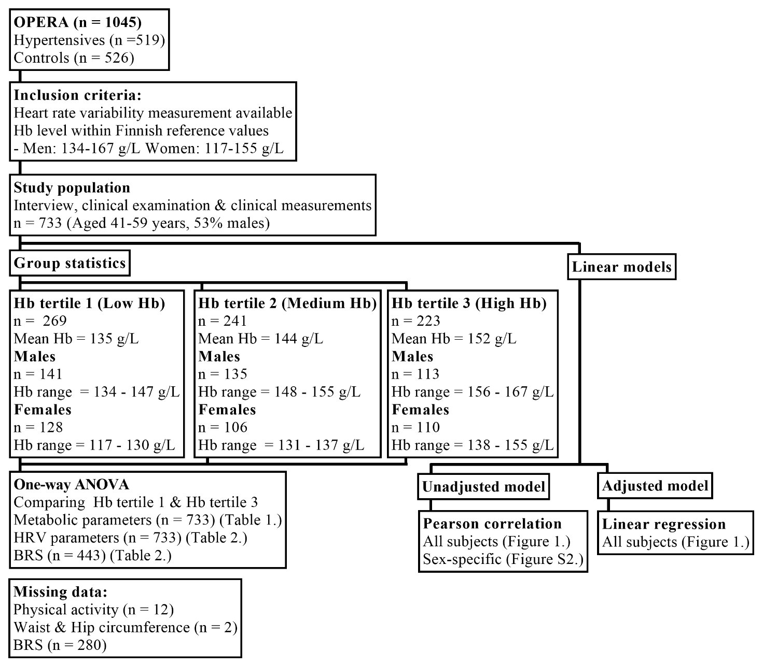

**Figure S1. Flow chart representing the study population and analyses done.** OPERA; Oulu Project Elucidating Risk of Atherosclerosis, Hb; Hemoglobin, HRV; Heart Rate Variability, BRS; Baroreflex Sensitivity.

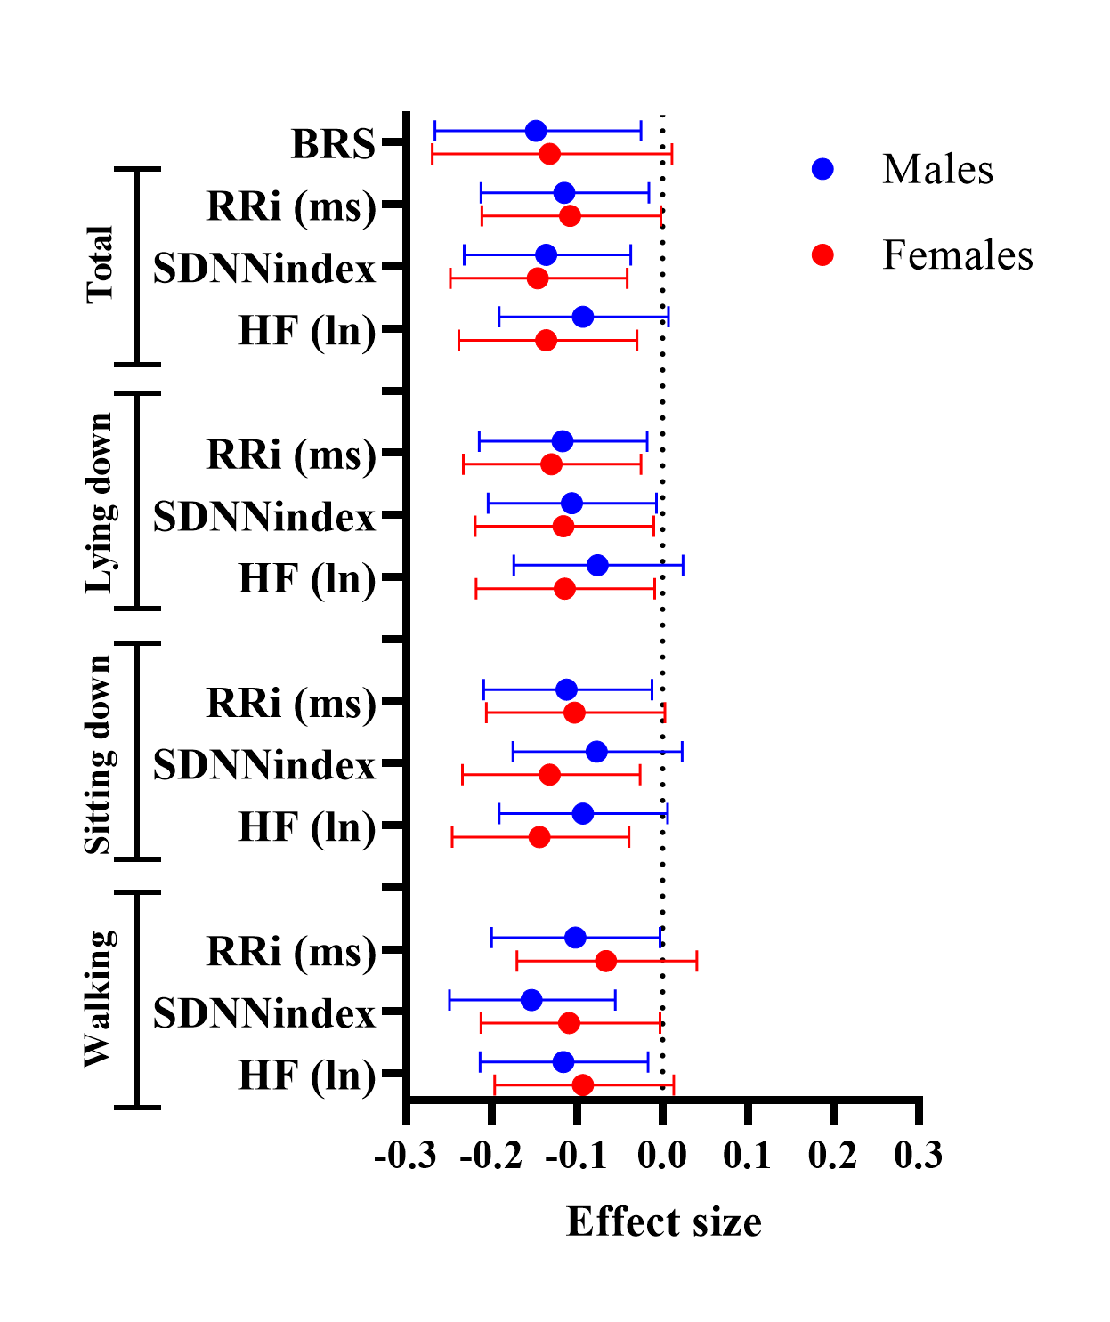

**Figure S2. Sex-specific Pearson correlations of Hb levels with Baroreflex and heart rate variability parameters in the study population.** CI; Confidence interval,BRS; Baroreflex sensitivity, RRi; R-R interval, SDNNindex: index of the SD of the RRi, HF; High Frequency.

**References**

1. Kairisto V, Grönroos P, Loikkanen M, Savolainen E, Punnonen K, Syrjälä M. New Finnish reference limits for the basic blood count. *Lääkärilehti*. 2003;51–52:5147–5153.

2. Grimby G. Physical activity and muscle training in the elderly. *Acta Med. Scand. Suppl.* 1986;711:233–237.

3. Recommendations for routine blood pressure measurement by indirect cuff sphygmomanometry. American Society of Hypertension. *Am J Hypertens*. 1992;5:207–209.

4. Perkiömäki J, Ukkola O, Kiviniemi A, Tulppo M, Ylitalo A, Kesäniemi YA, Huikuri H. Heart rate variability findings as a predictor of atrial fibrillation in  middle-aged population. *J Cardiovasc Electrophysiol*. 2014;25:719–724.