LABORATORY PTOTOCOLS

a. NTM species identification

The NTM species identification procedure refers to the Vitek-MS Mycobacterium/Nocardia Kit manual, as follows:

1. NTM colonies were taken from LJ media using a 1 μL loop and put into a 1.5 mL microtube containing 0.5 mm of glass beads and 500 μL of 70% ethanol.
2. Vortex was carried out for 15 minutes and then incubated vertically at room temperature for 10 minutes.
3. Vortex was carried out again, transferred into 2 ml of round-bottomed microtube, and then centrifuged at a speed of 10.000-14.000 g for 2 minutes.
4. Supernatant was removed, 10 μL of 70% formic acid was added to the pellet, and then vortex was carried out until homogeneous.
5. 10 μL of acetonitrile was added, and then vortex was carried out until homogeneous.
6. Centrifugation was carried out at a speed of 10.000-14.000 g for 2 minutes.
7. 1 μL of supernatant was taken, placed on the target spot on the slide, and allowed to dry completely.
8. 1 μL of matrix VITEK® MS-CHCA (bioMerieux, USA) was added and allowed to dry until the matrix and isolate crystallized.
9. Slide was loaded into the VITEK® MS MALDI TOF machine (bioMerieux, USA), and the sample number was added.
10. The results were read using a computer connected to MALDI TOF VITEK® MS (bioMerieux, USA). The identification test results will appear on the monitor in the form of the NTM species name.
11. NTM sensitivity test to various antibiotics.

The testing procedure was carried out following the Susceptibility Testing of Mycobacteria, Nocardiae, and Other Aerobic Actinomycetes guidelines; Approved Standard—Second Edition from the Clinical and Laboratory Standard Institute, with the following steps:

1. Determination of the concentration of the stock of antibiotics was conducted through the dilution process. The dilution was carried out based on the content of each antibiotic used to obtain a final concentration of 1000 μg/mL.
2. 0.1 mL of Middlebrook 7H9 broth was added to each well microdilution plate using a pipette, and one column was left for negative control with a volume of 0.2 mL.
3. 0.1 mL of antibiotic was added to each column, and serial dilution was carried out in each subsequent column, leaving 1 column for positive control.
4. Bacterial colonies were taken from 3-5 colonies of LJ medium and transferred to the saline solution using a tube until it reached turbidity of 0.5 McFarland (1-2 × 108 CFU/mL).
5. Diluted suspension of 0.5 McFarland (1-2 × 108 CFU/mL) was carried out using the saline solution in a ratio of 1:20 so that the concentration became 5-10 x 106 CFU/mL, then 0.1 mL was added into each appropriate column, except for the sterile control column.
6. In each well, around the Microdilution plate, saline was added to keep the atmosphere moist.
7. Microdilution plate was wrapped with plastic or plastic tape to prevent dryness.
8. Incubation was done at a temperature of 35±2°C for 7 days.
9. Observation of growth was conducted through the growth of bacteria in wells containing antibiotics compared to growth controls.
10. The test was repeated 3 times, and the MIC value was determined for each test.
11. Determination was carried out into sensitive (S), intermediate (I), or resistant (R) groups based on the MIC criteria according to Table 1.

Table 1. MIC values for each type of antibiotic

|  |  |  |  |  |
| --- | --- | --- | --- | --- |
| Antibiotic | MIC Category (μg/mL) | | | |
| Sensitive | *Intermediate* | | Resistant |
| Ciprofloxacin (CIP) | ≤1 | | 2 | ≥4 |
| Moxifloxacin (MFX) | ≤1 | | 2 | ≥4 |
| Clarithromycin (CLR) | ≤2 | | 4 | ≥8 |
| Amikacin (AMK) | ≤16 | | 32 | ≥64 |
| Imipenem (IPM) | ≤4 | | 8-16 | ≥32 |
| Trimethoprim/sulfamethozaxole (SOX) | ≤2/38 | | - | ≥4/76 |
| Doxycyclin (DOX) | ≤1 | | 2-4 | ≥8 |

Note: For SOX antibiotics, MIC values between 2/38 and 4/76 are included in category I.

1. Biofilm formation:
2. NTM isolates were grown in Middlebrook 7H9 medium for 24 hours at 370C.
3. Each well of a 96-well microtiter polystyrene plate was filled with 198 μL of Middlebrook 7H9 medium (except the wells in column 1 and 12, row A and H)
4. 2 μL of NTM isolate suspension was added into each column filled with media and left 1 column for negative control. In the negative control column, isolate *S. epidermidis* ATCC 12228 was added.
5. The wells in column 1and 12, row A and H, were filled with saline to keep the atmosphere moist. The biofilm formation test using 96-well microtiter polystyrene plate is shown in figure 1.
6. Incubation was completed at 37°C for 7 days.
7. The wells were washed three times with 200 μL PBS.
8. Adherent cells were stained with 0.1% crystal violet (50 μL), and then washed with distilled water 3 times (using a pipette).
9. The paint was resuspended with 200 μL of 5% isopropanol acid, and then the absorbance was observed at λ 595 nm.
10. The bacterial OD value was calculated based on the absorbance value for 6 repetitions carried out in the B-G well. The OD value of bacteria was obtained by calculating the average absorbance value of at least 3 almost the same.
11. ODc value was calculated, where ODc = Average OD of the negative control + 3x SD of negative control.
12. The results were interpreted into categories of strong, medium, weak, and unable to form biofilms (negative), as shown in Table 2.

Table 2. Interpretation of the results of biofilm formation

|  |  |  |
| --- | --- | --- |
| No | **Bacterial OD value and ODc value** | Interpretation |
| 1. | Bacterial OD >4x Odc value | Strong |
| 2. | 2x Odc value < Bacterial OD < 4x Odc value | Moderate |
| 3. | ODc < Bacterial OD < 2x Odc value | Weak |
| 4. | Bacterial OD ≤ Odc value | Negative |

1. Ability to perform sliding motility:
2. Sliding motility media was prepared, namely Middlebrook 7H9 (without OADC) and 0.3% agar.
3. Inoculation of NTM culture was carried out as much as 3 μL at optical density (OD) 600.6 (2.7 × 105 CFU) in the middle of the sliding motility media, and the plate was covered with parafilm.
4. Incubation was carried out at 37°C in a 5% CO2 atmosphere for up to 16 days in a humid atmosphere.
5. Measurement of the length of the NTM growth area was carried out on days 4, 8, 12, and 16 using digital calipers in mm.
6. The sliding motility test was carried out 3 times.
7. The average length of growth was calculated from 3 test repetitions.
8. Ability to perform adhesion and invasion:
9. A549 cell line (human type II pneumocyte) culture was carried out.
10. Supplement at DMEM (Invitrogen, Australia) was added with 10% FBS (Bovogen, Australia), 100 μg/mL of streptomycin, and 2 mM of L-glutamine.
11. Observation of monolayer cell growth was carried out until it reached >95% growth.
12. The monolayer cells were washed with PBS, and about 1x107 CFU of NTM bacteria were added to each well.
13. Incubation of A549 cell line (human type II pneumocyte), which had been infected at 37oC for 4 hours, was carried out.
14. The culture medium was removed, and 0.25% trypsin was added to the PBS to remove the A549 cell line (human type II pneumocyte) from the well surface.
15. The A549 cell line (human type II pneumocyte), which had been washed using 200 μL of 0.025% sterile Triton X-100, was lysed.
16. Dilution was carried out for 1000x.
17. 20 μL suspension was put into Middlebrook 7H9 medium to determine the amount of bacterial CFU attached to each well.
18. Incubation was carried out for 10 days.
19. Bacterial colonies were counted.
20. Tests were repeated on each species three times at different times. Each time the test was repeated twice.
21. Observation of NTM biofilm cell structure using SEM:
22. Bacterial suspension was prepared equivalent to 1 Mc Farland
23. 20 μL of bacterial suspension was put into a 12-well microplate filled with a round cover glass and 1980 l of Middlebrook 7H9 media.
24. Incubation was carried out at 35-370C for 7 days.
25. Wells overgrown with biofilm were washed with PBS 2 times.
26. The cover glass was taken and rehydrated using ethanol serially (70% for 10 minutes and then 96% for 10 minutes).
27. Ethanol was discarded, allowed to dry overnight at room temperature.
28. The cover glass was taken and coated twice with platinum vanadium using an ion sputter (Bal-Tec SCD 005) for 11 seconds, after which the cover glass was glued to double-side carbon tape to be observed using SEM (JEOL JED-2300, Japan).

Fig. 1

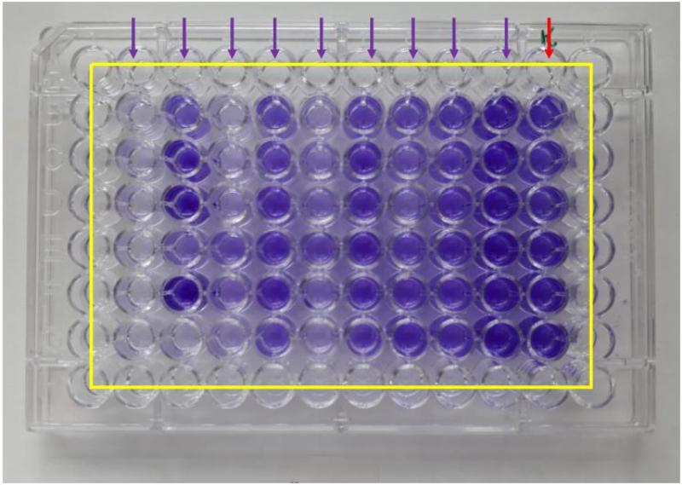

Figure 1. Biofilm testing on a 96-well microplate. The picture above shows the biofilm mass measurement test results on a 96-well microplate. The yellow line indicates the well filled with saline. Red arrows indicate columns for negative controls, and purple arrows indicate columns for samples. The negative control bacteria used was *S. epidermidis* ATCC 12228. The results were read using a microplate reader.