**Expression and purification protocol of GST-NDP52**

**by Chunmei Chang**, **James Hurley Lab (UC, Berkeley)**

**General information:** expression system: E.Coli BL21DE3, medium: Luria Bertani;plasmid origin: Addgene 171422; backbone: pGST2; resistance: Amp ; insert: *Homo sapiens* (NM_005831.5); tags & cleavage sites: N-term GST, Ext coeff: 82320 M-1cm-1, MW 77.9 kDa

1. **Protein expression:** E.Coli BL21DE3 cells are transformed with plasmid encoding for GST-NDP52 and plated on Amp plate. Protein expression is carried in 1.5 L medium, induced with 100 µM IPTG (isopropyl- β-d-thiogalactopyranoside) to an OD600 of 0.8 and grown at 18°C overnight. Cells are harvested by spinning at 4500xg for 20 minutes at 4C and stocked at -80C until purification.
2. **Protein Purification:** GST batch purification followed by Size Exclusion Chromatography

**Lysis Buffer:** 50mM Hepes pH=7.5; 300mM NaCl, 1mM TCEP, Protease Inhibitors (Roche).

**Wash Buffer:** 50mM Hepes pH=7.5, 300mM NaCl, 1mM TCEP;

**Elution Buffer:** 50mM Hepes pH=7.5, 300mM NaCl, 1mM TCEP;

**SEC Buffer:** 20mM Hepes pH=8, 200mM NaCl, 1mM TCEP.

**Columns/Resin:** - Glutathione Sepharose 4B

- S6_10/300 Increase

Pellets are resuspended in Lysis Buffer, sonicated for cell lysis and cleared at 16,000 rpm at 4°C for 1 hour.

Supernatant is incubated with Glutathione Sepharose 4B (GE Healthcare) at 4°C with gentle shaking for 4 hours, applied to a gravity column, and washed extensively with Wash Buffer.

Protein of interest is eluted with Elution Buffer and then applied onto a Superdex 6 column (10/300 Increase) pre-equilibrated in SEC Buffer at 4°C. Peak fractions containing pure protein are pooled, snap-frozen in liquid nitrogen and stored at −80°C.

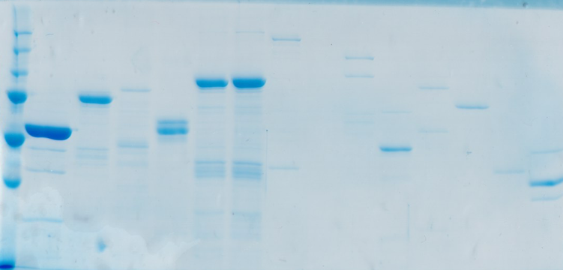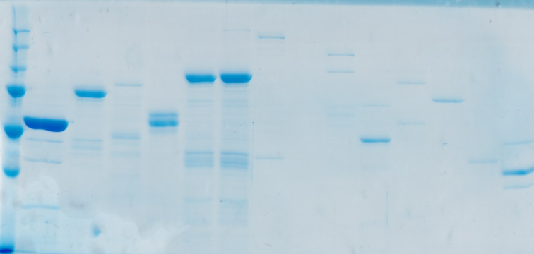

GST-NDP52

Yield: About 5 mg per liter culture