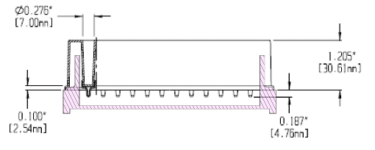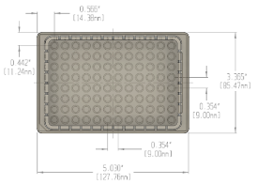
B.
A.
Figure 1. Design of filter plate adapters. (A) Section analysis of an adapter overlayed with Arctic White filter plate schematic. There is adequate volume beneath the wells to collect a small volume of leakage without contact with the membrane, and a recessed bottom enhances fit with 5810R MTP microplate bucket (Eppendorf). (B) Overhead view of Arctic White filter plate schematic overlayed on a 3D model of a plate adapter.
Adapters designed to hold filter plates during the incubation and centrifugation steps were modeled in Fusion 360 (Autodesk). Early low-cost prototypes were printed on a uPrint Plus (Statasys) fused deposition modeling (FDM) 3D printers in the KAVLI-PBBR Fabrication and Design Center using acrylonitrile butadiene styrene (ABS) on a preheated bed with a medium infill and soluble supports. After printing, models underwent acetone vapor smoothing using laboratory grade acetone in a sealed glass container until visibly smooth. Additional water resistance was added by coating with XTC-3D High Performance epoxy (Smooth-On).

The final version of the adaptor was manufactured on a HP Jet Fusion 580 (Hewlett-Packard) multi jet fusion (MJF) color 3D printer in durable Nylon 12 in the KAVLI-PBBR Fabrication and Design Center. The HP Jet Fusion 580 user’s manual recommends an application of melted paraffin wax to preheated parts (60-85C for 30 min) for improved water fastness. However, we found this step unnecessary for adapters printed without visible defects. 3D models can be downloaded from the NIH 3D Print Exchange (Model ID 3DPX-016424).

