**Isolation and Transfection of *Nicotiana benthamiana* Mesophyll Protoplasts for Fluorescent Protein Visualization**

Namitha Nayak1, Rajesh Mehrotra1, Sandhya Mehrotra1*

1Department of Biological Sciences, Birla Institute of Technology and Science-K. K. Birla Goa Campus

*Corresponding author: [sandhyam@goa.bits-pilani.ac.in](mailto:sandhyam@goa.bits-pilani.ac.in) ORCID:

**Abstract**

Protoplast transfection is routinely used to study the sub-cellular localization of fluorescent-tagged proteins. Using *N. benthamiana* protoplasts is advantageous as it is a hardy plant that grows well, especially in tropical climates. Isolating protoplasts from the leaves of young 3-4-week-old *N. benthamiana* plants compensates for the benefits of using the ephemeral *Arabidopsis*. Moreover, the larger protoplast size of *N. benthamiana* offers better visualization of fluorescent proteins at lower magnifications. The protocol described here is an easy method for *N. benthamiana* protoplast isolation and transfection with simple and economical modifications to increase yield and transfection efficiency. The protocol is optimized for easy performance with minimal laboratory equipment.

**Keywords**

Confocal microscopy;Fluorescent protein; *Nicotiana benthamiana*; Protoplast; Transfection

**Abbreviations**

BSA- Bovine Serum Albumin; CaCl2- Calcium Chloride; KCl- Potassium Chloride; KOH- Potassium Hydroxide; MgCl2- Magnesium Chloride ; MES- Morpholinoethanesulfonic sodium salt; NaCl- Sodium Chloride; PEG- Poly Ethylene Glycol.

**Introduction**

The protoplast isolation and polyethylene glycol-mediated protoplast transfection method detailed here is tailored for *Nicotiana benthamiana*mesophyll tissue*.*The large leaf surface area and cell size of *Nicotiana* *benthamiana* are beneficial for protoplast yield and fluorescent protein visualization, respectively. *N. benthamiana* protoplast yield heavily depends on the sample collection time point. Here, we detail the leaf size, number, and texture required for a good protoplast yield, along with economical modifications in enzyme solution preparation and protoplast pelleting steps necessary for a good yield of healthy protoplasts. The polyethylene glycol-mediated transfection protocol described here includes tips for better protoplast survival post-transfection. A transfection efficiency >50% requires ~1x105 healthy protoplasts and 5-10µG of pure plasmid DNA.

**Methods**

**Enzyme solution**

0.6 M D-Mannitol

20 mM KCl

20 mM MES-KOH buffer pH 5.7

10mM CaCl2

0.1% BSA

1% Cellulase ONOZUKA R-10 (Himedia #RM3331)

0.5% Pectinase from *Aspergillus niger* (Himedia #PCT1519)

**W5 solution**

154 mM NaCl

125 mM CaCl2

5 mM KCl

2 mM MES-KOH (pH 5.7)

**40% PEG solution**

40% Poly Ethylene Glycol-4000

0.2 M Mannitol

200mM CaCl2

**Reagent setup**

**Enzyme solution** Prepare a solution of (0.6 M) D-mannitol**\***, (20 mM) KCl, and (20mM) MES-K and heat at 70ºC for 10 minutes in a water bath. Cool the solution to room temperature and add (1%) cellulase ONOZUKA R-10 and (0.5%) pectinase**\*\***. Mix well to dissolve the enzyme powder and incubate at 60ºC in a water bath for 10 minutes. Cool to room temperature and add (10mM) CaCl2 and (0.1%) BSA. The enzyme solution is to be prepared fresh and cannot be stored.

* The concentration of D-mannitol is critical to prevent the bursting of extracted protoplasts. A 0.6M concentration is optimal for protoplasts isolated from 3-week-old *Nicotiana benthamiana* leaves (Fig. 1).

** Pectinase from *Aspergillus niger* gives a higher protoplast yield compared to macerozyme R-10 at 37ºC. Pectinase is also a more economical choice.

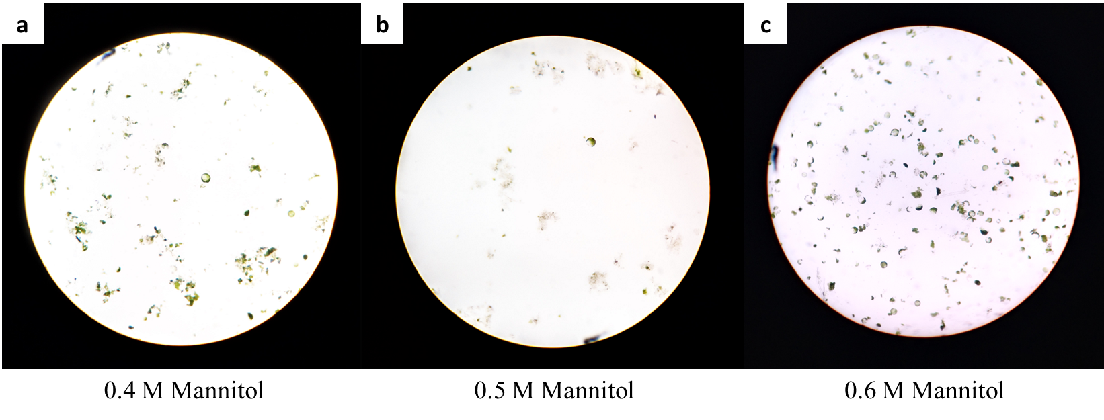

**Fig. 1**: *Nicotiana benthamiana*protoplast isolation using enzyme solutions of varying mannitol concentrations, observed under a light microscope at 10x magnification. A. *N. benthamiana* protoplasts in 0.4M D-mannitol, with a majority being lysed. B. *N. benthamiana* protoplasts in 0.5M D-mannitol enzyme solution. A majority of protoplasts show lysis. C. *N. benthamiana* protoplasts in 0.6M D-mannitol enzyme solution. A majority of the isolated protoplasts are viable.

**W5 solution** Preparea 2mMMES-Ksolution (pH 5.7) containing 154mM NaCl, 125mM CaCl2, and 5mM KCl. The W5 solution can be stored at 4ºC.

**40% PEG solution** Prepare a 40% PEG-4000 solution containing 0.2M mannitol and 200mM CaCl2. The solution can be stored at -20ºC for long-term use.

**Enzyme infiltration of *N. benthamiana* leaves**

1. Grow *N. benthamiana* seedlings in potting soil and maintain at 24ºC and 60% humidity (Fig. 1a).
2. Wash 30-50 top leaves* of 3-4-week-old *Nicotiana benthamiana* seedlings in distilled water. Slice each leaf in two using a scalpel (discard the midrib) and place in distilled water until enzyme infiltration (Fig. 2b, c).
3. In a 2 ml centrifuge tube containing 1 ml enzyme solution, submerge 2-4 leaf strips**. Close the tube and pierce the cap with the needle of a 2.5 ml syringe. Gently withdraw the air in the tube using the syringe to create a vacuum (Fig. 2d). Repeat for all leaf strips.
4. Transfer the infiltrated leaf strips to a petri dish containing the remaining enzyme solution**. Incubate the petri dish in the dark at 37ºC*** and 50 rpm for 4 hours (Fig. 2e).

*The time point of leaf collection is critical for optimal protoplast yield. Avoid using leaves with a diameter >2 cm. Ensure that the leaves have a grainy texture (Figure 2b).

** To avoid tearing, use a soft bristle brush to transfer the leaf strips.

*** Incubating at 37ºC gives a higher protoplast yield than at room temperature.

**Pelleting the protoplasts**

1. Post incubation, the enzyme solution turns light green (Fig. 2f). Filter the enzyme solution into a beaker using a 70µM cell strainer. Add an equal volume of W5 solution to the petri dish containing the leaf strips. Collect the strips using a soft bristle brush and gently prod to release more protoplasts. Strain the W5 solution through the cell strainer into the beaker containing the filtered enzyme solution (Fig. 2g).
2. Gently transfer the filtrate into a test tube placed in ice and allow the protoplasts to settle for 30-45 minutes*. Discard the supernatant using a Pasteur pipette and add 5mL of fresh W5 solution through the sides of the test tube. Allow the protoplasts to settle (Fig. 2h).
3. Pipette out the supernatant and redissolve the pellet in 500µL W5 solution. Count the protoplasts using the Neubauer chamber and adjust the volume for a final protoplast concentration of 105 cells/mL.

* Centrifugation is time-saving and increases protoplast recovery. However, gravity settling of protoplasts is preferred as it reduces cellular debris and increases the protoplast survival rate.

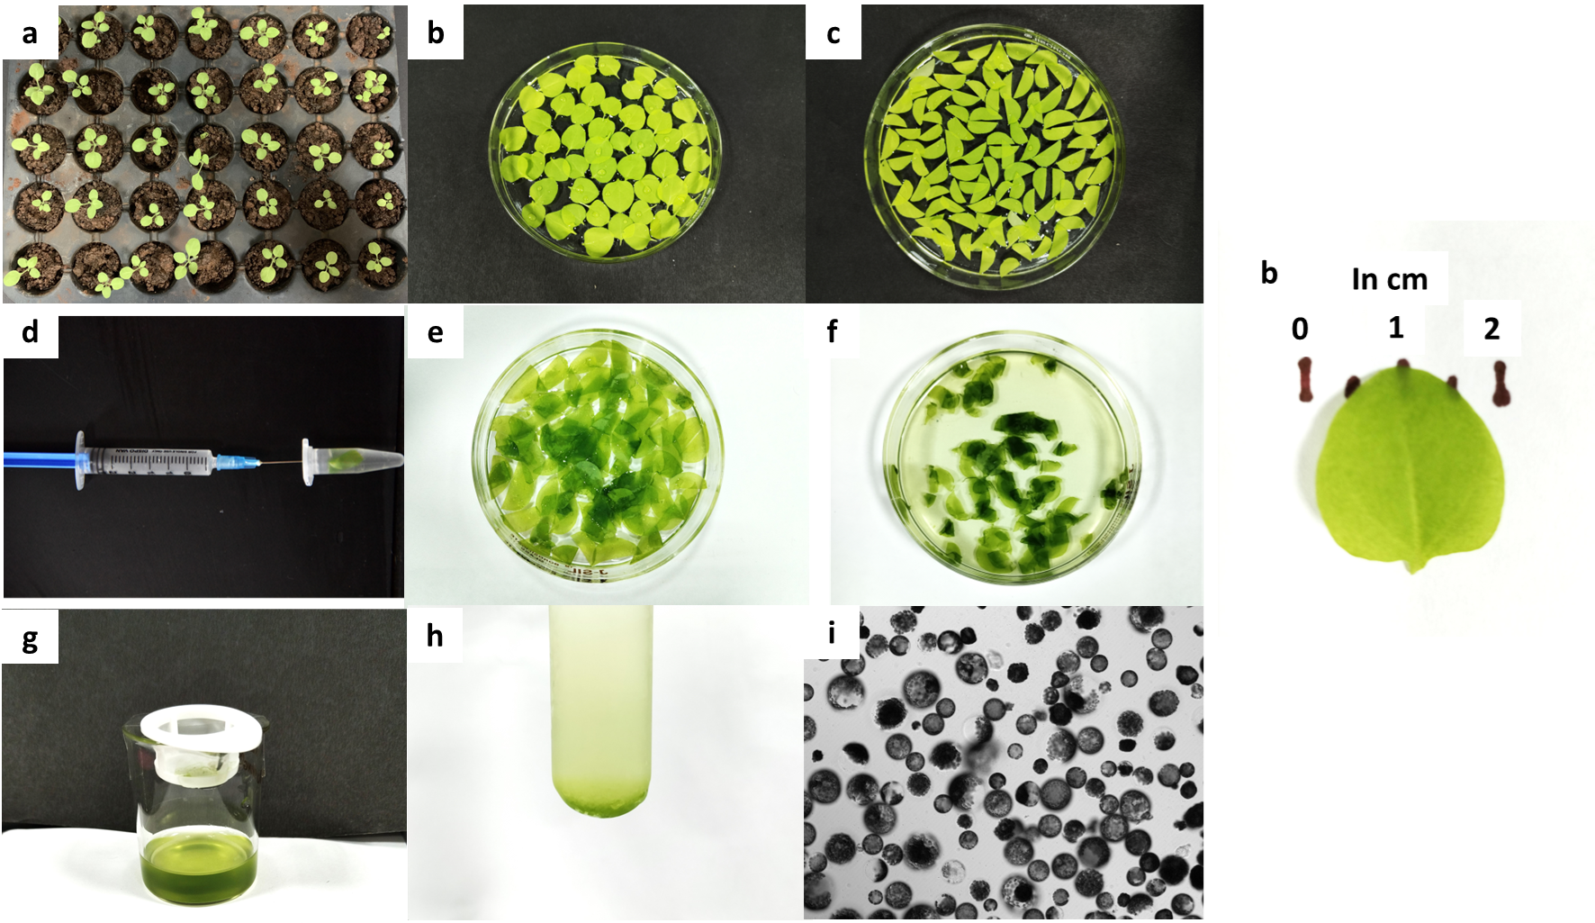

**Fig. 2:** Step-by-step process of protoplast isolation from 3-week-old *Nicotiana benthamiana* seedlings.

**PEG-mediated transfection**

1. Use freshly prepared protoplast solution (105 cells/mL)* for PEG-mediated transfection. Take 100µL of protoplast in W5 solution in a test tube (pipette carefully to prevent protoplast breakage). Add 1-10µG of pure plasmid DNA (isolated using QIAGEN mini/midiprep kit) in nuclease-free water or elution buffer. Incubate for 5 minutes at room temperature.
2. Add 100+X (X being the volume of DNA added) of 40% PEG-4000 solution from the sides of the test tube (Avoid mixing or pipetting) and incubate at room temperature for 10 minutes.
3. Post-incubation, dilute the transfection mixture by adding 2 mL of W5 solution from the sides of the tube. Allow the protoplasts to settle. Pipette out the supernatant and replace it with 0.5mL of fresh W5 solution.
4. Incubate the test tube containing the transfected protoplasts in the dark for 16-18 hours. Post incubation, visualize the protoplasts under a confocal microscope (Fig. 3).

* 105 cells/mL is optimal for the transfection procedure. A higher concentration of protoplasts reduces protoplast survival and increase cellular debris post-transfection.

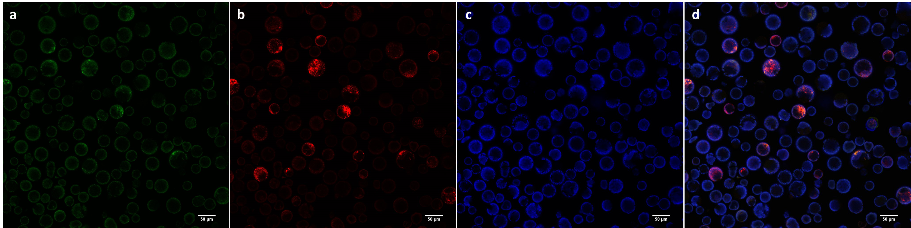

**Fig. 3:** Confocal microscopy of *N.benthamiana* protoplasts transfected with 5µG of pCAMBIA1302 (~10.5kB) and 2.5µG of pAN991_mScarlet-I (~4.7kB) vectors under 20x magnification. The GFP and chlorophyll were excited at 488nm, and the emission recorded at 499-535nm (a) and 630-735nm (c), respectively. mScarlet-I was excited at 561nm, and the emission was recorded at 579-633nm (b). The co-localization and scaling were done using the ImageJ software (d).

**Results**

Transfection efficiency increases with increased plasmid concentration. For plasmids <5kB, 1-5µG is sufficient for a high transfection efficiency. For plasmids of larger size, 5-10µG is necessary for a good transfection efficiency. Using a pure plasmid extract is critical to ensure better survival of protoplasts post-transfection and decrease fluorescing artifacts within the protoplasts.

**Discussion**

Isolation and transfection of protoplasts help to study the sub-cellular localization of fluorescent or fluorescence-tagged proteins. Several protocols have detailed the isolation and transfection of *Arabidopsis thaliana*mesophyll protoplasts (Yoo *et al*., 2007; Woo *et al*., 2009). However, protocols for *N.benthamiana* mesophyll tissue are few and brief. Here, we elaborate on the protocol standardized in our lab for *N.* *benthamiana* protoplast isolation and transfection (Nayak *et al*., 2024). We include tips to increase yield transfection efficiency and reduce debris and fluorescing artifacts that negatively affect fluorescent protein visualization.

The protocol described here is adapted from the protocol of Yoo *et al*., 2007 for *Arabidopsis* with modifications for *N. benthamiana* mesophyll cells. We find that 3-4-week-old *N. benthamiana* protoplasts require an enzyme solution of higher mannitol concentration to prevent the bursting of cells. As cellulase and pectinase enzymes have a high optimal temperature, incubation at 37ºC leads to high protoplast yield with no observable effect on the protoplast viability of *N. benthamiana*. Moreover, pectinase from *Aspergillus niger*, a comparatively economical choice, was found to perform better than Macerozyme-R 10 at 37ºC.

Sample collection time-point is critical to ensure high protoplast yield and reduce cellular debris. Repeated trials showed that the top leaves of 3-4-week-old *N. benthamiana* without pronounced midrib and veins, having a diameter <2 cm and a rough, grainy texture, were optimal for protoplast isolation. Rough chopping increases cellular debris, and it is advised to slice a single leaf no more than once down the midrib. Careful handling of leaf strips with a soft-bristle brush helps get a clean protoplast solution. Using a vacuum desiccator for enzyme infiltration saves time but can dry out the enzyme solution. Here, we use a syringe and microcentrifuge tube as an alternative. Although time-consuming, this method does not dry out the prepared enzyme solution and is gentler on the delicate leaf strips. Protoplast-pelleting by gravity leads to better protoplast survival than fixed-angle centrifugation of protoplasts at 100 rpm with no acceleration and deceleration.

A pure plasmid extract is critical for high transfection efficiency and lower fluorescing artifacts in protoplasts; therefore, any manual method of plasmid extraction is not advised. The transfection protocol is carried out in a round-bottom test tube as increased surface area leads to better protoplast survival post-transfection. 1x105 protoplasts are used in a single transfection experiment; increasing the protoplast number has also been found to reduce the survival rate post-transfection and increase cellular debris in the sample. All solutions are pipetted from the sides of the test tube to avoid disturbing the protoplast pellet, which boosts the survival rate post-transfection. A 10-minute incubation with the 1-10µG DNA and PEG solution is sufficient for good transfection efficiency.

**Acknowledgements**

Namitha Nayak is thankful to Council of Scientific and Industrial Research (CSIR)-India for Senior Research Fellowship. Confocal imaging was performed at Central Sophisticated Instrumentation Facility (CSIF), BITS-Goa.

**Statements and Declaration**

All authors contributed to study conception and design. Material preparation, data collection and analysis were performed by Namitha Nayak. The first draft of the manuscript was written by Namitha Nayak. Sandhya Mehrotra and Rajesh Mehrotra edited and revised the manuscript. All authors read and approved the manuscript. The authors declare no conflict of interest.

**References**

* 1. Nayak N, Mehrotra R, Mehrotra S (2024) The N-region sequence context impacts the chloroplast import efficiency of multi-TMD protein. Plant molecular biology, 114(4), 88. <https://doi.org/10.1007/s11103-024-01485-2>
  2. Wu FH, Shen SC, Lee LY, Lee S-H, Chan M-T, Lin C-S (2009) Tape-Arabidopsis Sandwich - a simpler Arabidopsis protoplast isolation method. Plant Methods 5(16). <https://doi.org/10.1186/1746-4811-5-16>
  3. Yoo SD, Cho YH, Sheen J (2007) Arabidopsis mesophyll protoplasts: a versatile cell system for transient gene expression analysis. Nature Protoc., 2(7):1565–1572. <https://doi.org/10.1038/nprot.2007.199>