Reprogramming into iPSCs using a Sendai virus (™ CytoTune-iPS 2.0) reprogramming factor delivery kit (ThermoFisher).

Purpose:
Reprogramming primary blood mononuclear suspension cells into induced pluripotent stem cells using a non-integrating RNA viral (Sendai) reprogramming factor delivery method. This ™ CytoTune-iPS 2.0 is a self-replicating RNA virus-based reprogramming approach which utilizes 3 pre-packaged viral particles expressing human KLF-4+OCT4/POU5F1+SOX2, hKLF-4 and hc-Myc proteins respectively. Use of Sendai viral particles for delivery allows for an efficient non-viral reprogramming of suspension blood and a wide range of other cells into induced pluripotent stem cells (iPSCs).

Scope:
This protocol describes the preparation of primary cell (blood-derived) cultures and their subsequent reprogramming into iPSCs using Sendai virus transduction.

Materials:

Reagents

- ™ CytoTune-iPS 2.0 kit A16517 1 kit (Store at -80°C).

REPROGRAMMING START DATE, Day 0 _____________________

PRODUCT LOT # used in this reprogramming ___________________

VIRAL lot-specific CUIs (10⁷/mL): hKOS hc-Myc hKlf4 .

Materials Required But Not Included in the kit

    - Corning® Matrigel® hESC-Qualified Matrix Corning 354277
    - Phosphate-Buffered Saline (PBS) various
    - Hank’s balanced salt solution (HBSS) various

Equipment
Standard cell culture equipment:
- BHCII hood
- CO₂ (5%) 37°C incubator
- Standard inverted microscope (with bright-field camera), e.g. Olympus CX41, with 2x - 20x objectives
- Centrifuge for 1.5/2.0mL microcentrifuge tubes
- Centrifuge (refrigerated) for 15/50mL tubes

Consumables:
- 15 and 50 ml Falcon tubes (Corning)
    - Sterile microtubes (1.5mL)
    - Tissue culture-treated 6-well plates (Corning)
    - Gloves (nitrile/latex, assorted manufacturers/sizes)
    - Disposable serological pipettes (5, 10 and 25 mL, Corning)
    - 0.22-µm Millipore syringe filter units (Millipore or Corning)

Procedure:
Preparation of Reagents and Materials
Use aseptic techniques to prepare the following reagents and materials.

Fibroblast culture medium
The following example is for preparing 50 mL of Fibroblast Culture Medium. If preparing other volumes, adjust accordingly.
Combine the following:
- 45 mL of DMEM (+Glutamate) base medium;
- 5 mL of fetal bovine serum (FBS), ES-qualified
- NEAA 1x (Gibco or like)
- Optional:Pen/Strep

Pre-warm to room temperature (20 - 25°C) before use. Store Fibroblast Culture Medium at 2 - 8°C for up to 4 weeks.

Reprogramming using Cyto Tune Sendai vectors

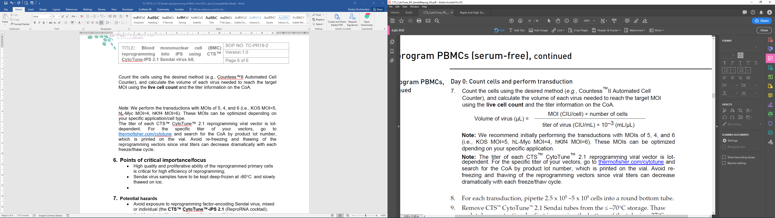
Count the cells using the desired method (e.g., Countess™II Automated Cell Counter), and calculate the volume of each virus needed to reach the target MOI using the live cell count and the titer information on the CoA.

Note: We perform the transductions with MOIs of 5, 4, and 6 (i.e., KOS MOI=5, hC-Myc MOI=4, hKlf4 MOI=6). These MOIs can be optimized depending on your specific application/cell type. The typical SeV titer is ~10⁸ CUI/mL
The titer of each ™ CytoTune™ 2.0 reprogramming viral vector is lot-dependent. For the specific titer of your vectors, go to thermofisher.com/cytotune and search for the CoA by product lot number, which is printed on the vial. Avoid re-freezing and thawing of the reprogramming vectors since viral titers can decrease dramatically with each freeze/thaw cycle.
Notes:
      - Cells that have already been infected with the Sendai virus are refractive to further infection by the Sendai virus. Therefore, you cannot transduce cells with ™ CytoTune™ 2.0 reprogramming vectors that have already been transduced with other Sendai vectors such as the CytoTune™-EmGFP Sendai Fluorescence Reporter or vice versa.
      - One ™ CytoTune™-iPS 2.0 Reprogramming Kit of three tubes supplies sufficient reagents to transduce a minimum of 2.0 × 106 cells at MOI=5-5-5 (i.e., KOS MOI=5, hC-Myc MOI=5, hKlf4 MOI=5).
      - The titer of each ™ CytoTune™ 2.0 Sendai reprogramming vector is lot-dependent. For the specific titer of your vectors, refer to the Certificate of Analysis (CoA) available on our website. Go to thermofisher.com/cytotune and search for the CoA by product lot number, which is printed on the vial.
      - Viral titers can decrease dramatically with each freeze/thaw cycle. Avoid repeated freezing and thawing of your reprogramming vectors. Viral titer is not guaranteed for kits that have been refrozen or thawed!
      - Prior to starting, ensure that the media are equilibrated to 37°C and appropriately gassed.
      - IMPORTANT! Peeling of vial labels has been observed during thawing in a water bath.

(optional) ReproTeSR™ medium for maintenance of adherent cells undergoing reprogramming
Preparing 500 mL of mTeSR™. If preparing other volumes, adjust accordingly.
Combine the following:
• 100 mL 5x mTeSR™ supplement (stored ≥-20°C and thawed overnight in TC fridge)
• 400 mL mTeSR™ for blood reprogramming base medium

Pre-warm to room temperature (23 – 25°C, not 37°C) before use.

Reprogramming Process notes

Somatic cells are transduced with the Sendai virus from the ™ CytoTune™-iPS 2.0 kit at day 0, and cultured in FIBROBLAST Medium. After Day 6 cells are cultured in mTeSR™ for the remainder of the reprogramming induction phase until iPS cell colonies emerge.

The major steps required for reprogramming of the primary human dermal fibroblasts using the ™ CytoTune™-iPS 2.0 Sendai Reprogramming Kit to generate iPSCs cultured feeder-free on rhLaminin521-coated culture dishes are shown below. Note that the timeline is provided as a guideline for experimental planning; the actual timeline can vary based on the cell type and experimental conditions (e.g. dynamics of colony appearance):

  - Day - 2: (Re)plate fibroblasts on TCP or Matrigel-coated TCP surface.
  - Day – 1: Change with a fresh fibroblast medium.
  - Day 0: Transduce the cells using the ™ CytoTune™ 2.0 Sendai reprogramming vectors at the appropriate MOI. Incubate the cells overnight.
  - Day 1: Replace the medium with fresh complete fibroblast medium to remove the ™ CytoTune™ 2.0 Sendai reprogramming vectors (make sure to dispose of the supernatant as biohazardous waste, i.e. with inactivation and double-containment steps!)
  - Day 4: Start transitioning into an mTeSR™ family medium by replacing half of the fibroblast medium with mTeSR™ Medium.
  - Day 5: Replace the entire medium with mTeSR™ Medium to conclude the transitioning, and continue culturing cells on rhLamini-521 coated culture dishes
  - Day 6–21: Replace spent medium with fresh mTeSR™ Medium every day and monitor the culture vessels for the emergence of iPSC colonies. When iPSC colonies are ready for transfer, perform live staining, and pick and transfer undifferentiated iPSCs onto fresh vitronectin-coated culture dishes for expansion.

Isolate single cell-derived iPS colonies and maintain by manual passaging into mTeSR1 or mTeSRplus media as per the manual passaging SOP.

Points of critical importance/focus
- High quality and proliferative ability of the reprogrammed primary cells is critical for high efficiency of reprogramming;
- Sendai virus kit samples have to be kept deep-frozen ≤-80°C and slowly thawed on ice immediately prior to use;

Potential hazards
- Avoid exposure to reprogramming factor-encoding Sendai virus, mixed or individual (the ™ CytoTune™-iPS 2.0);
- Avoid contact with mammalian cell-active antibiotic puromycin.

