REAGENTS

* Dulbecco's phosphate-buffered saline (DPBS), no calcium, no magnesium (Gibco, cat. no. 14190-144)
* 1× TrypLE Express enzyme, no phenol red (Gibco, cat. no. 12604-021)
* RNaseZap (Ambion, cat. no. AM9780)
* DNA-OFF (Takara Bio, cat. no. 9036)
* Triton X-100 (Sigma-Aldrich, cat. no. T9284)
* dNTP mix (10 mM each; Fermentas, cat. no. R0192)
* First-strand buffer (5×; 250 mM Tris-HCl, pH 8.3, at room temperature (25 °C); 375 mM KCl; 15 mM MgCl2; Invitrogen, cat. no. 18064-014)
* DTT (Invitrogen, cat. no. 18064-014)
* Superscript II reverse transcriptase (Invitrogen, cat. no. 18064-014)
* Recombinant RNase inhibitor (Clontech, cat. no. 2313A)
* Betaine (BioUltra ≥99.0%; Sigma-Aldrich, cat. no. 61962)
* Magnesium chloride (MgCl2; anhydrous; Sigma-Aldrich, cat. no. M8266)
* KAPA HiFi HotStart ReadyMix (2×; KAPA Biosystems, cat. no. KK2601) Critical: A HotStart DNA polymerase is necessary to minimize the background amplification when working with single cells and is more practical when working with automated liquid-handling platforms.
* Agencourt Ampure XP beads (Beckman Coulter, cat. no. A 63881)
* Ethanol 99.5% (vol/vol); Kemethyl, cat. no. SN366915-06) Caution: It is flammable; handle it using appropriate safety equipment.
* EB solution (10 mM Tris-Cl, pH 8.5; Qiagen, cat. no. 19086)
* TruSeq dual-index sequencing primer kit for single-read runs (Illumina, cat. no. FC-121-1003) or paired-end runs (Illumina, cat. no. PE-121-1003)
* Nextera XT DNA sample preparation kit, 96 samples (Illumina, cat. no. FC-131-1096)
* Nextera XT 24-index kit, 96 samples (Illumina, cat. no. FC-131-1001)

**Cell Lysis / Oligot-dT Priming**

Timing: ∼15 min (for eight-strip tubes)

1. Dilute the oligo-dT30VN primer to 10 μM by adding 10 μl of 100 μM oligo-dT primers and 90 μl of nuclease-free water to a tube and mix well.
2. Prepare cell lysis buffer by adding 1 μl of RNase inhibitor to 19 μl of a 0.2% (vol/vol) Triton X-100 solution. If you are working with purified RNA, this step can be omitted and a corresponding volume of water can be used instead.
3. Isolate single cells in the lowest possible volume (preferably ≤0.5 μl, possibly 0.3 μl) or pipet the appropriate amount of RNA into a 0.2-ml thin-walled PCR tube. Single cells can be obtained either by using a micro capillary pipette or via FACS.
4. Place each single cell into a 0.2-ml thin-walled PCR tube containing 2 μl of cell lysis buffer, 1 μl of oligo-dT primer and 1 μl of dNTP mix.
5. Quickly vortex the tube to mix, and then spin down the solution (700*g* for 10 s at room temperature) and immediately place it on ice.
6. Incubate the samples at 72 °C for 3 min and immediately put the tube back on ice.
7. Spin down the samples (700*g* for 10 s at room temperature) to collect the liquid at the bottom of the tubes, and then put them immediately back on ice. The oligo-dT primer is now hybridized to the poly(A) tail of all the mRNA molecules.

Purified RNA:

Xul RNA up to 2.5ul

1ul oligo-dT Primer (10uM)

1ul dNTP (10mM)

xul H2O

4.5ul Total

72 °C for 3 min, snap cool

**Reverse Transcription**

1. Prepare the RT mix for all reactions plus one additional reaction by combining and mixing the reagents listed in the table below.

|  |  |  |
| --- | --- | --- |
| Component | Volume (ul) | Final Conc |
| Superscipt II | 0.50 | 100 U |
| RNAse inhibitor (40 U/ul) | 0.25 | 10 U |
| Superscript II FS buffer (5X) | 2.00 | 1X |
| DTT (100 mM) | 0.50 | 5 mM |
| Betaine (5 M) | 2.00 | 1 M |
| MgCl2 (1 M) | 0.06 | 6 mM |
| TSO (100uM) | 0.10 | 1 uM |
| H2O | 0.29 | - |
| Total | 5.70 | - |

2. Add 5.7ul of RT mix to Samples for a total of 10ul.

3. Spin and incubate as follows:

|  |  |  |  |  |  |  |  |  |  |  |  |  |  |  |  |  |  |  |  |  |  |  |  |  |
| --- | --- | --- | --- | --- | --- | --- | --- | --- | --- | --- | --- | --- | --- | --- | --- | --- | --- | --- | --- | --- | --- | --- | --- | --- |
| |  |  |  |  | | --- | --- | --- | --- | | Cycle | Temperature (°C) | Time | Purpose | | 1 | 42 | 90 min | RT and template-switching | | 2–11 | 50 | 2 min | Unfolding of RNA secondary structures | |  | 42 | 2 min | Completion/continuation of RT and template-switching | | 12 | 70 | 15 min | Enzyme inactivation | | 13 | 4 | Hold | Safe storage | |

**PCR preamplification**

1. Prepare the PCR mix for all reactions plus one additional reaction by combining and mixing the following components:

|  |  |  |  |  |  |  |  |  |  |  |  |  |  |  |  |  |  |  |
| --- | --- | --- | --- | --- | --- | --- | --- | --- | --- | --- | --- | --- | --- | --- | --- | --- | --- | --- |
| |  |  |  | | --- | --- | --- | | Component | Volume (μl) | Final concentration | | First-strand reaction | 10 | – | | KAPA HiFi HotStart ReadyMix (2×) | 12.50 | 1× | | IS PCR primers (10 μM) | 0.25 | 0.1 μM | | Nuclease-free water | 2.25 | – | | Total volume | 25 | – | |

2. Add 15 μl of PCR mix to each tube from Step 12, which contains the first-strand reaction and perform the PCR in a thermal cycler by using the following program:

|  |  |  |  |  |  |  |  |  |  |  |  |  |  |  |  |  |  |  |  |  |  |  |  |  |  |
| --- | --- | --- | --- | --- | --- | --- | --- | --- | --- | --- | --- | --- | --- | --- | --- | --- | --- | --- | --- | --- | --- | --- | --- | --- | --- |
| |  |  |  |  |  | | --- | --- | --- | --- | --- | | Cycle | Denature | Anneal | Extend | Hold | | 1 | 98 °C, 3 min | – | – | – | | 2–19 (see below) | 98 °C, 20 s | 67 °C, 15 s | 72 °C, 6 min | – | | 20 | – | – | 72 °C, 5 min | – | | 21 | – | – | – | 4 °C | |

|  |  |  |
| --- | --- | --- |
| **Input Amount**  **Total RNA** | **Input Amount,**  **Cells** | **Typical No. of**  **PCR Cycles** |
| 10 ng | 1,000 cells | 12 |
| 1 ng | 100 cells | 12 |
| 500 pg | 50 cells | 13 |
| 100 pg | 10 cells | 15 |
| 10 pg | 1 cell | 18 |

**Ampure Cleanup**

1. Perform a typical Ampure cleanup using 1:1 ratio of Ampure:cDNA
2. Elute using 17.5ul EB solution and pipette 15ul to transfer to a new tube

**Quality Check cDNA**

1. Run a High Sensitivity Bioanalyzer Chip to check for quality of cDNA
2. A good library should be free of short (<500 bp) fragments and should show a peak at 1.5–2 kb.

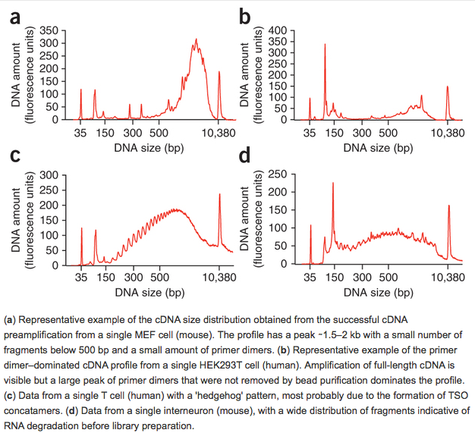

**Tagmentation Reaction**

1. Setup the tagmentation RXN as follows:

|  |  |  |
| --- | --- | --- |
| Component | Volume (μl) | Final concentration |
| Tagment DNA buffer (TD, 2×) | 10 | 1× |
| Amplicon tagment mix | 5 | – |
| DNA from PCR | Variable | – |
| Nuclease-free water | Variable | – |
| Total volume | 20 | – |

1. Incubate in a thermal cycler at 55°C for 5 minutes and bring to 4°C HOLD.
2. Add 5ul of NT buffer to the 20ul RXN and mix
3. Incubate at RT for 5min

**Enrichment of Tagmented cDNA**

1. Prepare the following PCR RXN as follows:

|  |  |
| --- | --- |
| **Component** | **Volume (μl)** |
| DNA | 25 |
| Nextera PCR master mix | 15 |
| Index 1 primers (N7xx) | 5 |
| Index 2 primers (N5xx) | 5 |
| Total volume | 50 |

1. Run the PCR RXN on a thermal cycler with the following conditions:

|  |  |  |  |  |
| --- | --- | --- | --- | --- |
| Cycle | Denature | Anneal | Extend | Hold |
| 1 | – | – | 72 °C, 3 min | – |
| 2 | 95 °C, 30 s | – | – | – |
| 3–14* | 95 °C, 10 s | 55 °C, 30 s | 72 °C, 30 s | – |
| 15 | – | – | 72 °C, 5 min | – |
| 16 | – | – | – | 4 °C |

*for 1ng, 8-12 cycles could be used

**Expected results:**

Using Single Cell (thus, purified RNA should yield better stats)

Sequence reads from each individual cell are normally in the range of 1–20 million, depending on the level of multiplexing in the sequencing. When sequencing 50-bp single-end reads, we find that normally 60% of reads map uniquely to the genome (20% multimapping and 20% with no match); of the uniquely mapping reads, >60% of the reads map to annotated RefSeq exons, 20% intronic and 20% intergenic, but these values depend on the completeness of the gene annotations. The read coverage across transcripts should be even.