**Analogizing the Nexus of Nutritional Status and Oral Health in Children of Pre-School age in Ranchi City of East India: A Cross-Sectional Study**

**Introduction**

Anthropometric measurements are the human body measurements which quantify us with vital indicators of nutritional status in children and adults. These include overall health, nutritive adequacy, growth and development measurements over time in growing children and adults. Body mass index (BMI) measurement index is used for measuring nutritional status quantitatively by measuring height and weight respectively and can be compared with other parameters like oral diseases. Voluminous research had been conducted so far to compare BMI with dental caries and periodontal diseases. However, there is a scarcity of literature in the arena of pediatric dentistry as far as BMI relationship with dental caries or oral hygiene standing in pre-school children is concerned. In fact, only handful of studies of such nature had been attempted so far in Jharkhand region of India. Thus, this research work is a genuine endeavor to recognise the association between nutritional status and dental health in pre-school children in Jharkhand region.

**Methodology**

The clinical study will be charted out in the Department of Pediatric and Preventive Dentistry, H.C.D.S.H., Hazaribag. 403 children will be selected by using random sampling method from pediatric clinics in Ranchi city. Children of age between 3 to 6 years with complete set of all primary teeth in dental arch will be counted in the study. In addition, written parental or guardians consent will be an essential prerequisite. Children with any systemic illness or medically compromised will be disqualified for the study. The demographic particulars of children will be recorded and examined in the board daylight. Training and calibration of the investigator will be conducted before carrying out the study. In this study, 403 preschool children of age between 3 to 6 years will be examined. Height and weight of each individual child will be documented. The subjects will be made to stand erect without shoes and the height will be measured using a stadiometer (Generic, China). The weight will be noted and measured usung a weighing machine (Crown, Hardik Medi-Tech). The following formula: BMI = WEIGHT (kg)/HEIGHT (m2) will be used to calculate Body mass index (BMI). The BMI will be then recorded, plotted and equated with sex and age using the CDC pediatric growth charts [Figure 1 and 2]. As per WHO Expert Committee recommendation on Physical Status: BMI-for-age at or above 95 percentiles will be overweight, BMI for-age between 85th and 95th percentiles will be at risk of overweight, BMI-for-age less than 5th percentile were underweight, and BMI-for-age between 5th and 85th percentiles will be taken under normal weight category.  Based on these CDC plotted growth charts, three groups will be made respectively:

Group 1-Normal weight (5th -85th percentile)

Group 2-Overweight (>85th percentile)

Group 3-Underweight (<5th percentile)

Figure *1*

[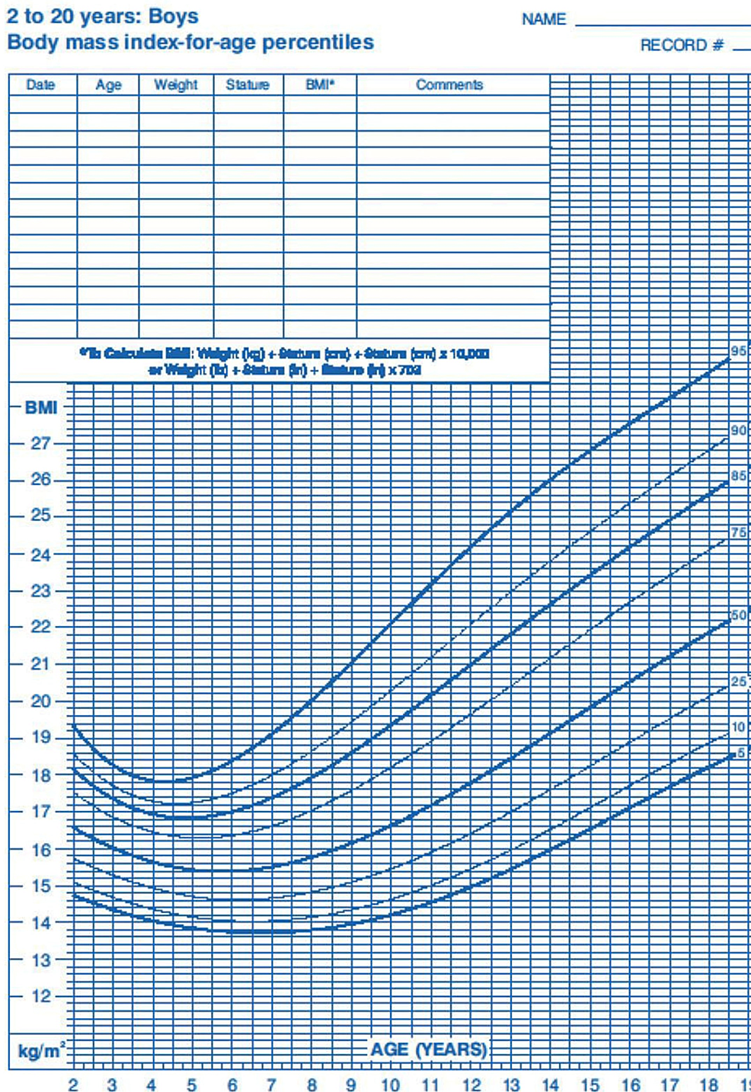](https://assets.cureus.com/uploads/figure/file/491971/lightbox_d628e3805c0111eda4dec1beb806523f-FIG-1-BMI-WORD.png)

**Figure 1: CDC pediatric growth charts for boys**

Figure *2*

[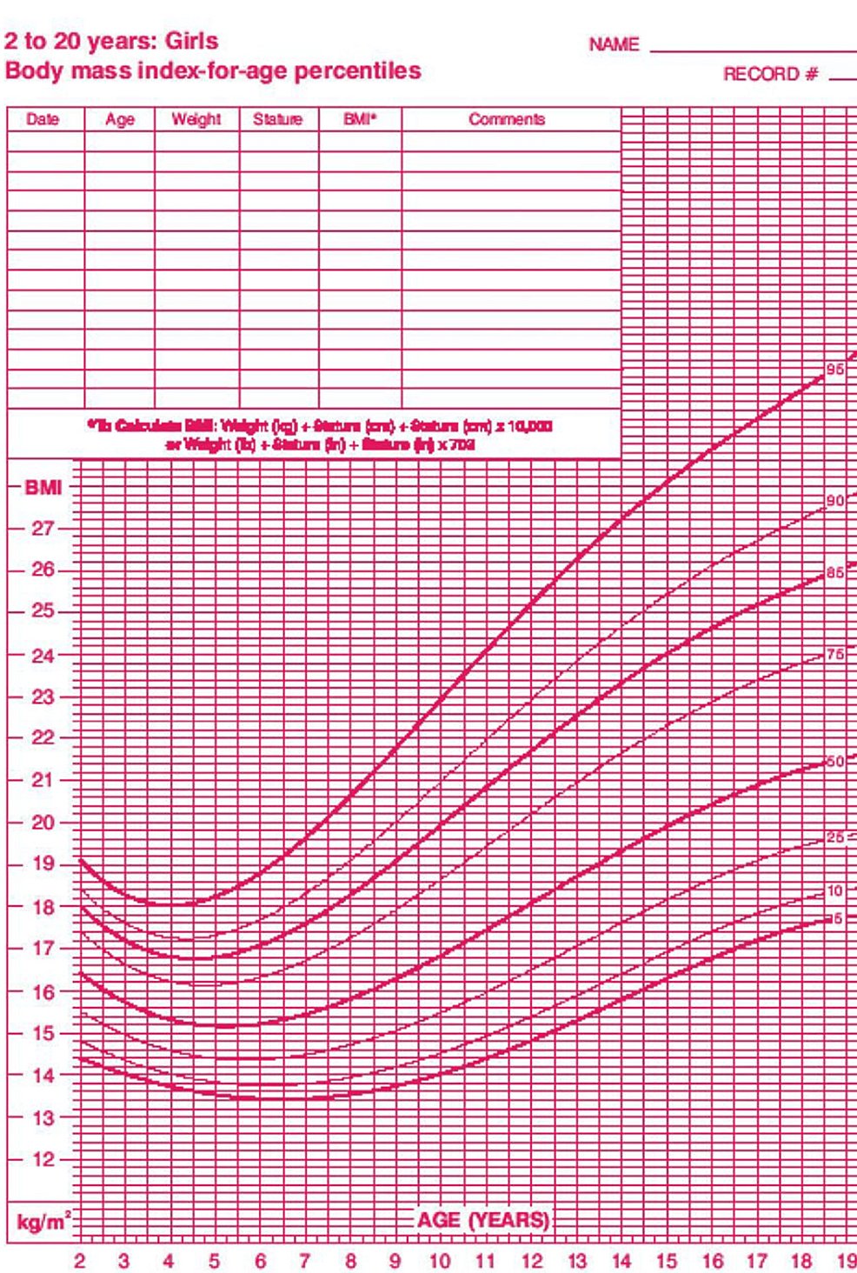](https://assets.cureus.com/uploads/figure/file/491976/lightbox_1a64b1505c0211ed97fd6d3cdc7df65b-FIG-2-BMI-WORD.png)

**Figure 2: CDC pediatric growth charts for girls**

The plaque (PI) and caries (def) index will be recorded as a part of Type 3 oral examination using only mouth mirror, probe, and cotton roll under optimal light. After isolation with cotton, “Plaque index” (by Sillness and Loe) will be recorded individually for each child. Index teeth chosen will be 55, 52, 64, 75, 72, and 84 and will be as per standardized studies [10]. In cases of missing index tooth, the tooth distal to it will be nominated or else only five teeth will be taken into account. Index tooth will be checked for four surfaces, mesiofacial, facial, distofacial, and palatal for scoring. The plaque score for individual tooth will be calculated by totalling the plaque scores of the four surfaces and dividing it by four. The PI for each subject will be tabulated by totalling the individual scores of all index teeth and dividing by total number of index teeth evaluated. Caries index (def) will be recorded as per WHO, Oral health Assessment form for children, 2013 for all subjects respectively. .

**Statistical analysis**

Results will be presented as Mean, standard deviation, range and values for continuous measurements and frequencies as number and percentages. One way ANOVA will be used for simultaneous multiple group comparisons. Categorical data will be analyzed by Chi-square test. P value of 0.05 or less will be considered for statistical significance. SPSS (Version,17) software will be used for data analysis.