**Sequencing of construct:**

**1) PCR to amplify region of interest**:

|  |  |
| --- | --- |
| **Master mix** | **1x** |
| H2O | 13,3 |
| 5x Colorless Reaction Buffer (Promega, #M3005) | 4 |
| 10mM dNTPs (ThermoFisher, #R0182) | 0,4 |
| Fw primer (CMV FW) | 0,6 |
| Rv primer (BGH RV) | 0,6 |
| GoTaq Polymerase (Promega, #M3005) | 0,1 |
| Σ | **19µl** |

Mix 19µl MM with 1µl DNA (50 ng)

**PCR Program:**

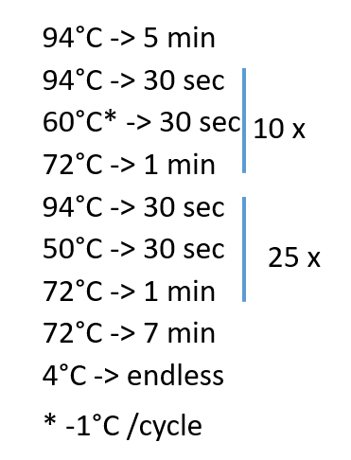

**2)** **Sodium acetate precipitation:**

1. Add 50µl sodium acetate (1ml 3M NaAcetate (Carl Roth) + 24ml 100% EtOH (VWR Chemicals BDH Prolabo)) to 20 µl PCR product
2. mix well and centrifuge at 3200rcf 45min (4°C)
3. Remove supernatant (pat plate on paper)
4. Add 100µl 70% EtOH onto pellet
5. centrifuge at 3200rcf 15min (4°C)
6. Remove supernatant (pat plate on paper)
7. Add 100µl 70% EtOH onto pellet
8. centrifuge at 3200rcf 15min (4°C)
9. Remove supernatant (pat plate on paper)
10. centrifuge upside down max. 600rcf 1min 4°C (top of sample down on tissue paper) to remove EtOH
11. add 15µl MilliQ-H2O to pellet and vortex 15-20min (speed 0-1)

**3)** **Sequencing-PCR:**

|  |  |
| --- | --- |
|  | 1xsample |
| H2O | 5,3µl |
| 5x Terminator Sequencing buffer | 3,3µl |
| BigDye v3.1 (ThermoFisher, #4337455) | 1,4µl |
| Σ | 10µl |

1. Add 5µl MM
2. Add 4µl DNA from 2 step k
3. Add 1µl primer FW or RV

Sequencing program:

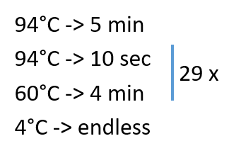

**4)** **Sodium acetate precipitation:**

1. Add 25µl sodium acetate to 10 µl PCR product from
2. mix well and centrifuge at 3200rcf 45min (4°C)
3. Remove supernatant (pat plate on paper)
4. Add 100µl 70%EtOH onto pellet
5. centrifuge at 3200rcf 15min (4°C)
6. Remove supernatant (pat plate on paper)
7. Add 100µl 70%EtOH onto pellet
8. centrifuge at 3200rcf 15min (4°C)
9. Remove supernatant (pat plate on paper)
10. centrifuge upside down max. 600rcf 1min 4°C (top of sample down on tissue paper) to remove EtOH
11. add 15µl MilliQ-H2O to pellet and vortex 15-20min (speed 0-1) COVER! **Light sensitive!**

**5) Load Sequencing-plate**

1. add 10µl Hi-Di Formamide (Applied Biosystems)
2. 7µl DNA after purification (Step 4k)
3. store in 4°C until sequencing