**Protocol for Dead-End Ultrafiltration using REXEED 25S for Isolation of *Salmonella* from Surface Water**

**Supplies Needed**

* Geotech pump (Geotech #91352123) with EZ-Load II pump head
* Assorted lengths of Masterflex Silicone tubing, size 36
* Carboy for liquid waste collection
* Ringstand with adjustable clamps to hold filter
* Hose clamps, appropriate size for Masterflex Silicone, size 36 tubing
* REXEED 25S filters (Dial Medical Supply)
* DIN adapters (Molded Products, MPC-855NS.375)
* Sterilized graduated cylinders (250 and 500 mL)
* 2X Buffered peptone water (BPW, Accumedia #7417)
* Control strain, *Salmonella* *typhimurium* BIOBALL® Luminate (BioMerieux, #422190)
* Backflush solution (see recipe below)
  + Deionized water (sterilized)
  + Tween 80 (Fisher T164)
  + Sodium hexametaphosphate (NaPP, Sigma 305553)
  + Antifoam Y-30 emulsion (Sigma A5758)

**Recipes**

Backflush solution preparation for 500 mL (each sample requires 100 mL):

1. Make a 10% NaPP/1% Antifoam Y-30 stock solution.
   * Add 1 g NaPP and 100 μL Antifoam Y-30 to 10 mL DI water. Shake vigorously to dissolve the NaPP.
2. Add 500 mL DI water to a 500-mL bottle (glass or plastic).
   * Add 2.5 mL of Tween 80 and 500 μL of the 10%NaPP/1% Antifoam Y-30 stock solution. Swirl to dissolve the Tween 80.
3. Final concentration in Backflush solution: 0.5% Tween 80/0.01% NaPP/0.001% Antifoam Y-30

**Protocol**

1. If needed, add control strain to water sample by gently tipping vial over the opening. Close sample bottle tightly and thoroughly mix sample before proceeding.
2. Prepare for filtration by setting up Geotech pump in the biosafety cabinet (BSC). Ensure enough room around pump to include filtrate/waste collection bottle and ringstand for holding filter.
3. Ensure you have different lengths of Masterflex tubing to allow for insertion into the sample bottle, through the pump head, connecting at the top port (RED) of the ultrafilter using DIN adapter with a second piece tubing connecting to the lower side port (BLUE end, NOT bottom port) of the ultrafilter ending in a collection container.
4. Attach intake tubing to the REXEED 25S so the sample will flow through the filter as indicated on the label (from top to bottom, RED to BLUE). Attach the outgoing tubing to the opposite end of the filter with the outlet end in a waste collection bottle (Figure 1).

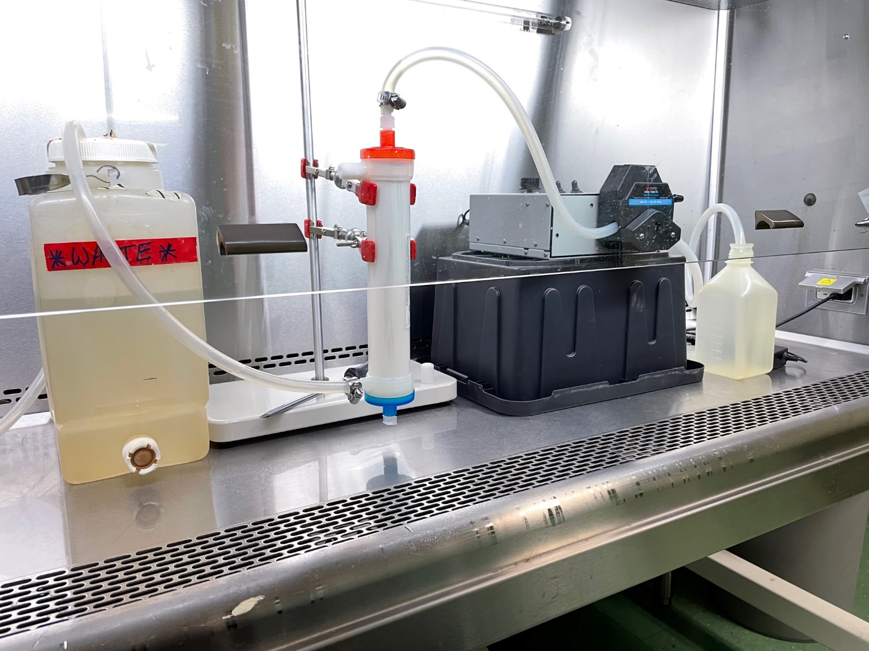**Figure 1.** Ultrafiltration set up for sample filtration. Tubing connects using DIN adapter at top port (RED) and at lower side port. Bottom port (BLUE) and upper side port remain closed/capped during filtration.

1. Place inlet of intake tubing into the 1 L bottle containing surface water, ensure the tubing is clamped in EZ Load pump head, and water is flowing through tubing in the appropriate direction. Then turn on pump, set pump rate to ¾ of the maximum flow rate, and adjust pump-speed after pumping has initiated to reach a steady/constant flow rate through the filter.
2. Turn off pump once filtration is complete and any remaining water in tubing should be drained into the waste collection container. **WARNING!** The pressure built up in the intake tubing will lead to a sudden discharge of said pressure when the pump head is released. BE PREPARED for this by using a gloved hand to secure the tubing in the sample container before you release the pressure.

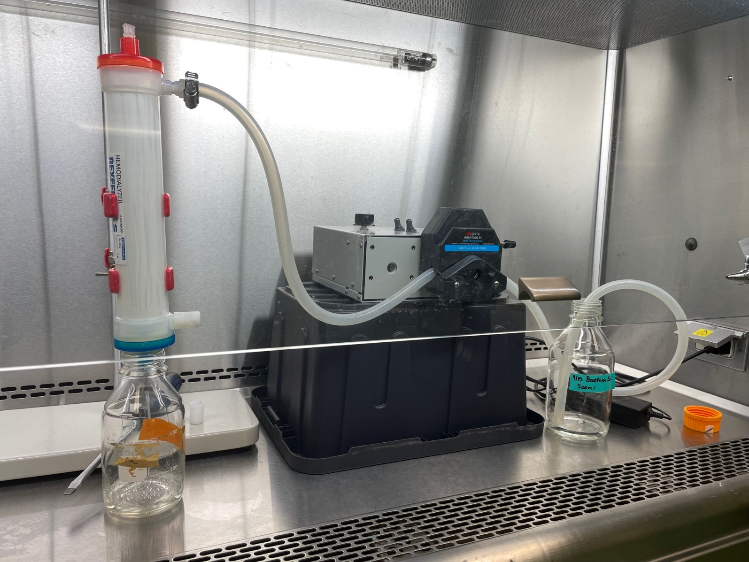**Figure 2.** Backflush pump and filter set up. Make note of the closing of the top port (RED) and lower side port before opening upper side port. Tubing is only necessary for upper side port as a collection bottle will sit at open bottom port (BLUE) to collect backflush for enrichment.

1. Reposition tubing on the REXEED 25S filter in the configuration shown in Figure 2. Start by removing the intake tubing and DIN adapter at the top, closing the port with the cap, and discard tubing/adapter in decontamination container. Remove tubing from lower side port and re-cap so all ports on the filter are sealed. Tubing can then be attached to upper side port (Fig 2) – remember to remove cap from side port furst. Thread tubing through Geotech EZ Load pump.
2. Place collection bottle below the bottom port (BLUE) and remove cap on filter before backflushing.
3. Place prepared backflush solution (100 mL) as pictured in Fig 2 and begin pumping as described in steps 4 and 5 until the backflush solution is used and liquid stops flowing from the open bottom port. **REMEMBER:** the pressure will build up so when released it can be violent (tube can be ejected from backflush bottle). To prevent this, secure tubing in backflush bottle (using a gloved hand) before releasing pump head.
4. Collect as much backflush filtrate as possible and once flow has stopped turn off pump and remove tubing from backflush collection. To avoid spills from water remaining in tubing, all tubing should go into a bin for decontamination via autoclave.
5. Add appropriate volume of concentrated 2X BPW to backflush filtrate bottle to make a 1:1 dilution. Incubate enriched backflush at 37oC for 18-24 h.

For next steps, refer to “Selective Enrichment Protocol for *Salmonella* Isolation from Surface Water”