Appendix II: 2,4-dinitrophenylhydrazine α-ketoglutarate detection assay protocol

2,4-dinitrophenylhydrazine α-ketoglutarate detection assay for Prolyl Hydroxylase Domain (PHD) proteins

Note: this protocol accompanies the following publication:

S. J. Wong, et al., Development of a colorimetric α-ketoglutarate detection assay for prolyl hydroxylase domain (PHD) proteins. J. Biol. Chem. 296, 100397 (2021).

Assay schematic at a glance (created with BioRender.com)

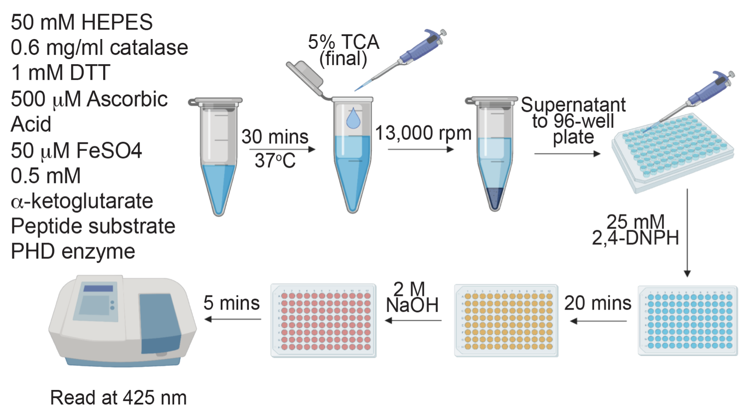

Reagent preparation

Reagent stock | Stock concentration | Working concentration | Preparation notes
HEPES pH 7.0 / MES pH 6.0 | 0.5 M | 50 mM
Bovine liver catalase | 21 mg/ml | 0.6 mg/ml
DTT | 10 mM | 1 mM | Prepare fresh
Ascorbic acid | 40 mM | 500 µM | Prepare fresh
FeSO₄ | 1 mM | 50 µM | Prepare 500 mM in 20 mM HCl, then dilute to 1 mM in water just before use.
α-ketoglutarate | 20 mM | 0.5 mM
Peptide | 20 mM | 100 µM | Dissolved in DMSO
PHD enzyme source | 20 µM | 10 µM | Prepare fresh
Trichloroacetic acid (TCA) | 10% | 5%
Sodium phosphate pH 7.2 | 0.5 M | 50 mM
2,4-DNPH | 50 mM | 25 mM | Prepare fresh. Dissolve in 0.5 M phosphoric acid, let stand for 30-60 mins, then add water to intended concentration. Filter through 0.45 µM filter to remove precipitate.
NaOH | 6 M | 2 M

Instructions

In vitro hydroxylation assay

- Prepare 5 Eppendorf tubes containing 50 µl of 10% TCA.
  - Label tubes: 0 min, 1 min, 2 min, 5 min, 15 min.
- Prepare cofactor solution containing HEPES/MES, catalase, DTT, ascorbic acid, FeSO₄, α-ketoglutarate, and peptide in a 150 µl volume in an Eppendorf tube (using the working concentrations).
- Add 150 µl of 20 µM PHD enzyme into the cofactor solution.
- Vortex briefly.
- Place into a 37 ºC tabletop shaking incubator and start the timer (counting up).
  - This step equilibrates the temperature of the reaction to 37 ºC.
- At T = 1 min on the timer, withdraw 50 µl of the reaction solution and quench in the “0 min” tube containing 10% TCA, and replace the reaction tube in the incubator.
- Repeat this for the other time points.
  - At T = 2 min, withdraw 50 µl of the reaction solution and quench in the “1 min” tube
  - At T = 3 min, withdraw 50 µl of the reaction solution and quench in the “2 min” tube
  - At T = 6 min, withdraw 50 µl of the reaction solution and quench in the “5 min” tube
  - At T = 16 min, withdraw 50 µl of the reaction solution and quench in the “15 min” tube
- Briefly vortex the quenched reactions.
- Keep the quenched reactions at 4 ºC until ready for downstream processing.
  - Reactions have been stored up to 3 days with no loss of signal.

Color development with 2,4-DNPH

- Centrifuge the quenched reactions at 13,000 rpm for 15 minutes.
- Meanwhile, add 10 µl of 0.5 M sodium phosphate to 5 wells of a 96-well plate.
- Transfer 90 µl of the supernatant of the quenched reaction to a well containing 10 µl of 0.5 M sodium phosphate (V_{T} = 100 µl).
  - Do the same for the other 4 quenched supernatants.
- Using a multi-channel pipette, add 100 µl of 50 mM 2,4-DNPH to the wells (V_{T} = 200 µl). Pipette up and down gently to mix.
- Leave at room temperature for 20 minutes.
- Using a multi-channel pipette, add 50 µl of 6 M NaOH to the wells (V_{T} = 250 µl). Pipette up and down gently to mix.
- Leave at room temperature for 5 minutes.
- Read at 425 nm on a spectrophotometer.

Data handling

- Calculate the amount of α-ketoglutarate consumed from a standard curve processed in the same way as the samples.
- Plot the amount of α-ketoglutarate consumed against time, to obtain a curve that looks like this:

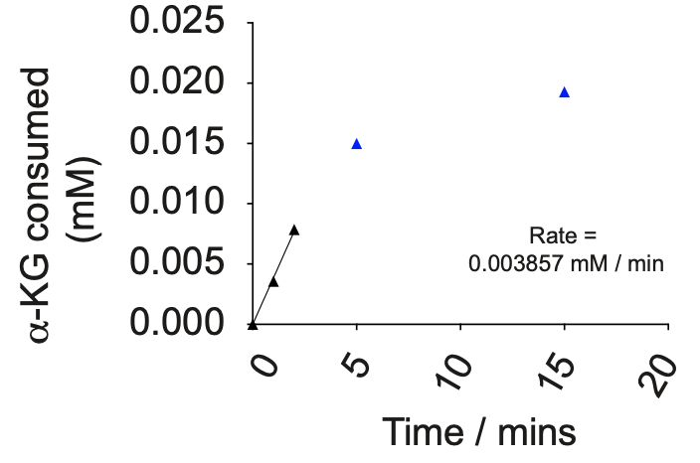

- The initial rate should be taken as the linear portion of the curve. In this case, from T = 0 to 2 mins.

Hewitson, K. S., Schofield, C. J., & Ratcliffe, P. J. (2007). Hypoxia-inducible factor prolyl-hydroxylase: purification and assays of PHD2. Methods in enzymology, 435, 25–42. https://doi.org/10.1016/S0076-6879(07)35002-7

