Mouse Cardiac Perfusion Fixation
and Brain Collection

- Scope and Applicability: This protocol describes the procedures for intracardiac perfusion fixation of postnatal mice, including anesthesia, exsanguination, fixation, brain removal and post-fixation storage. This procedure should be performed by trained personnel only, or with supervision by a trained IVS staff member.

- Materials:
  - 0.9% NaCl solution (Saline)
  - Fresh 4% Paraformaldehyde (PFA)
  - 1X PBS (-)
  - 1X PBS with 0.1% Sodium Azide
  - 10%-30% Sucrose in 1X PBS (-)
  - 100 mL graduated cylinder
  - Two 500 mL or larger containers for PFA and Saline
  - Aluminum foil
  - Perfusion board
  - Vinyl Dissection Pad
  - Plastic tray
  - Needles
  - Surgical scissors (sharp pointed end)
  - Nose cone
  - Forceps
  - Isoflurane
  - Blunt tip perfusion needles, 22G and/or 25G
  - Glass vial (one per brain)
  - 50 mL conical tube (one per brain), or otherwise specified container
  - Peristaltic pump tubing (1/16” ID, 3/16” ID, 1/16” wall thickness)
  - Luer lock 3-way Stopcock
  - Male luer integral lock ring 200 series
  - 70% Ethanol
  - PFA waste bottle
  - Approved disinfectant
  - Deionized water
  - Kim wipes or Gauze pads
  - RL934DW Labels (Online Labels Inc.)
  - Circular Labels (Avery 94500, WeatherProof white film)
  - 0.22 µm vacuum filter (Stericup-GP Vacuum Filtration St 250 ml)
  - Nuclease-free water (Milli-Q Water with Biopak filter or equivalent)
  - RNase Away
- Equipment:
  - VetEquip Table Top Laboratory Animal Anesthesia System
  - Class II Biological Safety Cabinet
  - Animal Facility VWR Brand 4°C refrigerator
  - Harvard Apparatus Peristaltic Pump 66 (MA1-55-7766)
  - Orbitron Rotator II (Model 260250), Boekel Scientific (or equivalent)
  - Zebra Printer (LP2442)
- Safety:
  - Only IACUC approved and appropriately trained personnel may perform this procedure.

Warning: Personal Protective Equipment (PPE) should be used at all times while operating this protocol. If you are unsure what PPE you should be using, see your immediate supervisor.

Isoflurane Warning: Acute over-exposure to waste anesthetic gases (WAG) may cause eye irritation, headache, nausea, drowsiness or dizziness. Repeated exposure may cause damage to cardiovascular system and central nervous system. Refer to MSDS for additional information. Consult the surgical workstation guide to ensure all parts of the dispensation rig are functioning properly. Employee exposure monitoring is periodically conducted by EHS and may be requested at any time from EHS.

- Output:
  - Harvested brains that are post-fixed overnight in 4% paraformaldehyde (PFA) at 4°C, then rinsed with PBS.
  - Brains are then stored at 4°C in requested solution.
- Reference Documents:
  - AF0061: Brain Dissection Post-Natal Mice
    - https://www.protocols.io/view/brain-dissection-of-post-natal-mice-ddtf26jn
  - QC1011: Tissue Quality Evaluation for Brain Perfusion/Dissection Specimens
    - https://www.protocols.io/view/tissue-quality-evaluation-for-brain-perfusion-diss-ddsj26cn
  - RP0001: Phosphate Buffered Saline (PBS)
    - https://www.protocols.io/view/phosphate-buffered-saline-pbs-ddsg26bw
  - RP0061: 0.9% Saline Solution
    - https://www.protocols.io/view/0-9-saline-solution-ddr92596
  - RP0068: PBS with 0.1% Sodium Azide
    - https://www.protocols.io/view/pbs-with-0-1-sodium-azide-ddr8259w
  - RP0196: Fresh 4% Paraformaldehyde in PBS
    - https://www.protocols.io/view/fresh-4-paraformaldehyde-in-pbs-ddr4258w
  - RP0064: 30% Sucrose for Cryoprotection of brains after Perfusions
    - https://www.protocols.io/view/30-sucrose-for-cryoprotection-of-brains-after-perf-bg5ujy6w
  - VetEquip Tabletop Laboratory Animal Anesthesia System (LAAS) Operation Manual
  - Harvard Apparatus Peristaltic Pump 66 Manual
  - RP0238: Nuclease-free PBS
    - To be Published

- Setup:
  - Print out the LabTracks perfusion task. Retrieve animals from designated room by verifying that the cage card has the same cage number and LabTracks ID as listed on the task (see Figure 1).
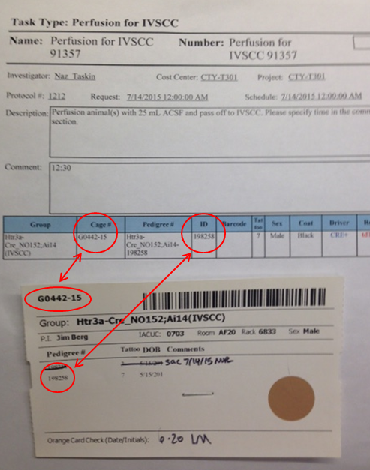
Figure 1. Verifying the cage number and specimen ID match the perfusion request

  - Obtain 4% PFA
Note: Fresh 4% PFA should be obtained from Reagent Prep ahead of time. Reagents should be requested according to standard protocols, using Reagent Request paperwork, and providing sufficient notice as requested. Fresh 4% PFA expires after 7 days.
    - Calculate the total volume of fresh 4% PFA needed for all mouse perfusions that day by adding the total volume for each animal/age point. Refer to Table 1 for these volumes. Add 20 mL to that total to account for the large surface area of the bottom of the jar holding 4% PFA.
  - Set up for Perfusion
    - Ensure Isoflurane level is sufficient to complete procedure.
    - Prepare container with 0.9% Saline. Calculate the total volume of 0.9% Saline needed for the day by adding 20 mL per animal that will be perfused. Also, add an additional 20 mL to the total to account for the large surface area of the bottom of the jar holding 0.9% Saline.
    - Attach the appropriately sized blunt needle to the luer connector by twisting it on tightly (22G for P28 and older, 25G for below P28).
    - Place feeding tubes into 0.9% Saline and 4% PFA. Turn pump power on, and press any key to initialize. Turn stopcock to PFA, then set to Pump mode (by pressing the mode key until “Pump” is highlighted), press start and visually inspect that the tubing fills until PFA passes the stopcock. Press stop, turn the stopcock to Saline, and pump until Saline exits the needle, at least 6 mL. This will ensure that no bubbles are introduced into the mouse cardiovascular system.
    - Set the flow rate of the pump (in mL/min) by pressing the Set button, followed by the Rate button. See Table 1 in Section 10, for appropriate flow rates depending on mouse size/age.
    - Label pre-filled glass vial containing 4% PFA with the LabTracks ID number of the mouse to be perfused, 4% PFA, and the date.
    - Cover perfusion board with aluminum foil, place inside plastic tray using needles to elevate to allow for drainage.
    - Place nose cone on one end of perfusion board.
  - Set up for omFISH Perfusion
    - Obtain Nuclease-free 1X PBS - Can be obtained by Reagent Prep or filtered from 1X PBS provided by Reagent Prep by using 0.22 µm Vacuum Filter.
      - To filter, use the vacuum line in the Biological Safety Cabinet with a gas line to the 0.22 µm Vacuum Filter. Pour 1xPBS into the top section and then turn on the vacuum. Once filtered, detach bottom container and use supplied lid. Label bottle with “Nuclease-free 1xPBS” label.
    - Obtain Nuclease-free water.
    - Clean the surgical tools with RNase Away spray, sit for ~1 minute and rinse thoroughly with Nuclease-free water 5-10 times.
- Methodology/Procedures:
  - After removing mouse from cage, double check the cage number, LabTracks ID, ear notches, sex, and tattoos all are consistent with what is requested on the perfusion task.
  - Follow steps in to anesthetize animal to a surgical plane.
  - Weigh animal between transferring from induction chamber to nose cone and record weight on task.
  - Switch Isoflurane flow to a nose cone. Position the mouse supine, with nose inserted into the nose cone; Isoflurane flow should be at 2.5-3%.
  - Use the toe pinch reflex test to determine whether the mouse is anesthetized to a surgical plane. The absence of a response indicates the mouse is ready to perfuse.
  - Pin all four paws to the perfusion board with needles.
  - Spray mouse body with 70% Ethanol.
  - Cut the ventral surface of skin over the diaphragm.
  - Grasp the xyphoid process with forceps. Carefully snip the diaphragm to open the thoracic cavity.
  - While holding the xyphoid process, snip up both sides of the rib cage. Avoid nicking the heart, lungs, or the veins going along the rib cage.
  - Bend the flap of muscle and ribs (created by the previous step) and pin the top part of the rib cage to the perfusion board with a needle.
  - Carefully snip the right atrium.
  - Grasp the heart with forceps and then insert the blunt perfusion needle into the left ventricle directing the tip of the needle toward the aorta (see Figure 2 for anatomical reference). Note: exsanguination will not occur if needle is placed in the right ventricle or crosses the septum.
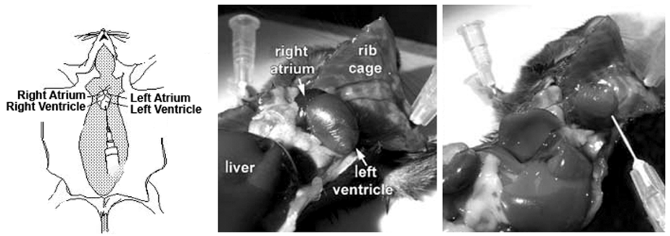
Figure 2. Anatomical reference for mouse preparation and needle placement.

  - Lay needle and tubing flat against the perfusion board. Ensure that the needle remains in place in the heart during this process.
  - Press mode until Pump mode is highlighted and reads 0 mL. Press start to run 0.9% Saline until at least the volume specified according to the age of the mouse is reached (see Table 1 in Section 10) and until the liver is clear. If perfusate is observed through nose/mouth, or if liver is not clearing, stop the pump, reposition the needle (directed toward aorta, and then continue pumping. Do not perfuse with Paraformaldehyde if mouse is not exsanguinated. Press Stop once saline is complete.
  - At this point, turn off Isoflurane and switch flow back to induction chamber.
  - Carefully turn stopcock to 4% PFA, without tapping tube or forming a bubble, which will prevent fixative from accessing the smallest vessels and capillary beds.
  - Set pump to “Dispense” mode by pressing the Mode button. To set a specific volume to dispense, press the Set button, followed by the Volume button. Enter the correct volume (in mL) to be dispensed. Note: the volume of the tube is approximately 3 mL, depending on the length of the tubing. Thus, to dispense 50 mL of PFA for an adult mouse perfusion, set the dispense volume to 53 mL, then hit Enter.
  - Press start to dispense 4% PFA until the appropriate volume of PFA has been pumped through the mouse system (See Table 1 in Section 10). Using Dispense mode, the pump will automatically stop once the appropriate volume has been reached.
  - If perfusing multiple animals, wait until at least 25mL of PFA has been dispensed to place next animal in chamber. Turn on Isoflurane flow to 5%.
  - Remove the needles from the animal. If the perfusion was successful, the animal will be stiff.
  - Prior to beginning the perfusion of the next animal, press mode until Pump is highlighted and dispense at least 6 mL of 0.9% Saline through the tubing again to ensure that all PFA is out of the tubing. Press Stop.
  - Remove the brain from the skull according to SOP AF0061.
  - Evaluate perfusion and dissection quality (see SOP QC1011).
  - Place the brain in the glass vial containing at least 10 mL 4% PFA.
    - Unless otherwise requested, specimens should be stored for 3-6 hours at room temperature with gentle agitation (i.e., orbital shaker or nutator).
    - After 3-6 hours place the specimens at 4°C for ~12 hours to overnight.
    - It is preferable to have the fixation time be less than 24 hours. However, if this is unavoidable due to an intermittent weekend or other schedule interruption, the fixation time may be extended if approved by the requestor.
- Brain Transfers Directions
  - Directions for printing 50 mL conical tube labels (consult LabTracks Reference Sheet if necessary):
    - Log into LabTracks.
    - Locate Group the animal is in.
    - Mark the animal dead as “Perfusion”
    - While the animal is selected, click on “Print Cards”
    - Select “Perfusion Labels (Use this one)”
    - Print out using the applicable Zebra Printer, assuring the labels are lined up and adjust as necessary.

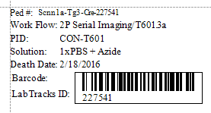
Figure 3. LabTracks generated label

  - Place labels on tubes in correct orientation as shown in figure 4.
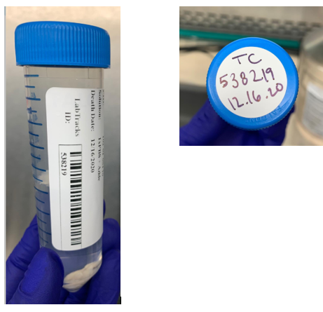
Figure 4. Label orientation

  - Fill with solution indicated on the label. Be sure to use at least 20 mL of post fixation solution.
  - Prepare an extra 50 mL conical tube for the rinse. Fill with 1x PBS (-) and write “PBS rinse” on the tube.
  - NEXT MORNING: Specimens will need to be transferred to their post fixation solution, which will be specified on the printed LabTracks labels (see direction below) and on the LabTracks perfusion task. Perform brain transfers in a Biological Safety Cabinet.
  - For omFISH brain transfers
    - Make sure the post-perfusion fixation time is less than 24 hrs. Post-fix in Nuclease-free 1X PBS (refer to 7.4 for where to obtain).
    - Spray with RNase Away and then rinse with Nuclease-free water 5-10 times the 50 mL conical rinse tube and transfer spoon. Fill the rinse tube with Nuclease-free 1xPBS.
    - Use clean gloves and avoid touching any surfaces with the transfer spoon.
    - Transfer these specimens first.
  - Remove brain from 4% PFA, and rinse with 1x PBS (-). Remove brain from rinse tube and place in the specimen’s designated conical tube. Check the workflow on the label and write the following information on the top of the tube circular label.
    - For 2P Serial Imaging: TC: Animal ID, and perfusion date.
    - For anything else: Animal ID, requestor initials, and perfusion date.
  - Store upright at 4°C, unless brain will be immediately embedded. Deliver to location specified on perfusion LabTracks task.
- Take Down:
  - After the last perfusion, complete the following steps to remove all solutions from the tubing.
    - Turn stopcock to PFA. Remove tubing from PFA and place in DI water. Press start to dispense at least 3 mL of DI water through the tube. Remove the tube from DI water and Pump air through the tube until it passes the stopcock. Press Stop.
    - Switch stopcock to Saline. Remove tubing from Saline and place in DI water. Press start and dispense at least 3 mL of deionized water through the tubing. Then remove the tubing from the water and run air through the tubing to dry it, until all of the water is removed.
  - Using approved disinfectant, clean the peristaltic pump as well as the tubing that was contaminated by blood during the perfusion process.
  - Pour the PFA solution caught in the plastic tray into bottle labeled “PFA Waste.”
  - Place plastic tray, perfusion board, vinyl dissection mat, scissors, and forceps in the sink and spray with approved disinfectant. Use water and a brush to remove debris. Rinse in 70% Ethanol and place on an absorbent pad to dry.
  - Dispose of used needles in a Sharps container.
  - Clean induction chamber with approved disinfectant. Ethanol and Quatricide should not be used.
  - After brain transfer, pour the 4% PFA left in the glass vials into the PFA waste bottle. Place empty vials into broken glass bin.
    - If recycling tubes, be sure to rinse with water three times before placing in recycle bin.
  - Place biohazardous materials, used gauze, or absorbent pad in biohazard trash container.
  - Dispose of PFA waste daily in the PFA waste barrel as indicated by facilities/EHS and rinse the dispensation bottle with tap water three times (deface any identifying labels/markings with a permanent marker) and throw it in standard trash.
  - Dispose of animal carcass in appropriate animal waste container.

- Technical Information:
  - Table 1. Perfusate flow rate and volumes required per mouse size:
Mouse Age | Flow Rate (mL/min) | Volume NaCl (mL) | Perfusate Volume PFA (mL)
Adult | 9 | 10 | 50
P21 – P30 | 7 | 7 | 20
P11 – P20 | 6 | 5 | 15
P4 – P10 | 5 | 5 | 10
Note: When accounting for total volume of NaCl and PFA, add ~20mL to account for volume of the peristaltic pump tubing and dead space. Excess saline is pumped from the transition from saline to PFA due to length of tube.

