Stock Solution Preparation Documentation Sheet

1. 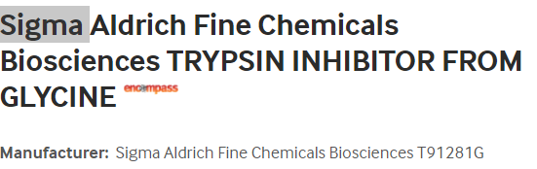**Fisher Product** Catalog #501784544 Trypsin Inhibitor from Glycine max (soybean) – lyophilized powder



**2.0 Preparation of *Trypsin inhibitor Stock (10 mg/mL)* for Addition to Media:**

**Preparation of *10 mg/mL Trypsin Inhibitor Stock*:** (Follow instructions below)

*Note: The expiration date is indicated on the Certificate of Analysis and/or bottle. Store frozen at -20 ⁰C. Attach a copy of the CoA to this sheet.*

|  |  |  |  |  |  |
| --- | --- | --- | --- | --- | --- |
| **Material** | **Source** | **Lot#** | **Expiration Date** | **Quantity Required** | **Quantity Used** |
| Trypsin Inhibitor |  |  |  | 1000 mg |  |
| PIM (T) (no additives) |  |  |  | QS to 100 mL |  |

Prepared by Date

***Preparation of Stock Trypsin Inhibitor for Addition to Media:***

* Weigh 1 gm (1000 mg) of trypsin inhibitor from the bottle and QS to 100mL with serum free PIM(T) ® (no additives). This will give a ***stock concentration of 10 mg/mL***
* Mix with a stir bar and stirring plate until totally dissolved
* Allow to stand on ice at least 30 min before filter sterilizing
* Filter sterilize the solution using a 0.2 µm filter
* The expiration date of the solution is indicated on the Certificate of Analysis (CoA) and/or the bottle. **Document expiration date as listed on the CoA.**
* Aliquot into sterile tubes, 5 mL samples, label as stock solution, add expiration date.
* Store and freeze at -20ºC for later use. Stock solution is stable at -20ºC.
* Inhibitor must be added fresh to the medium before culture or shipment. Add 5 mL of Trypsin Inhibitor stock to each 500 mL bottle of PIM(T)®. This will give a ***final working concentration of 100 μg/mL*** of Trypsin Inhibitor in the media.

1. **Addition to Media:**
   1. ***Add 5 mL of Trypsin Inhibitor stock to each 500 mL bottle of PIM(T)® for NIPT shipping. This will give a final working concentration of 100μg/mL of Trypsin inhibitor in the media.***