Growth Stages

The following document will give an overview about the usual scale used to describe wheat growth stages. We will focus here on the main stages related to different key points that are developed on this website, more details can be found on the Agriculture and Horticulture Development Board website (<http://cereals.ahdb.org.uk/>) and the wheat big picture website (<http://www.cerealsdb.uk.net/cerealgenomics/WheatBP/Documents/DOC_WheatBP.php>).

Growth or developmental stages are specific times at which recognizable physical changes can be seen on the plant. The need to identify such stages is very important because they are accompanied by various morphological and physiological changes, which will affect any performed treatments and experiments. A few examples of these changes are tillering, booting, heading, flowering, grain filling, and maturity. Many crop management activities, like the application of fertilizer, pesticide and irrigation, are more effective when applied at specific developmental stages. Therefore, proper understanding of the developmental stages is a basic requirement for a successful research program in wheat.

Several staging systems have been established to describe wheat development. The Zadoks system is the most commonly accepted and allows precise staging (Zadoks et al., 1974). It consists of a two-digits code: the first digit referring to the principal stage of development (from 0 to 9, germination to kernel ripening) and the second digit allowing subdivision of the bespoke principal. Besides the Zadoks system, the Haun and the Feekes-Large systems have also been widely used. The Haun system mainly refers to the leaf production stage of development by expressing leaf length of each emerging leaf (Haun, 1973). The Feekes-Large system numerically identifies the main stages such as tillering or ripening but lacks the subdivisions allowed by the Zadoks system, making it less detailed (Feekes, 1941; Large, 1954). A correspondence has been established between the Zadoks and the Feekes-Large systems (see associated file). The Waddington scale focuses on the development of the spike meristem and pistil of barley and wheat (Waddington et al., 1983). The scale begins at the time of the transition apex and ends just prior to anthesis (see associated file).

Figure 1 shows the principal stages according to the Zadoks scaling system. The figure is from the AHDB wheat growth guide and more details can be found on the AHDB website. The key points will be detailed in the following section and linked to the related sections of this website.

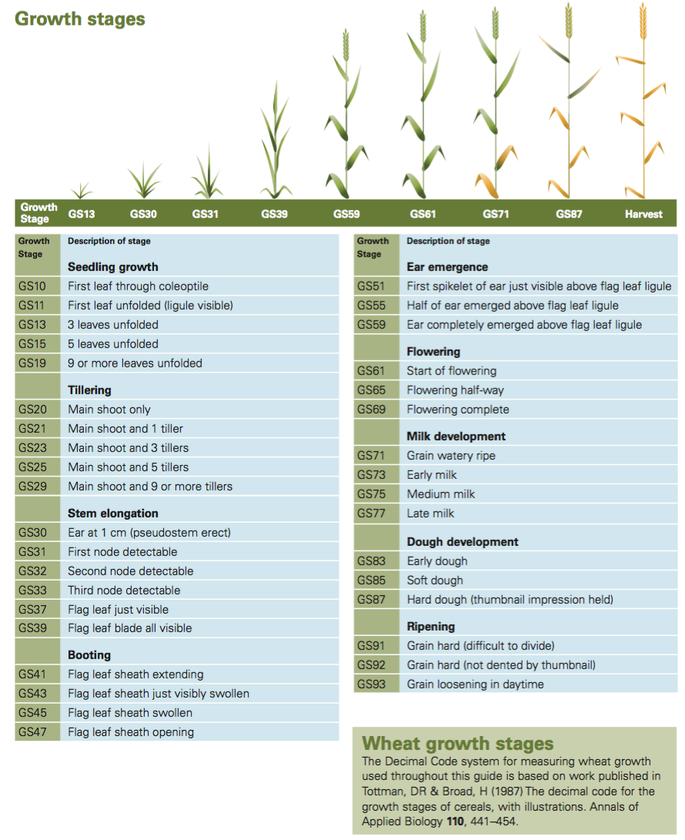

Figure 1. Illustration of the Zadoks scale system to describe wheat growth stages

Source: AHDB website http://cereals.ahdb.org.uk/

# Germination and seedling growth (GS00 to GS19)

The Zadoks system starts at 0 with the germination stage which occurs from the initial stage of the dry kernel to the coleoptile emergence and the first leaf formation at its tip. Then, the seedling development stage (1) takes place and is characterised by leaf formation. About one leaf is produced every four to five days, usually up to nine leaves in total. One can typically start to sample leaves for DNA extraction at the three leaf stage to ensure to not remove too large a proportion of the plant. Emergence date for a particular cultivar is when 50% of the seedlings have emerged. Emergence largely depends on the depth at which the seeds are sown and also the germination energy or the amount of food reserve in the endosperm. So appropriate sowing depth and the viability of the seed are important considerations for effective seedling emergence.

# Tillering (GS20 to GS29)

After the emergence of the fifth leaf additional tillers start to be produced, leading to the tillering stage (2). Tillers are lateral shoots emerging at the base of the main stem of the plant. Each tiller have the potential to produce a grain head, which is why tiller management is important regarding yield. Plants are generally potted up at the beginning of this stage. Three tillers per plant are frequently produced but certain varieties can produce more (up to nine). Every additional tiller represents a subdivision of the tillering stage. It is important to notice that the head differentiation also occurs during the tillering stage and the stem starts to elongate once its formation is complete. This leads to the stem elongation stage (3).

# Stem elongation (GS30 to GS39), booting (GS40 to GS49) and heading (GS50 to GS59)

Terminal spikelet (GS30) is the stage at which the final spikelet can be observed on the forming spike/ear within the stem of the main tiller. To determine terminal spikelet stage is laborious and requires the dissection of tillers. Determination of GS31 is an alternative that can be estimated infield as the date at which the first node can be detected at approximately 1 cm above the tillering node, and is more easily seen with the naked eye. Every subdivision of the stem elongation stage corresponds to the formation of a new internode before the flag leaf emergence occurs. When the flag leaf blade is completely visible, the booting stage starts (4). As the stem continues to elongate, the ear is pushed through the flag leaf sheath. The heading stage (5) begins when the ear emerges from the flag leaf sheath and continues until the entire ear has emerged. Wheat emasculation for crossing purposes is usually performed during the early stages of the heading stage in order to avoid any self-pollination. Heading date can be evaluated by counting the number of emerged ears within the population. For example, heading date could be recorded as the time when 50% of the spikes have emerged from the flag leaf sheath, although one could also consider 25 or 75 %.

# Flowering (GS60 to GS69)

The flowering stage (6), or anthesis, begins after heading and it is at this stage that the anthers release their pollen. However, certain varieties can start to flower while the ear is not yet fully emerged from the flag leaf sheath. There is a gradient in flowering time along the spike/ear of a plant, with the florets of the central spikelets flowering first. Over the next few days the spikelets above and below the central spikelets will flower, with the most distal florets flowering last. Once the anthers start to release their pollen they will also begin to extrude from the florets. Thus, it is easy to detect a spike post-anthesis and estimate the flowering date. Determining the proper pollen maturity for crossing purposes is detailed in the section How to cross wheat protocol. The period of pollination within a single head is about four days. Anthesis is physiologically one of the most sensitive stages and highly affected by temperature.

# Milk and Dough development (GS70 to GS89)

Milk development stage (7) starts once the flowering is complete and is the early kernel formation stage. It is subdivided in early, medium and late milk. The developing endosperm starts as a milky fluid that increases in solids as the milk stage progresses. Kernel size then increases rapidly during this stage which occurs one to two weeks after pollination. The dough development stage (8) is the stage during which most of the kernel dry weight (starch and protein content) accumulates. Hard dough stage represents the attainment of maximum dry weight with approximately 30 % moisture content. This stage is also known as physiological maturity.

# Ripening (GS90 to GS99)

Finally the seed moisture will decrease down to 13 to 14 % and once the crop is at physiological maturity, no more kernel dry weight will accumulate. This is the ripening stage and the seed may be harvested at the end. (9). A good indicator for maturity is when the peduncle and the flag leaf start to lose their green colour, which correspond to the kernel attaining about 95% of its dry weight. Again, ripening date can be evaluated for a given variety when 50% of the peduncles are ripe.

# Generation times in the greenhouse

In general, winter wheat grown in a greenhouse requires six to eight months to finish one seed to seed cycle (including a vernalization period of 30 to 60 days). A spring variety takes three to four months as it does not require vernalization (or very little). Some varieties are called facultative because they only need a shorter vernalization period (15 to 30 days) with temperatures varying from 3 to 15 °C.

References:

Zadoks, J. C., Chang, T. T. and Konzak, C. F. (1974), A decimal code for the growth stages of cereals. Weed Research, 14: 415-421. doi: 10.1111/j.1365-3180.1974.tb01084.x

Haun, J. R. (1973), Visual Quantification of Wheat Development. Agronomy Journal, 65: 116-119. doi: 10.2134/agronj1973.00021962006500010035x

Feekes, W. (1941). De tarwe en haar milieu [Wheat and its environment]. Verslagen van de Technische Tarwe Commissie. (in Dutch and English). 17: 523–888

Large, E. C. (1954), Growth Stages in Cereals Illustration of the Feekes Scale. Plant Pathology, 3: 128-129. doi: 10.1111/j.1365-3059.1954.tb00716.x

Waddington, S. R., Cartwright, P. M. and Wall, P. C. (1983), A Quantitative Scale of Spike Initial and Pistil Development in Barley and Wheat. Annals of Botany, 51: 119–130. doi: 10.1093/oxfordjournals.aob.a086434