RNA isolation and qRT-PCR.
Authors: Narayana Yadavalli^{1,2,3,4,6}, and Shawn M. Ferguson^{1,2,3,4,5,6*}Departments of Cell
1. Biology, Yale University School of Medicine, New Haven, Connecticut 06510, USA.
2. Neuroscience, Yale University School of Medicine, New Haven, Connecticut 06510, USA.
3. Program in Cellular Neuroscience, Neurodegeneration and Repair.
4. Wu Tsai Institute Yale University School of Medicine, New Haven, Connecticut 06510, USA.
5. Kavli Institute for Neuroscience⁵, Yale University School of Medicine, New Haven, Connecticut 06510, USA.
6. Aligning Science Across Parkinson’s (ASAP) Collaborative Research Network, Chevy Chase, MD, 20815, USA.

Abstract
This protocol describes the RNA isolation from cultured cells and quantitative RT PCR.

Keywords
Primers, SYBR, PCR

Reagents require:
- RNeasy Micro Plus kit (Qiagen)
- iScript cDNA synthesis Kit (Bio-Rad)
- Primers
- SYBR Green Master Mix (BioRad)
- 96 well plates (BioRad)
- Optical Adhesive Covers
Procedure:
- Aspirate media from cells and rinse cells with PBS on ice.
- Isolate RNA using RNeasy Micro Plus kit (Qiagen) according to manufacturer’s protocol.
- Generate cDNA from 1μg purified RNA using iScript cDNA synthesis Kit (Bio-Rad) according to manufacturer’s protocol.
- The iScript cDNA was diluted 1:10 by using sterile water.
- Combine 10uL SYBR Green Master Mix (BioRad) with 6.78uL Sterile Water per sample.
- Combine 16.78μL diluted SYBR Green Master Mix with 0.61μL each of 10μM forward and reverse primers per sample. Pipette this mixture into wells of 96-well qPCR plate 2 technical replicates were ran for each sample.
- Pipette 2uL of diluted RNA from step 4 in well with SYBR Green Master Mix.
- Cover plate with Optical Adhesive Covers (Applied Biosystems).
- Spin down plate in tabletop centrifuge.
- Run qPCR in CFX96 Real-Time System (BioRad) using the following PCR steps.
- PCR cycle
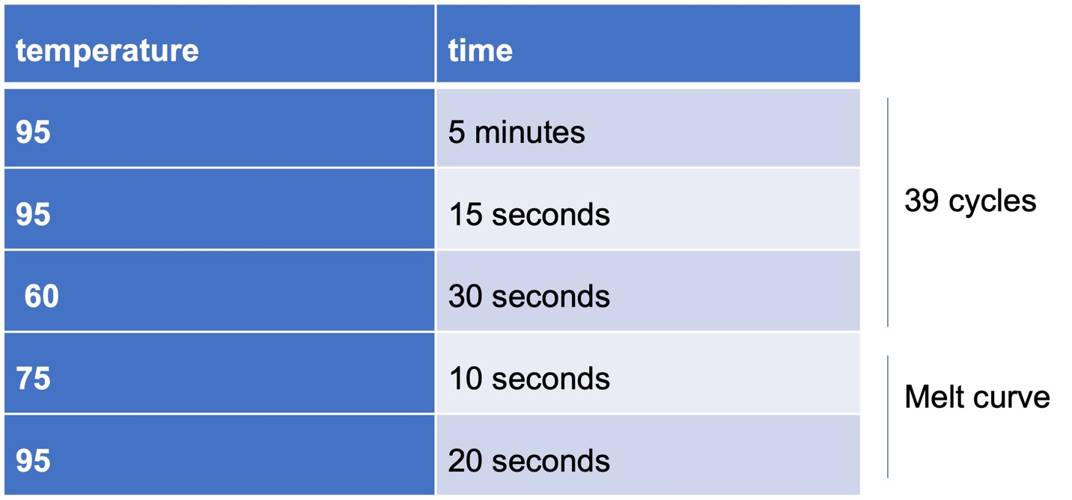
Analysis of qRT PCR data:
- The ΔCT values were calculated by subtracting respective gene CT value from housekeeping gene GAPDH value.
- Followed by calculating 2^{ΔCT} values and mRNA expression levels for genes of interest was normalized to GAPDH and represented relative to control.

